The BOSS (Back Office System Server)
Training Workbook

ACM® BOSS (Back Office System Server) Training Workbook
© 1996-2003 Productivity Solutions Incorporated. All Rights Reserved.
TRADEMARKS
ACM is a registered trademark of Productivity Solutions Incorporated.
pcANYWHERE is a registered trademark of Symantec.
MS Word and Windows NT are registered trademarks of Microsoft.
All other trademarks or registered trademarks are the property of their respective owners.
PRODUCTIVITY SOLUTIONS INCORPORATED (PSI) has made every effort to ensure that the information in this guide is complete, precise, and current. PSI assumes no liability to any person or entity with respect to alleged loss or damage caused by this workbook. The examples, sample screens, and reports used throughout this guide are intended for illustrative purposes only and may not conform to your system requirements. Implied warrantees are hereby specifically disclaimed. PSI may make improvements and/or changes in the product(s) and/or program(s) described in this publication at any time.
WARNING
All computers supplied with the ACM system are shipped fully assembled. Additional modifications to the system are not to be made by the user.
Composed in AvantGarde and Garamond using Microsoft Word.
Written and designed at Productivity Solutions Incorporated, Suite 509, 10550 Deerwood Park Blvd., Jacksonville, FL 32256.
Printed in the USA.

Contents
The BOSS (Back Office System Server) Training Workbook 1
Contents 2
Preface 2
How This Workbook Is Organized 2
Section One: BOSS Introduction 2
Overview 2
Logging on the BOSS 2
BOSS Desktop 2
Controlling Active Windows on the Desktop 2
Icons on the BOSS Bar 2
Section Two: Installation and Routine Maintenance Procedures 2
Changing the Status of the Self Checkout Lanes 2
Accessing the System View Window 2
Opening a Lane 2
Closing a Lane 2
Assigning Shopper Assistant Cards 2
Accessing the System Configuration Program 2
Adding a Shopper Assistant Card 2
Using the Quick Lookup Manager 2
Using the Quick Lookup Item Properties Window 2
Quick Lookup Item Properties Window Field Descriptions 2
Add A New Quick Lookup Item 2
Adding a Quick Lookup Item Without a Picture 2
Editing Quick Lookup Items 2
Moving Items Between Tabs 2
Delete Items 2
Editing Quick Lookup Tabs 2
Quick Lookup Sort Items Menu Field Descriptions 2
Sorting Quick Lookup Tabs 2
Editing Tab Arrangements 2
Editing Tab Order 2
Editing Tab Names 2
Saving Edits to the Quick Lookup Screens 2
Distribute Edits to the Quick Lookup Display to the Lanes. 2
Use the Find Function 2
Find Window Field Descriptions 2
Find a word or phrase 2
Inserting a New Image in a Foreign Language 2
Editing Images in a Foreign Language 2
Edit Existing Items in a Foreign Language Screen 2
Delete Items in a Foreign Language Screen 2
Scheduling Events with the ACM Scheduler 2
Accessing the ACM Scheduler Application 2
Adding an Event with the ACM Scheduler 2
Modifying an Existing Event 2
Deleting an Existing Event 2
Exiting ACM Scheduler 2
Practice Session 2
Installation and Routine Maintenance Procedures 2
Hands-On Section 2
Section Three: ACM System Security Procedures 2
ACM System Interface with the POS 2
An Item’s Process: 2
How Security Works 2
Modifying Item Records in the Security Database 2
Accessing the Security Database Maintenance Program 2
How Learning at the Self Checkout Lane Affects Database Records 2
Security Override (Learning Mode) Process 2
Practice Session 2
System Security 2
Section Four: Reporting Procedures 2
Daily Procedures 2
Manually Printing Daily Reports 2
Reviewing the Override Detail Report 2
How to use the Item Override Detail Report 2
Reviewing the Item Return Detail Report 2
How to use the Item Return Detail Report 2
Reviewing the Shopper Assistant Activity Summary Report 2
Field Descriptions of the Shopper Assistant Activity Summary Report 2
Example of the Shopper Assistant Activity Summary Report 2
How to use the Shopper Assistant Activity Summary Report 2
Reviewing the Transaction Summary Report 2
Field Descriptions of the Transaction Summary Report 2
Example of the Transaction Summary Report 2
Tender Type Summary 2
Security Mode Summary 2
How to use the Transaction Summary Report 2
Reviewing the Type 2 Item Override Summary Report 2
Monitoring Problems 2
Field Descriptions of the Type 2 Item Override Summary Report 2
Example of the Type 2 Item Override Summary Report 2
How to Use the Type Two Override Summary Report 2
Reviewing the Item Security Summary Report 2
How to use the Security Summary Report 2
Reviewing the Shopper’s Assistant Activity Detail Report 2
How to use the Shopper Assistant Activity Report 2
Reviewing the Learn Not-on-File Activity Detail Report 2
Field Descriptions of the Learn Not-on-File Activity Detail Report 2
Example of the Learn Not-on-File Activity Detail Report 2
How to use the NOF Activity Detail Report 2
Distributing the Sales Per Hour Summary Report 2
Example of the Sales Per Hour Summary Report 2
How to use the Sales Per Hour Summary Report 2
Reviewing the Weekly Worksheet Summary 2
Example of the Weekly Worksheet Summary Report 2
How to use the Weekly Worksheet 2
Reviewing the Coupon Activity Report 2
Example of the Coupon Activity Report 2
How to use the Coupon Activity Report 2
Reviewing the Department Activity Detail Report 2
Example of the Department Activity Detail Report 2
How to Use the Department Activity Detail Report 2
Reviewing the Item Void Detail Report 2
Example of the Item Void Detail Report 2
How to Use the Item Void Detail Report 2
Reviewing the Order Size Summary Report 2
Example of the Order Size Summary Report 2
How to Use the Order Size Summary Report 2
Reviewing the System Event Summary 2
Example of the System Event Summary Report 2
How to Use the System Event Summary Report 2
Practice Session 2
Daily and Weekly Procedures 2
Example of a Type 2 Override Summary Report 2
Example of a Learn Not-on-File Report 2
Appendix A – Using the BOSS mouse 2
Appendix B – Shopper Assistant Card Assignment Suggestions 2
Appendix C – Weights and Measures Information 2
Glossary of Self Checkout Terms 2
Index 2

Preface
This workbook is for the individual in charge of maintaining the ACM Self Checkout BOSS (Back Office System Server). Store management uses this product as a resource on the system’s operations.

How This Workbook Is Organized
Section 1: BOSS Introduction
Section 2: Installation and Routine Maintenance Procedures
Section 3: System Security Procedures
Section 4: Reporting Procedures
Note: | Notes – important information concerning the subject discussed.
 | Buttons – pictures representing the buttons that appear on the BOSS computer screen. These buttons, when clicked on with the mouse, activate a system function.
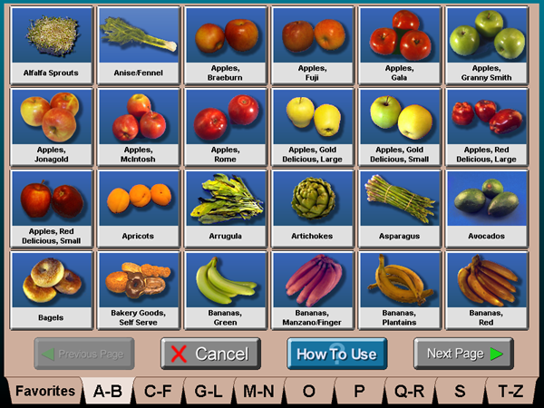 | Screen Captures – pictures representing the screens that appear on the BOSS computer screen as seen by the user.
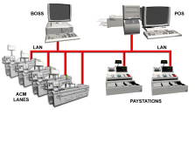 | Figures – graphics or diagrams used to illustrate components of the Self Checkout System..
Captions are located next to or under graphics | Captions – details or explanations about screen captures or figures.

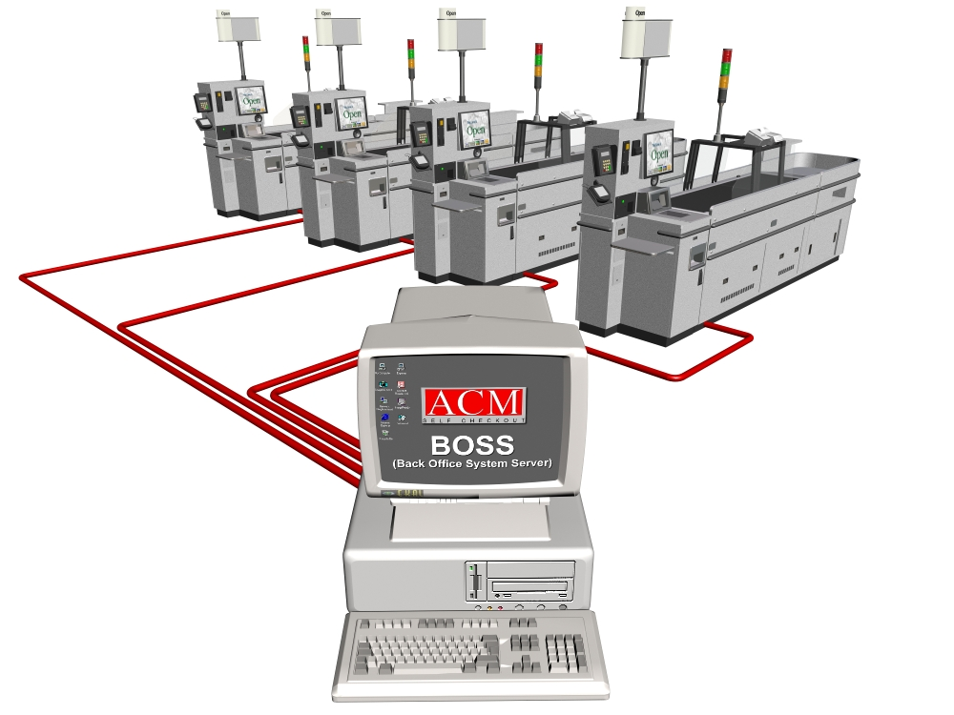
Section One: BOSS Introduction
This section introduces Back Office System Server (BOSS) features and applications.

Overview
The BOSS is a major component of the ACM Self Checkout system. It stores system configuration information including shopper assistant cards and system log data. It configures Quick Lookup™ screens, generates reports, and maintains the system’s master security database.
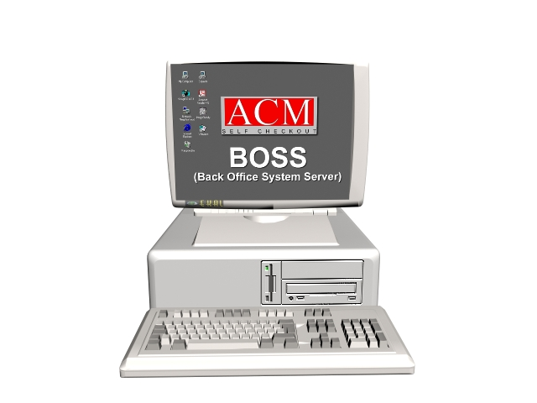
Figure 1. ACM Back Office System Server (BOSS)
The BOSS connects to the Self Checkout lanes through cables and wires known as a Local Area Network (LAN). Using the LAN, the BOSS transfers data to and from the Self Checkout lanes located in the frontend of your store. The LAN may consist of ethernet cables, token ring cables, a store loop, or a combination of the above. Use the BOSS to maintain the master security database of the Self Checkout System and to print management reports. The master security database contains information on every item in your store. The reports include information such as the number of shoppers who use the Self Checkout lanes, the number of items processed, and the total dollar sales. Additionally, the BOSS collects information on how well the system works for your shoppers. For example, it tracks the number of returned items and not-on-file items that are scanned at the Self Checkout lanes.
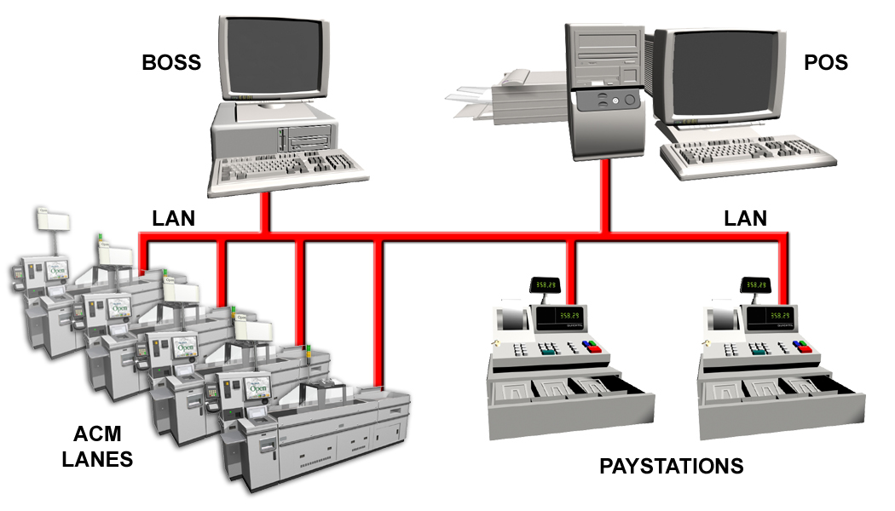
Figure 2. ACM System Interface

Logging on the BOSS
Accessing the BOSS application when the BOSS monitor is dark:
- Move the mouse or press any key on the BOSS computer keyboard.
- Simultaneously press the Ctrl, Alt and Delete keys on the BOSS computer keyboard.
- The login screen appears.
- The User Name displays as AcmBoss in the User Name field.
- Type AcmBoss in the User Password field.
Note: Use capital letters where appropriate (AcmBoss) when typing in the User Password on the BOSS login screen.

BOSS Desktop
The BOSS Desktop is a standard Windows 2000® desktop. Access BOSS applications the BOSS Bar toolbar.
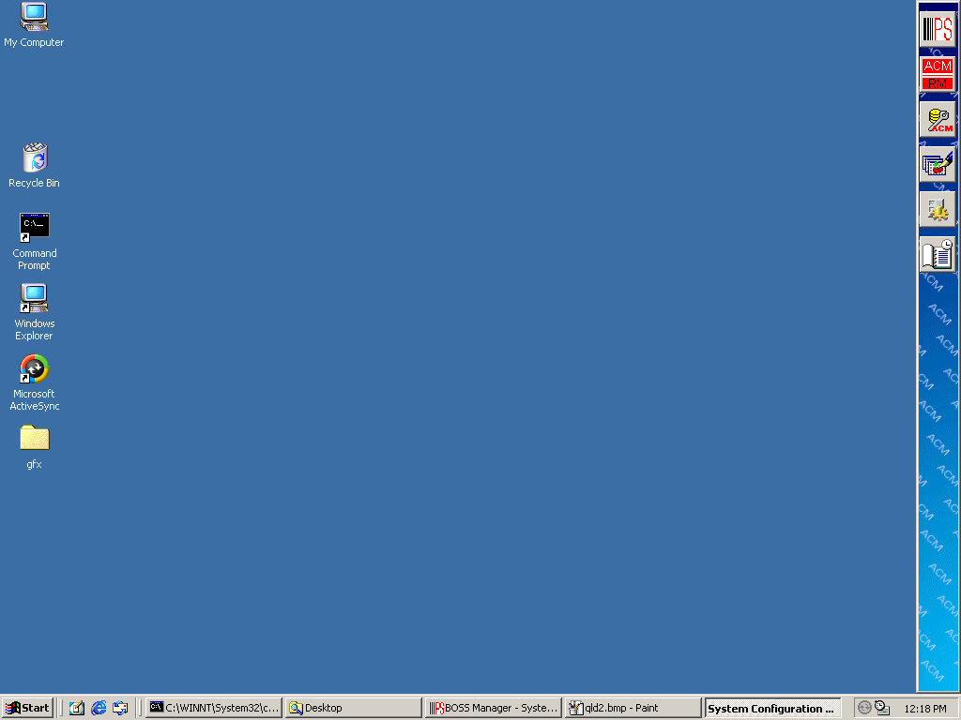 Figure 3. BOSS Desktop
Standard Windows Icons
BOSS Bar Desktop Icons

BOSS Task Bar

Important Note
The BOSS Manager application runs continuously on the BOSS Desktop. Verify that it is running by noting that the Task Bar at the bottom of the screen lists the BOSS Manager application. If you try to exit or close the BOSS Manager, the BOSS Manager Dialogue Box says the BOSS Manager should not be closed. Click OK to close the dialogue box.
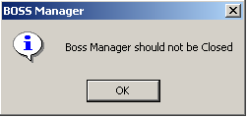
Figure 4. BOSS Manager Information Box
To view an application full screen, click the application’s button on the BOSS Task Bar.
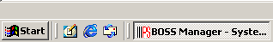
Figure 5. BOSS Task Bar

Controlling Active Windows on the Desktop
Every application has three icons in the top right corner that control the view, close, or exit the application. There are three options in controlling the active window.
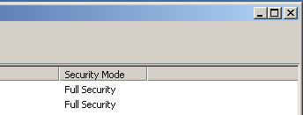
Minimize
Maximize
Exit/Close
Figure 6. Active Desktop Window
Minimize: The left button in the upper right-hand corner of the window minimizes the window to a button on the Task Bar.
Maximize: The middle button makes the window appear full screen. The icon changes when the window becomes full screen. Clicking it again reduces it to the original size.
Close/Exit: The right button closes the window or application.

Icons on the BOSS Bar
The BOSS server runs the following applications.
BOSS Manager – Creates, updates and deletes all security information in the system’s databases. Use this program to view system information and control system operations. Access the BOSS Manager through three different windows: System View, System Event View and Capture View.
- The System View displays the status of each Self Checkout lane: Open, Closed, or Busy. Open and close the Self Checkout lanes in this view.
- The System Event View displays significant events that occur on the lanes or the BOSS.
- The Capture View displays diagnostic information from a selected lane or the BOSS. PSI tracks the performance of the BOSS and all lanes with this information.
 Report Generator – Generates ACM Self Checkout Reports. The report generator can output to a printer, export to a file, or display the report on the screen.
 Quick Lookup Screen Generator – Adds, modifies, and deletes items on the Quick Lookup™ screens.
 System Configuration – Interfaces system configuration information including adding, modifying, and deleting shopper assistant cards.
 Security Database Maintenance – Allows manual changes to a record in the security database.
 Scheduler – Schedules events such as automatically running reports and applications.
Section Two: Installation and Routine Maintenance Procedures
This section provides ACM BOSS maintenance procedures for the Self Checkout System.

Changing the Status of the Self Checkout Lanes
Store management opens and closes Self Checkout Lanes from the BOSS Manager application. Follow these procedures to open or close the Self Checkout Lanes.

Accessing the System View Window
- Click the BOSS Manager icon.
- The BOSS Manager window displays.
- Click the System View button (if it is not already selected) 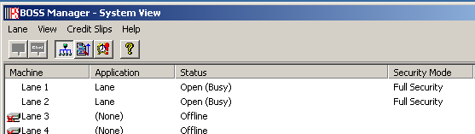
System View Button
Figure 7. BOSS “System View” screen
Table 1. System View screen field descriptions.
Column name | Description
Machine | Displays lane to monitor. For example: “Lane 1,” “Lane 2,” etc.
Application | Describes the function of the lane in the “Machine” category: None, Lane, Lane Diagnostics, POS Emulator.
Status | Describes the status of the lane: Offline, Open (Busy), Open (Idle), Opening, Closed, Closing, Waiting to Close, Synchronizing.
Security Mode | Displays the lane’s current security mode. For example: “Full Security” or “Speed Mode.”
Table 1: “System View” screen

Opening a Lane
- Click the lane number you wish to open under the Machine column.
- From the menu bar, click Lane, then Open (or click the Open icon).

Closing a Lane
- Click the lane number you wish to close under the Machine column.
- From the menu bar, click Lane, then Close (or click the Close icon).
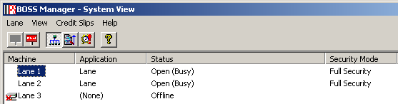
Open Lane Icon
Close Lane Icon
Lane Selected

Figure 8. BOSS Manager System View Window

Assigning Shopper Assistant Cards
Assign shopper assistant cards so your associates can perform shopper assistant functions at the Self Checkout lanes such as overriding security, voiding items and orders, and reprinting receipts. Add, modify and delete shopper assistant cards as follows.
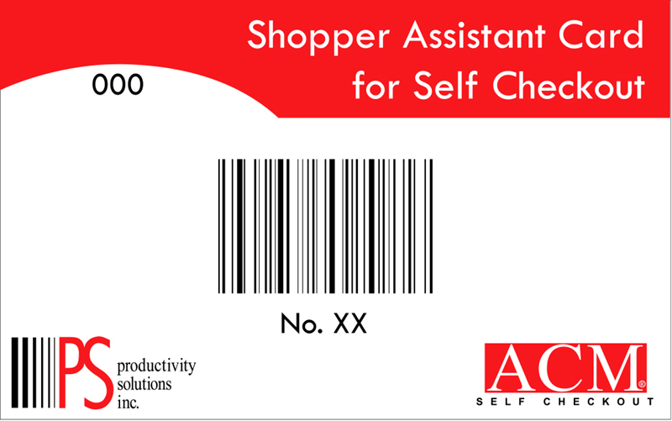
Card key modifier allows the card to access information only in your store.
Card number assigned to the assistant using the card.
Barcode that when scanned allows the assistant to access the Shopper Assistant Menu from the lane.
Figure 9. Shopper Assistant Card

Accessing the System Configuration Program
From the BOSS Desktop:
- Single click the System Configuration icon. A System Configuration Password window displays.
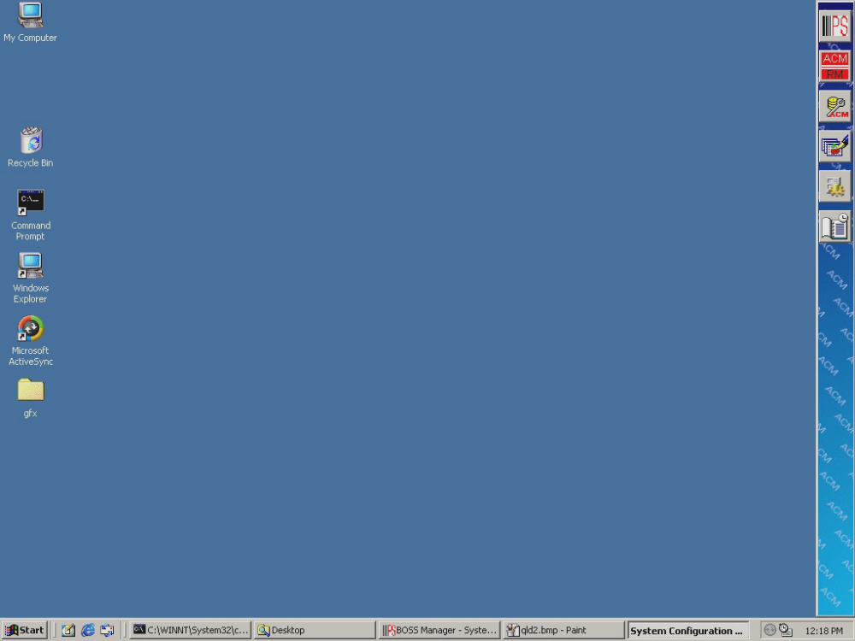

System Configuration Icon
Figure 10. BOSS Desktop
- The Assistant Configuration Program screen displays.
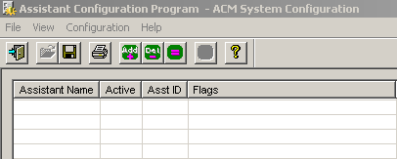
Figure 11. Assistant Configuration Program Menu

Table 2. Assistant Configuration Program Menu Field Descriptions
Column name | Description
Assistant Name | The Shopper Assistant’s name as defined in the system.
Active | Y or N; Y = card is defined and activated; N = card is defined but inactivated.
AsstID | Shopper assistant card number in the format xxxxxxyyyzz; where xxxxxx = manufacturer’s code (always 081513), yyy = card’s key modifier, and zz = card’s number.
Flags | Y or N; Y = activated field; N = inactivated field. These fields are system-generated switches that describe which shopper assistant functions are activated for an Assistant ID.
Table 2: Assistant Configuration Program Menu

Adding a Shopper Assistant Card
- From the System Configuration program screen, select Configuration, then Add Assistant ID or click the Add Entry icon. The Edit Assistant ID window displays.
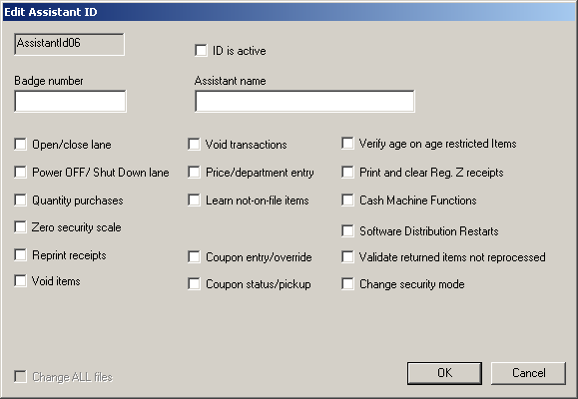
Figure 12. Edit Assistant ID Menu.

Column name | Description
AssistantID## | System-generated number.
ID is Active | Checked = active; unchecked = inactive. Enables the administrator to activate or deactivate an assigned card.
Badge Number | Shopper assistant card number in the format xxxxxxyyyzz; where xxxxxx = manufacturer’s code (always 081513), yyy = card’s key modifier, and zz = card’s number.
Assistant Name | Name of shopper assistant assigned to this card.
Open/Close Lane | Checked = on; Not checked = off. Check this box to enable the cardholder to use his or her shopper assistant card to open and close the Self Checkout Lanes.
Power Off Lane | Checked = on; Not checked = off. Check this box to enable the cardholder to use his or her shopper assistant card to power off the Self Checkout Lanes from the Lane Menu screen.
Quantity Purchase | Checked = on; Not checked = off. Check this box to enable the cardholder to use his or her shopper assistant card to assist shoppers with quantity purchases at the Self Checkout Lane from the Shopper Assistant Menu screen.
Zero Security Scale | Checked = on; Not checked = off. Check this box to enable the cardholder to use his or her shopper assistant card to zero the security scale at the Self Checkout Lane from the Shopper Assistant Menu screen.
Reprint Receipt | Checked = on; Not checked = off. Check this box to enable the cardholder to use his or her shopper assistant card to reprint receipts for shoppers at the Self Checkout Lane from the Shopper Assistant Menu screen.
Void Item | Checked = on; Not checked = off. Check this box to enable the cardholder to use his or her shopper assistant card to void single items from a shopper’s order at the Self Checkout Lane from the Shopper Assistant Menu screen.
Void Transaction | Checked = on; Not checked = off. Check this box to enable the cardholder to use his or her shopper assistant card to void items or transactions at the Self Checkout Lane from the Shopper Assistant Menu screen.
Price Department Entry | Checked = on; Not checked = off. Check this box to enable the cardholder to use his or her shopper assistant card to key-in price and department entries at the Self Checkout Lane from the Shopper Assistant Menu screen.
Learn Not on File | Checked = on; Not checked = off. Check this box to enable the cardholder to use his or her shopper assistant card to Learn a not-on-file items at the Self Checkout Lane.
Coupon Entry or Override | Checked = on; Not checked = off. Check this box to enable the cardholder to use his or her shopper assistant card to perform coupon manual entries at the Self Checkout Lane.
Coupon Status or Pickup | Checked = on; Not checked = off. Check this box to enable the cardholder to use his or her shopper assistant card to perform coupons pickup or check coupon status at the Self Checkout Lane.
Verify Age on Age Restricted Items | Checked = on; Not checked = off. Check this box to enable the cardholder to use his or her shopper assistant card to verify age on age restricted items at the Self Checkout Lane.
Print and Clear Reg. Z Receipts | Checked = on; Not checked = off. Check this box to enable the cardholder to use his or her shopper assistant card to print and clear electronic signature capture receipts generated at the Self Checkout Lane.
Cash Machine Functions | Checked = on; Not checked = off. Check this box to enable the cardholder to use his or her shopper assistant card to perform cash maintenance and cash diagnostic procedures.
Software Distribution Restarts | Checked = on; Not checked = off. Check this box to enable the cardholder to use his or her shopper assistant card to perform software distribution restart procedures.
Validate Returned items Not Processed | Checked = on; Not checked = off. If store’s system has this feature, check this box to enable the cardholder to use his or her shopper assistant card to validate items that are rejected by the ACM.
Change Security mode | Checked = on; Not checked = off. Check this box to enable the cardholder to use his or her shopper assistant card to change the lane’s security mode.
Table 3. Edit Assistant ID Menu Field Descriptions
- Check the box next to the “ID is Active” field to activate the card.
- Type the badge number in the “Badge Number” field. The key modifier codes and card numbers are printed on the shopper assistant card.
- Type the shopper assistant’s name in the “Assistant Name” field.
- Check the boxes next to the desired fields to activate access privileges for this user.
- Click OK. The name appears on the list.
Modifying a Shopper Assistant Card User
- From the System Configuration Program screen, double click the shopper assistant’s name (or single click the name and press the Modify Entry icon). The Edit Assistant ID window displays.
- Change information as needed.
- Click OK.
Deleting a Shopper Assistant Card User
- From the System Configuration Program screen, click the shopper assistant’s name.
- Click the Delete Entry icon.
- At the prompt, click Yes.

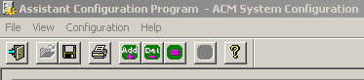
Delete Entry Icon
Figure 13. System Configuration Program Screen Tool Bar

Exiting the System Configuration Program
- Prior to exiting, click File, then Save (or click the save icon). If you omit this ‘save’ step, a prompt appears when exiting the program.
- To exit, from the menu bar, click File, and Exit (or click the close box [x] in the upper right-hand corner of the screen.)

Using the Quick Lookup Manager

Using the Quick Lookup Item Properties Window

Quick Lookup Item Properties Window Field Descriptions
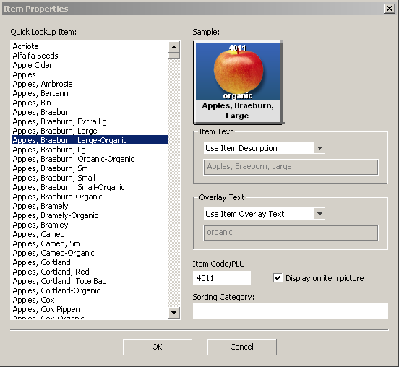
Figure 14. QLM Item Properties Menu

Field | Function
- Quick Lookup Item | List of all Lookup Items available for creating new button files.
- Sample | Displays graphic image and text overlays of the selected item.
- Item Text | Drop-down list of three button display options: display the item description on the sample, display a preset alternate description, or display custom text from the Item Text field.
- Overlay Text | Drop-down list of three button display options: display the preset overlay text, do not display any overlay text, or display custom overlay text from the Overlay Text field.
- Item Code/PLU | Enter each item’s Point of Sale Code into this field for a visual reference on the Quick Lookup screen.
- Display on Item Picture | Selected to display the item PLU on the button.
- Sorting Category | Use to create custom item sorting categories.
Table 4.Item Properties Menu Field Descriptions

Add A New Quick Lookup Item
- Right click the center of the QLI Manager screen. A shortcut menu appears.
- Click Insert New… (see figure 2). The Item Properties window appears.
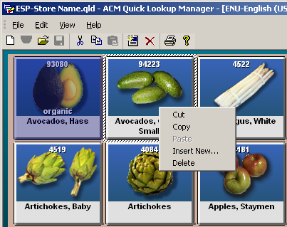
Figure 105 QLM Manager
- Sselect an item from the Quick Lookup Item list (see figure 14).
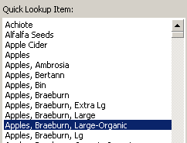
Figure 16. QLI Item Menu
- In the Item Text drop-down list, click the item text type.
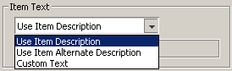
Figure 17. Item Text Menu
- In the Overlay Text drop-down list, click the item overlay text type.
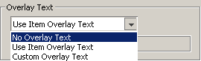
Figure 18. Item Overlay Menu
- Type the item’s PLU or POS code into the Item Code/PLU field.
- Select or clear the Display on Item Picture box as necessary.
- Type any text in the Sorting Category field to create a new sorting category.
- Click OK.

Adding a Quick Lookup Item Without a Picture
- Complete steps 1-3 in the Add A New Quick Lookup Item procedure then continue to step 2 of this procedure.
- In the Item Text drop-down list, click the Blank text type.
- Complete steps 5-9 in the Add A New Quick Lookup Item procedure.

Editing Quick Lookup Items
- Double-click the item button.
- Select an item from the Quick Lookup Item: list, insert item into the tab.
Figure 19. QLI Item Menu
- In the Item Text drop-down list, click the item text type.
Figure 20. Item Text Menu
- In the Overlay Text drop-down list, click the item overlay text type.
Figure 21. Item Overlay Menu
- Type the item’s PLU or POS code into the Item Code/PLU field.
- Select or clear the Display on item picture box as necessary.
- Type any text in the Sorting Category field to create a new sorting category.
- Click OK.

Moving Items Between Tabs
- Right-click the item you want to move. A shortcut menu appears.
- To copy the item into another tab, click Copy.
- To move the item into another tab, click Cut.
- Click the tab in which you want to place the copied or cut item.
- Right-click the place you want the item to appear.
- A shortcut menu appears. Click Paste.

Delete Items
- Right-click the image. A shortcut menu appears.
- Click Delete.

Editing Quick Lookup Tabs

Quick Lookup Sort Items Menu Field Descriptions
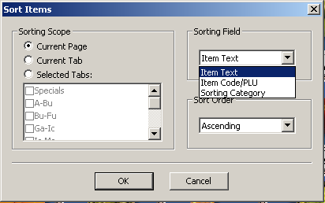
Figure 22. Sort Item Menu
Field | Function
- Sorting Scope | Three option buttons:  Current Page - Alphabetizes selected images on the active page.  Current Tab - Alphabetizes selected images on the active tab.  Selected Tabs - Alphabetizes selected tabs activated by selection.
- Sorting Field | Drop-down list of three text types to sort: item text, item code/PLU, or customized category.
- Sorting Order | Drop-down list of two alphabetical sort directions: ascending or descending from the top of the screen.
Table 5. Sort Item Menu Field Descriptions

Sorting Quick Lookup Tabs
- On the Edit menu, click Sort…
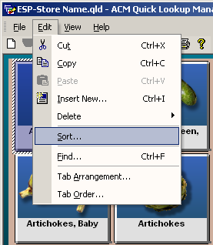
Figure 23. Edit Toolbar Menu
- In the Sorting Scope field, click Current Page, Current Tab, or Selected Tabs.
- In the Sorting Field drop-down list, click Item Text, Item Code/PLU, or Customized Category.
- In the Sorting Order drop-down list, click Ascending or Descending.
- Click OK.

Editing Tab Arrangements
- On the Edit menu, click Tab Arrangement.
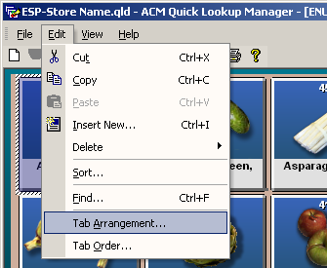
Figure 24. Edit Toolbar Menu
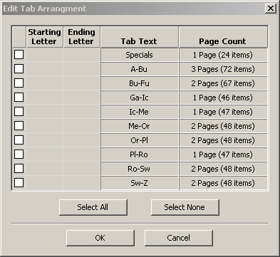
Figure 25. Edit Tab Arrangement Menu
- Select the appropriate check boxes to arrange specific tabs, or click the Select All button.
Caution: Do not select your special tabs or they will lose both name and Quick Lookup Items.
- In the Starting Letter list, select the starting letter for each tab.
- In the Ending Letter list, select the ending letter for each tab.
- Click OK.

Editing Tab Order
- On the Edit menu, click Tab Order.
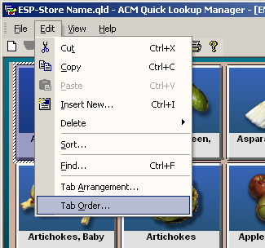
Figure 26. Edit Tab Menu
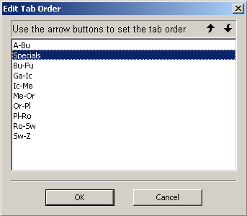
Figure 27. Edit Tab Order Menu
- In the Edit Tab Order list, click the tab of your choice.
- Click the and arrows in the top right hand corner of the window to move the tab up or down the list.
- Repeat steps 2 and 3 until the tabs are ordered.
- Click OK.

Editing Tab Names
- Double-click the Tab you want to rename.
- The Edit Tab dialog box appears.
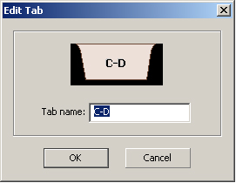
Figure 28. Edit Tab dialog box
- Type the new name for the tab in the Tab name field and click OK.

Saving Edits to the Quick Lookup Screens
- On the File menu, click Save.
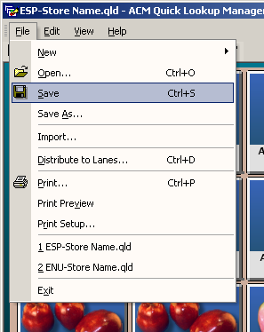
Figure 29. Toolbar File Menu

Distribute Edits to the Quick Lookup Display to the Lanes.
Note: Distribute one Quick Lookup Display (QLD) to the lane, then close and reopen the lane. The BOSS only sends the latest QLD file to the lane as the lane opens.
- On the File menu, click Distribute to Lanes.
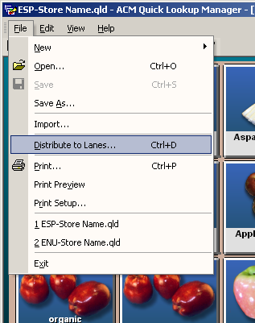
Figure 30. Toolbar File Menu
- Close all self checkout lanes.
- Reopen all self checkout lanes.
Note: Quick Lookup edits do not activate at the lane until it is closed and then reopened.

Use the Find Function

Find Window Field Descriptions
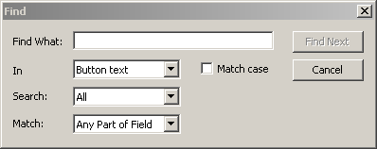
Figure 31. Find Menu
Field | Function
- Find What: | Type the word or phrase to find.
- In | Drop-down list with three options:  Button Text - Search for word or phrase in the button text only.  Item ID - Search for word or phrase in the item ID field only.  User-Identified - Search for word or phrase in the user defined text fields only.
- Search:
- Match: | Drop-down list with three options:  Any part of the field - Search for word or phrase in any part of the field.  Whole field - Search for word or phrase as the whole field.  Start of field - Search for word or phrase in the start of the field only.
Table 6. Find Menu Field Descriptions

Find a word or phrase
- On the Edit menu, click Find….
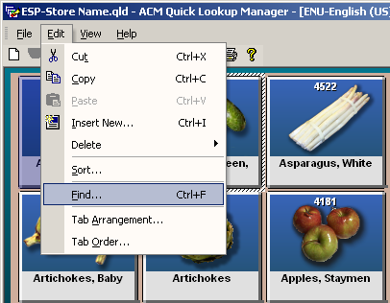
Figure 32. Edit Toolbar Menu
- Type a word or phrase in the Find What field.
- In the In drop-down list, click a text location you want to search.
- In the Search: drop-down list, click the direction in which you want to search.
- In the Match: drop-down list, click the part of the field you want to search.
- Select or clear the Match case check box.
- Click Find Next.

Inserting a New Image in a Foreign Language
- Right click the center of the QLI Manager screen. A shortcut menu appears.
- Click Insert New.
Figure 33. QLM Manager
- The Item Properties window appears In the Quick Lookup Item list, select an item to insert it into the tab.
Figure 34. QLI Item Menu
- In the Item Text drop-down list, click the item text type.
Figure 35. Item Text Menu
- In the Overlay Text drop-down list, click the item overlay text type.
Figure 36. Item Overlay Menu
- Type the item’s PLU or POS code into the Item Code/PLU field.
- Select or clear the Display on item picture box as necessary.
- Type any text in the Sorting Category field to create a new sorting category.
- Click OK.

Editing Images in a Foreign Language
Changes to individual tabs are not universal. Make the same edits to each language set.

Selecting Language Definition
Table 7 lists language abbreviations used in the file naming conventions for Quick Lookup Definition files (.qld). Refer to it to determine which Quick Lookup Definition file you want to open.
English(Canada) | ENC
English(UnitedKingdom) | ENG
English(UnitedStates) | ENU
French(Canada) | FRC
Spanish(SpainTraditionalSort) | ESP
Table 7. Language Abbreviations
- On the File menu, click Open.
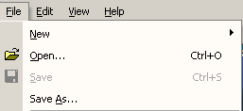
Figure 37.Toolbar File Menu
- Select the .qld file from the import file list.
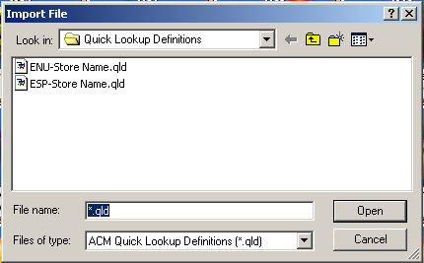
Figure 38. Import File Menu
- Click Open.

Edit Existing Items in a Foreign Language Screen
- Double-click the item button.
- In the Quick Lookup Item list, select an item to insert it into the tab.
Figure 39. QLI Item Menu
- In the Item Text drop-down list, click the item text type.
Figure 40. Item Text Menu
- In the Overlay Text drop-down list, click the item overlay text type.
Figure 41. Item Overlay Menu
- Type the item’s PLU or POS code into the Item Code/PLU field.
- Select or clear the Display on item picture box as necessary.
- Type any text in the Sorting Category field to create a new sorting category.
- Click OK.

Delete Items in a Foreign Language Screen
- Right-click the image. A shortcut menu appears.
- Click Delete.

Scheduling Events with the ACM Scheduler
The BOSS has extensive reporting capabilities, providing information to examine and enhance ACM system performance and management. The ACM Scheduler enables users to schedule reports to generate automatically.

Accessing the ACM Scheduler Application
- From the BOSS desktop, single click the ACM Scheduler icon. The ACM Scheduler window displays.
- The monthly view displays. Clicking on the tabs on the left of the screen can change the views.
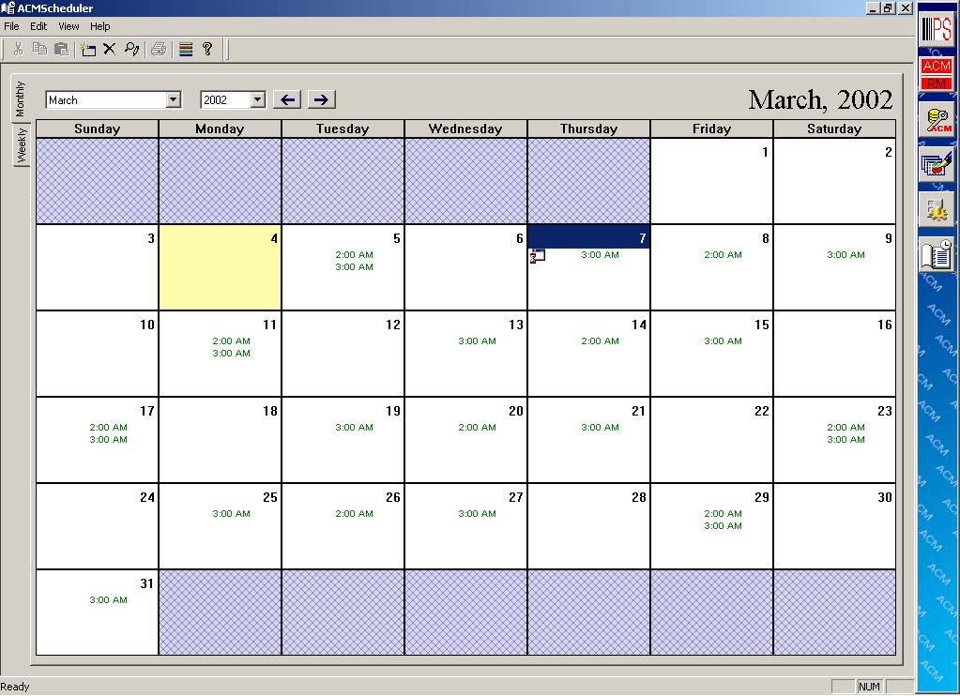
Monthly
&
Weekly Tabs

Date Selected
Figure 42. ACM Scheduler Calendar View
Note: The monthly view displays initially because it is the default view.

Adding an Event with the ACM Scheduler
- To schedule an event with the monthly or weekly view displayed, click the date of the event (or the start day of a recurring event.)
- Select Edit, then Add Event (or select the Add icon on the toolbar). The Scheduler Event Information window displays.
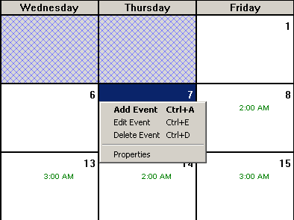
Figure 43. Add/Edit Event Menu
- Enter information as desired into the different fields of the Scheduler Event Information window, and then press Continue.
- On the Add Event screen, select ACM Report as the event type.

Table 8. Add Event Window field descriptions
FIELD NAMES | FIELD DESCRIPTIONS
Event Type | Options: ACM Report or Application. For user level, only ACM Report is available.
Report | Field contains a scrollable list with all available reports. Allows the user to select the report to schedule. To select a report, find and click the report, the name appears in the report field.
Number of Days to Span | Number of days the report spans when run.
Destination | The system either prints reports to a printer configured on the system/network or sends it to a file. Sending the report to a file saves it. The system prompts the user to assign a file name and location. Click the down arrow next to the field, and then select the desired destination option.
Event Time | Time the report generates. Select time by selecting the field to modify and clicking on the up or down arrows to raise or lower the numbers as desired.
Interval | Interval options include Single, Daily, Weekly and Monthly. The system prompts you to designate particulars based on the interval you select.
Duration | Duration specifies how long the event occurs. The system automatically defaults to the maximum of two years duration. Clicking on the down arrow adjacent to the Duration field causes a calendar to display. You may then specify duration.
Table 8. Field Descriptions ACM Scheduler Add Event Window
- Select the report to schedule by clicking on the arrow adjacent to the report field.
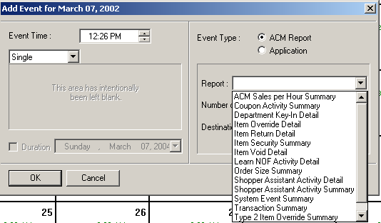
Select Report
Figure 44. Add Event Menu Report Field
- Select the number of days the report spans, then select the destination. The system typically prints to the printer configured for the system, although the system can save the report to a file.
- Select the event time, by clicking on the hour and/or minute field and either typing the desired numbers, or clicking on the up or down arrows (to raise or lower the number.)
- Select the interval for the report. The options are Single, Daily, Weekly, and Monthly.
- The system prompts for other choice to further specify the interval.
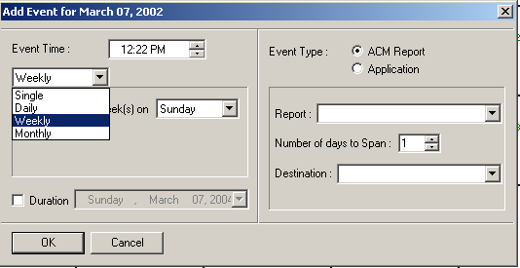
Figure 45. Add Event Menu Event Time Field
- Select the Duration field by clicking in the small box adjacent to the Duration field. The field brightens and the system defaults to the maximum default duration of two years.
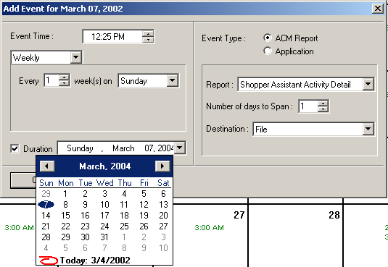
Figure 46. Add Event Menu Duration Field
- Click OK. Repeat the same procedures to schedule additional reports. As you schedule each report, the time of report generation displays on the monthly calendar.
- To view more details about an event, switch views to the weekly view.
Note: Recommended daily reports (printed each day, spanning a one-day period): Learn NOF Activity Detail, Type 2 Override Summary. Suggested weekly reports: ACM Sales Per Hour Summary, Shopper Assistant Activity Summary, Transaction Summary, and the Weekly Worksheet Summary (if available).

Modifying an Existing Event
- From the ACM Scheduler, with the monthly or weekly view displayed, click the date of the event (or the start day of a recurring event). Select Edit then Edit Event (or select the Edit icon on the toolbar). The Edit Events window displays, listing all events scheduled for that date. Select the report to edit, then click Edit.
- The Scheduler Event Information window displays. Change information as desired into the different fields of the Scheduler Event Information window, then click Continue.
- The Add Event Window displays with the previously entered information. Click the desired field and change as necessary. Click OK and the window closes. The Edit Events window redisplays. Click OK to save the change to the system.
- Repeat the procedure for additional changes.

Deleting an Existing Event
- From the ACM Scheduler, with the monthly or weekly view displayed, click the date of the event (or the start day of a recurring event). Select Edit then Delete Event (or select the Delete icon on the toolbar). The Delete Events window displays, listing all events scheduled for that date. Select the report to delete, then click Delete.
- If you schedule the event for multiple days, the system asks if you want to delete all scheduled dates. Choose “Yes” to delete the event for all dates scheduled. Choose “No” to delete the event for the chosen day only.
- The Delete Events window redisplays. Select OK. The ACM Scheduler Monthly view displays. Repeat procedures as needed.

Exiting ACM Scheduler
- After all Reports have been added, edited, or deleted, exit the ACM Scheduler. From the menu bar, click File and Exit (or click the close box [x] in the upper right-hand corner of the screen).

Practice Session

Installation and Routine Maintenance Procedures
___________ | You can minimize the BOSS Manager to the task bar from the desktop.  - True  - False
___________ | Can store management personnel open and close individual ACM lanes from the BOSS?  - Yes  - No
___________ | Which of the following statements best completes this statement: To open or close a lane from the BOSS, 1) Select the BOSS Manager icon, 2) click the “System View” button, 3) clickce on the desired lane number, and then…  - double click the menu bar and select the ON/OFF button.  - click LANE (from the menu bar) and then OPEN or CLOSE.  - select VIEW (from the menu bar) and click the ON/OFF button.
___________ | To assign a shopper assistant card, you must select the System Configuration icon. When the System Configuration Password box appears, which of the following must you select to access the Assistant Configuration program?  - OK  - Cancel
___________ | When adding a shopper assistant card, you can add an assistant name and then activate card functions by clicking in the desired field. Therefore, each shopper assistant can have personalized privileges activated on his or her shopper assistant card.  - True  - False
___________ | In order to modify a shopper assistant card from the Assistant Configuration Program screen, you would _____________ on the shopper assistant name. You can then modify the card’s information in the Edit Assistant ID window.  - single click  - double click
___________ | When deleting a shopper assistant card, you would select a specific shopper assistant’s name and click the Delete Entry Icon.  - True  - False
___________ | The Quick Lookup Screens are used to process non-barcoded items.  - True  - False
___________ | In order to add a new item to the Quick Lookup Screen, you must be able to access a blank space.  - True  - False
___________ | In order to modify an item on a Quick Lookup Screen, you can double click the picture and then make your changes in the edit item window.  - True  - False
___________ | When you make a change to the Quick Lookup Screens, the information then distributes to the ACM lanes. Distribute it by clicking on File (from the menu bar) and then selecting Distribute to Lanes. Should you close and open each of the ACM lanes in order to apply these changes?  - Yes  - No
___________ | The ACM Reports Generator prints reports and allows the user to save default report settings to ease the report printing process.  - True  - False
___________ | The ACM Scheduler provides the capability to set reports to automatically print.  - True  - False
___________ | The principle difference between the ACM Reports Manager and the ACM Scheduler is___________________________  - the ACM Reports Manager allows the user to print reports automatically; the ACM Scheduler allows you to keep personal calendar of appointments.  - The ACM Reports Manager allows the user to print report histories of available data. The ACM Scheduler allows the user to schedule reports to print at specified intervals.
___________ | Once you activate the ACM Scheduler, you can select to view the calander either monthly or weekly.  - True  - False

 | Hands-On Section  While seated at the BOSS, perform the following installation procedures:  ☑ Check off procedures, once performed, on the line provided.
_______ 1. Close and then open an ACM lane from the BOSS Manager.
_______ 2. Add, modify, and delete a shopper assistant card.
_______ 3. Add, modify, and delete an item in the Quick Lookup System.
_______ 4. Add, edit, and delete a report using the ACM Scheduler.

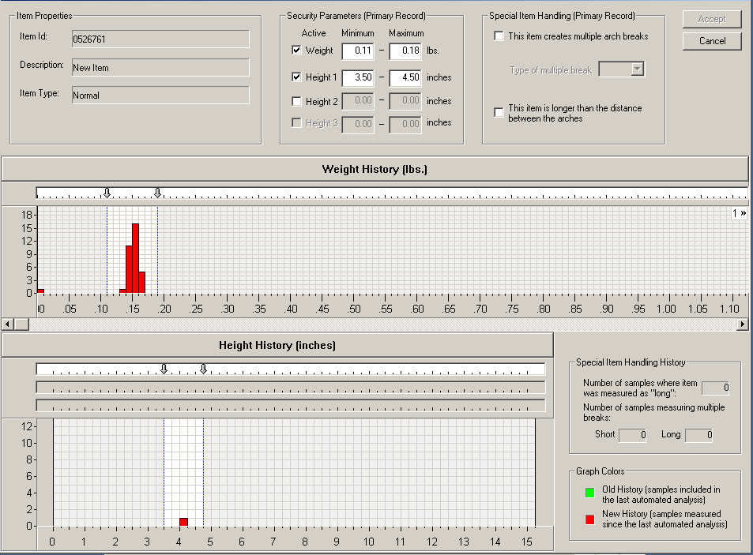
Section Three: ACM System Security Procedures
This section covers the procedures used by store personnel that effect how the Self Checkout System enforces item security.

ACM System Interface with the POS
The Self Checkout System interfaces with your store’s current point of sale (POS) system. The diagram below illustrates the communication between the systems as the lane processes and verifies the security of an item.

An Item’s Process:
- A shopper processes an item at the Self Checkout Lane.
- The lane’s computer sends the item’s UPC/PLU to the POS system. The POS retrieves the price and description information and sends it to the lane. The lane voices the price and displays the price and description on the monitor’s electronic receipt.
- The lane’s computer then provides the security record for that item. The item, once placed on the belt, moves through the security area where its parameters are checked and verified against the security record.

How Security Works
Note: Never reveal to shoppers how the security system works. Shoppers should simply know that the security system that checks every item for accuracy and integrity.
The ACM 700 TPS security database record for an item contains a weight range and up to three height ranges for the item. The ACM 500 TPS security database record for an item contains only weight range item information. The lane enforces security on an item depending on how the item processes: typically, by weight, by quantity, or by random weight (type 2 barcoded).
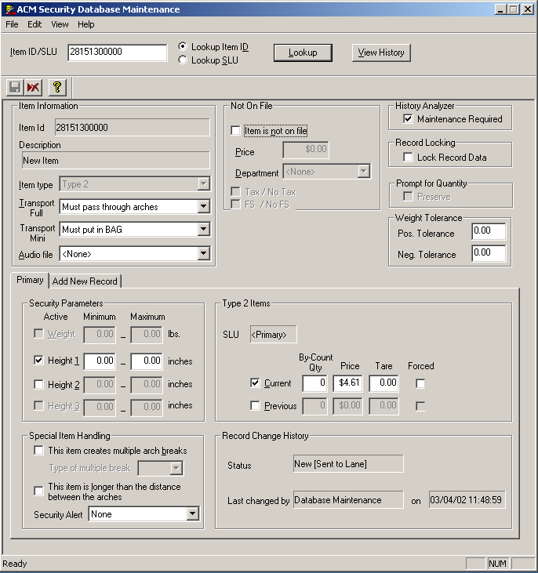
Enter Item
UPC
Audio Files
POS Description
Transport Methods
Figure 46. Security Database Maintenance Screen

Modifying Item Records in the Security Database
The following are procedures for manually correcting security database issues that are identified at the Self Checkout Lanes. The topics in this section include:
- Modifying Produce Audio Codes
- Modifying Transport Methods
- Forcing a Prompt for Quantity
- Modifying Tare Values for Weight Required Items
- Modifying Positive and Negative Tolerance for Type 2 Items

Accessing the Security Database Maintenance Program
To make manual adjustments, you must first access the Security Database Maintenance Program.

- From the BOSS desktop, single click the Security Database Maintenance icon. The Security Database Maintenance Program displays.
- To access the security record for an item, you must enter the item’s identification code.
- To enter a standard barcode, start with the leading digit and enter all of the numbers across the bottom (except the last check digit).
- To enter a Type 2 barcode, start with the digit 2, enter the next five digits, then follow with five zeros (00000).
- To enter a PLU code, enter the four-digit code.
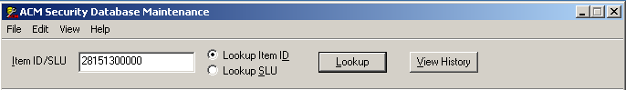
Figure 47. Security Database Maintenance Screen
Enter Item UPC

Modifying Produce Audio Codes
If an incorrect audio prompt voices for an item at the lane, correct the audio file for the item in the item’s security record.
- With the Security Database Maintenance screen active, click in the “Item ID” field. Enter the item’s PLU. The security record for the item displays.
- Click the down arrow next to the “Audio File” field. Choose the proper file name.
- From the menu bar, click File and Save. (Or, click the Save icon.)

Modifying Transport Methods
Shoppers must place most items on the belt on the ACM 700 or in the bagging area on an ACM 500. However, an item may not fit due to its size or shape, or it may be fragile. The lane does not require the shopper to place it in the bagging area or on the belt.
ACM 700 Transport Settings
If an item is marked incorrectly, perform the following:
- With the Security Database Maintenance screen active, click in the “Item ID” field. Enter the item’s barcode. The security record for the item displays.
- Click the down arrow next to the “Transport Full” field. Choose a transport method.
- Must pass through arches: The system voices the price and the belt begins moving, signaling the shopper to place the item on the belt.
- Optionally pass through arches: Shoppers may opt to place these items on the belt. The belt moves when the shopper scans the item.
- Must not pass through arches: A voice prompt informs shoppers that he or she does not need to place the item on the belt and can carry to the bagging area. The belt does not move.
- From the Menu Bar, click File and Save. (Or, click the Save icon.)
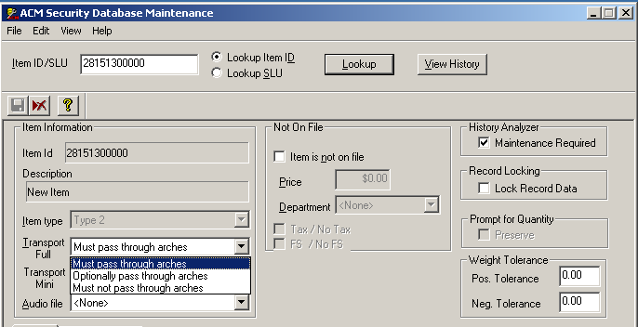
ACM 700 Transport Options
Figure 48. Security Database Maintenance Screen

ACM 500 Transport Settings
If an item is marked incorrectly, perform the following:
- With the Security Database Maintenance screen active, click in the “Item ID” field. Enter the item’s barcode. The security record for the item displays.
- Click the down arrow next to the “Transport Mini” field. Choose a transport method.
- Must put in the BAG: The system voices the price and the shopper must place the item in the bagging area to prevent generating a security error.
- Optionally/Must Not put in BAG: The shopper may opt to place these items in the bagging area
- From the Menu Bar click File and Save. (Or, click the Save icon.)
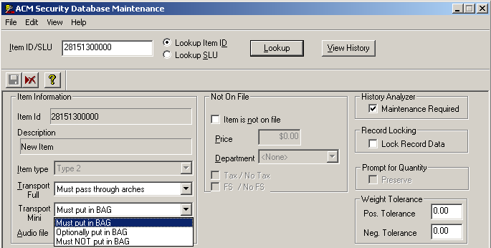
ACM 500 Transport Options
Figure 49. Security Database Maintenance Screen

Forcing a Prompt for Quantity
Occasionally, you may need to force the Self Checkout lanes to prompt a shopper for quantity information while processing an item. To force a prompt for quantity:
- With the Security Database Maintenance screen active, click in the “Item ID” field. Enter the item’s PLU. The security record for the item displays.
- the “Item Type” field (located in the Item Information section) and choose “Prompt for Quantity.”
- From the menu bar, click File and Save. (Or, click the Save icon.)

Modifying Tare Values for Weight Required Items
When a shopper scans a weight-required item at the Self Checkout lane, the lane automatically deducts a tare value from the weight before calculating the price. Adjust this value if the lane does not properly credit an item.
- With the Security Database Maintenance screen active, click in the “Item ID” field. Enter the item’s PLU. The security record for the item displays.
- Click and assign a value to the “Tare Value” field.
- From the menu bar, click File and Save. (Or, click the Save icon.)

Modifying Positive and Negative Tolerance for Type 2 Items
Random weight items that have been processed (cooked, steamed, frozen, packed in ice, de-boned), may return at the Self Checkout Lanes until store level personnel correct the security record for the item.
- With the Security Database Maintenance screen active, click in the “Item ID” field. Enter the item’s UPC/PLU. The security record for the item displays.
- Click in and assign a value to the “Positive or Negative Tolerance” field.
- Use positive Tolerance to adjust for alterations, such as packing in ice, that causes the item to weigh more.
- Use Negative Tolerance to adjust for alterations, such as steaming, that cause items to weigh less.

Common Uses for Assigning Positive and Negative Tolerance
Packing in ice | Positive tolerance | 1 pound
Thawing / turkey  Thawing / chicken | Negative tolerance  Negative tolerance | .5 pounds  .25 pounds
Steaming / seafood | Negative tolerance | .25 pounds
De-boning / seafood  De-boning / meat | Negative tolerance  Negative tolerance | .33 pounds  .75 pounds
Grinding / meat | Negative tolerance | .75 pounds
Slicing / meat | Negative tolerance | .25 pounds
Marinating / meat  Marinating / seafood | Positive tolerance  Positive tolerance | .20 pounds  .20 pounds
Cutting or cubing fruit  Cutting or cubing veg. | Negative tolerance  Negative tolerance | .25 pounds  .25 pounds
Table 9. Positive and Negative Tolerance Items
- From the Menu Bar, click File and Save. (Or, click the Save icon.)
Modifying Item Height and Weight Security
- With the Security Database Maintenance screen active, click the View History button.
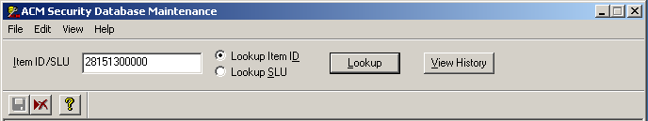
Figure 50. ACM Security Database maintenance Screen
View History Button
- The History Details screen appears.
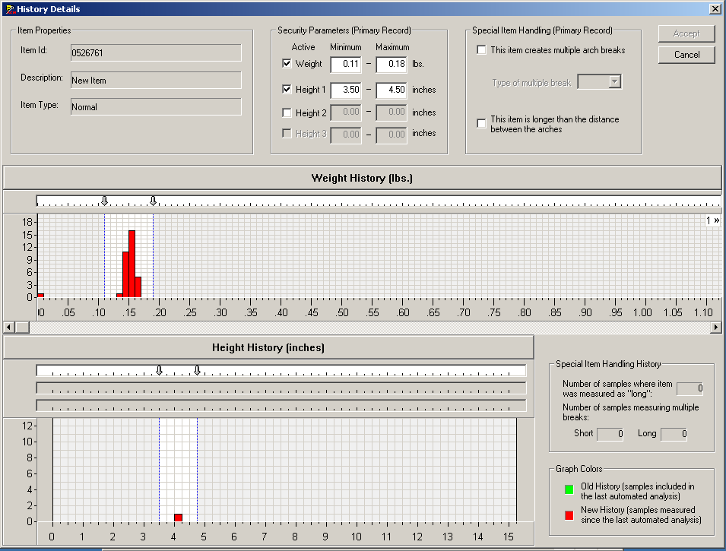 Figure 51. History Details Screen
- To Change item weight security parameters insert new item weight information into the “Weight” field, or move the slider arrows to the desired position.
- To Change item height security parameters insert new item height information into the appropriate “Height” fields (Heights 1,2, 3), or move the slider arrows to the desired positions.
- Click Accept to save new security information.

Exiting the Security Database Maintenance Program
From the menu bar, click File and Exit (or click the close box [x] in the upper right-hand corner of the screen).

How Learning at the Self Checkout Lane Affects Database Records
The Self Checkout Lane can learn security information of items either automatically or with minimal assistance from a store associate. Three lane functions accomplish these tasks:
- Security Override (Learning Mode) Process
- Learn Not on File Process
- Automatic Learn Process of New Items

Security Override (Learning Mode) Process
When an item returns, the shopper assistant scans a shopper assistant card, which places the lane in a security override or learn mode. When processing an item in the override mode, the lane sends the lane-measured information (weight and height) to the BOSS. The BOSS then sends the new information to all of the Self Checkout Lanes.

Override Process for Most Items (Except Random Weight)
Use this process to quickly adjust for package changes, or to adjust for incorrect or incomplete security records. When a shopper assistant scans an item in the override mode, the security database creates an alternate record with the new lane-measured information. Each item can have up to nine (9) alternate records (nine separate overrides) with differing lane-measured information. The lane-checks measurements against both the primary security database record and each alternate record. If any record matches, the item processes without returning.
The ACM also collects history information each time a shopper scans this item. When the lane collects enough data to provide a good sampling, an administrator modifies the record and deletes the alternate record(s).

Override Process for Random Weight Type 2 Barcoded) Items
This automatic process accounts for random weight items that required a store-initiated price markdown (such as a “quick sale” for items close to expiration). Use this feature to maintain system security for these items while not causing further inconvenience to shoppers. When a shopper assistant processes a random weight item in the override mode, the lane calculates an alternate price per pound record or unit price for this item.
- For scale-weighed random weight items, the lane calculates the price by taking the price from the barcode and dividing it by the lane-measured weight.
- For by-count random weight items, the lane calculates the price by taking the price from the barcode and dividing by a value of one (1).
The first time a shopper assistant scans an item with a marked-down barcode, the item returns to the shopper. The shopper assistant next processes the item in the override mode, which automatically creates an alternate security record for the item. Additional identical marked-down items process at the lane using the alternate record so these items do not continually return when scanned.

Learn Not on File Process
The Self Checkout Lanes can learn a temporary price and department record in the ACM security database for an item that does not yet have a record in the POS. When a shopper scans this type of item at the lane, the system immediately calls a shopper assistant by flashing the lane light. When the shopper assistant scans the item in the override mode, the system prompts the assistant through the “learn not on file” process (“enter price” and “enter department”). The manually entered information and lane-measured parameters are sent to the BOSS, where they are stored in the item’s security database record. The BOSS then sends this information to all of the Self Checkout Lanes.

Automatic Learn Process of New Items
When a new item (an item for which the security database has no record) is scanned WHO SCANS THIS? at the lane, the system goes into an automatic learn process. Each time shoppers scan this item, the lane-measures its characteristics and sends it to the item’s security database record in the BOSS. The BOSS immediately sends this information to all of the Self Checkout Lanes.

Practice Session

System Security
___________ | When a shopper processes an item at the Self Checkout Lane, the lane sends the UPC/PLU to the POS for a price and description. Next, the lane computer provides the security record for the item and compares this information to the lane-measured parameters for security verification.  - True  - False
___________ | In order to activate the security override (learning) mode at the lane, what must happen?  - You must shut down and then turn on the lane.  - You must scan a shopper assistant card.
___________ | A security database record can store up to ____________ alternate records.  - 9  - 14
___________ | When you learn a not-on-file item at the ACM Lanes, does it automatically update the POS?  - Yes  - No
___________ | When a shopper scans a new item at an ACM lane, the BOSS automatically builds a security database record for that item.  - True  - False

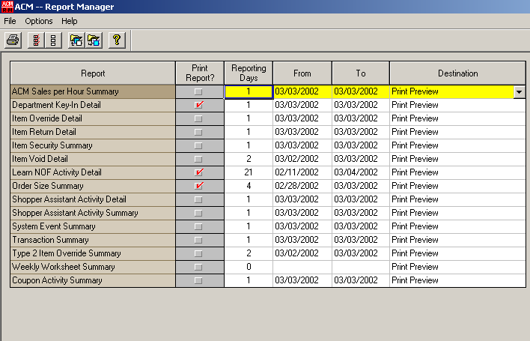
Section Four: Reporting Procedures
This section provides the procedures necessary to maintain the ACM Self Checkout System on a daily and weekly basis.

Daily Procedures
The following information in this section gives suggested guidelines to follow when using ACM Self Checkout reports to monitor and enhance system performance.

Manually Printing Daily Reports
- First run the recommended daily reports.
- From the BOSS desktop, click the Report Generator icon. The ACM – Report Manager window displays.
- Select the reports you wish to run.
- Verify that the dates in the “From” and “To” category are correct (usually the previous day’s date).
- Choose a destination for the report (typically the printer since you need to analyze the reports). Other options include Print Preview, which displays the report(s) on the monitor, or File, which saves the report or reports to a designated file.
- From the menu bar, click File and Print. (Or, click the Printer icon.)

Reviewing the Override Detail Report
Use this report to quickly verify that shopper assistants are using the shopper assistant cards to override item security after an item has first returned. A quick review reveals what item was overridden and at what price. When the shopper assistant overrides the item correctly, both weight and height display. If not, the item either processed incorrectly or is a large item that does not belong on the belt.
 |  |  |  |  |  | Item Override Detail Report  January 1, 2000 – January 6, 2000  PSI Test Store
Date | Time | Lane | Assistants Name | Assistants ID | Item Code |  | Description | Price | Weight | Height
8/21/2002 | 15:09:03 | 1 | John Smith | 081513000000 | 12345671234 |  | Dog Food | $7.00 | 3.32 | 15.12
8/21/2002 | 15:12:03 | 1 | John Smith | 081513000000 | 12345671234 |  | Cat Food | $3.00 | .32 | 1.19
8/21/2002 | 15:23:03 | 1 | John Smith | 081513000000 | 12344444560 |  | Fish Food | $27.00 | 4.32 | 10:18

How to use the Item Override Detail Report
STEPS | ACTIONS
1 | Review all fields by shopper assistant name to see if any one entry stands out as excessive.  Note: Keep in mind the hours in which associates work the Self Checkout lanes. Assistants that work the lanes longer hours consistently have higher volume than those associates working fewer hours.
2 | Review Item fields to see if any one entry stands out as excessive. This might mean the system has problems learning security on this item. Ensure the lane learns all items correctly with a weight and height to reduce further returns.
3 | If suspicious activity is present, run the Shopper Assistant Activity Detail Report for more information. Forward all problems to your store manager.

Reviewing the Item Return Detail Report
This report shows item rejects by type, item code, description and reason for rejection. Review the item descriptions to determine which items are not within the expected weight or height range according to the database.
Item Return Detail Report
January 1, 2000 – January 6, 2000
PSI Test Store
Date | Time | Lane | Item Type | Item Code | Description |  | Price | Weight | Height | Reject Reason
8/21/2002 | 15:09:03 | 1 | Coupon | 12345671234 | CPN Type 2 |  | $1.00 | 0.00 | 0.00 | Pos Coupon REJ
8/21/2002 | 15:12:03 | 1 | 07199070002 | 12345671234 | Cat Food |  | $3.00 | .32 | 1.19 | Not on Belt
8/21/2002 | 15:23:03 | 1 | 07199070002 | 12344444560 | Fish Food |  | $27.00 | 4.32 | 10:18 | Not on Belt

How to use the Item Return Detail Report
STEPS | ACTIONS
1 | Review all fields by item type to see if any one entry stands out as excessive. Type II returns that are excessive are more often problems with packaging or scale file downloads.
2 | Review all fields by item description to see if any one entry stands out as excessive. This might mean the system has problems learning security on this item.
3 | Compare to the Item Override Detail report to ensure the shopper assistants learn items correctly.

Reviewing the Shopper Assistant Activity Summary Report
This report provides a quick means to verify that shopper assistants are using the shopper assistant cards accurately. If the shopper assistant encounters problems, you may need to train the assistant on that function. You can deactivate the function from the person’s card until you train him or her. Shopper assistants who key in excessively need training. If every shopper assistant keys in excessively, the store may have a pricing problem. Use the Learn-Not-On-File feature to record the item’s UPC code for easier identification.

Field Descriptions of the Shopper Assistant Activity Summary Report
FIELD NAME | DESCRIPTION
Assistant’s Name | Name of the Shopper Assistant.
Card ID | Card number that has been assigned to the assistant.
# Security Overrides | Number of security overrides performed within a specific reporting period.
Avg. $ for Overrides | Average dollar amount for the overrides performed.
# Learn NOFs | Number of not-on-file items that were learned at the Self Checkout lanes within a specific reporting period.
Avg. $ for Learn NOFs | Average price of the items that were added.
# Dept. Key-Ins | Number of department key-ins performed within a specific reporting period.
Avg. $ for Dept. Key-Ins | Average price of the items that were added in this manner.
# Voids | Number of item voids performed within a specific reporting period.
Avg. $ for Voids | Average price of the items that were voided.

Example of the Shopper Assistant Activity Summary Report
Shopper Assistant Activity Summary
January 1, 2000 – January 6, 2000
PSI Test Store
Assistant’s Name | Card ID | # Security Avg. $ for  Overrides Overrides |  | # Learn Avg. $ for  NOFs Learn NOF |  |  | # Dept Avg. $ for  Key-Ins Key-Ins |  | # Item Avg. $ for  Voids Item Void |  | # Trans Trans  Voids Void $
John Smith | 08151300001 | 5 | $5.41 |  |  |  | 2 | $3.29 | 1 | -$2.18
Jane Jones | 08151300002 | 1 | $1.59 | 1 |  | $3.39
Samantha Richards | 08151300003 | 5 | $2.39 |  |  |  | 34 | $0.10 |  |  | 21 | $560.00
Dan Johnson | 08151300004 | 1 | $0.99 | 2 |  | $3.19
Dawn Williams | 08151300005 | 11 | $2.39 | 1 |  | $1.71
Christina Westin | 08151300006 | 4 | $2.51 | 3 |  | $2.98 | 1 | $2.10
Michael Daly | 08151300007 | 6 | $3.46 |  |  |  |  |  | 1 | -$6.99
Kevin Logan | 08151300008 | 1 | $0.79 | 2 |  | $1.79 | 1 | $0.99 | 1 | -$4.99
Larry Jackson | 08151300009 | 4 | $1.05 |  |  |  | 1 | $1.28
Rose Gibson | 08151300010 | 2 | $0.55

How to use the Shopper Assistant Activity Summary Report
STEPS | ACTIONS
1 | Review all fields by shopper assistant name to see if any one entry stands out as excessive.  Note: Keep in mind the hours in which associates work the Self Checkout lanes. Assistants that work the lanes longer hours consistently have higher volume than those associates working fewer hours.
2 | Review for excessive Department Key-ins and Learn-Not-On-Files because they can identify either training or pricing issues in the store.
3 | If suspicious activity is present, run the Shopper Assistant Activity Detail Report for more information. Forward all problems to your store manager.

Reviewing the Transaction Summary Report
The Transaction Summary displays the activity at the ACM Lanes. It lists information about security modes, number of orders, sales, voids, order size/price, orders requiring card assistance, orders with security returns, and orders with NOF returns. The time sequence for this and all Boss reports is 24:00:00 – 23:59:59; it does not follow your POS store close procedure times.

Field Descriptions of the Transaction Summary Report
FIELD NAME | DESCRIPTION
Main Section of the Report
Lane | Number of the Self Checkout lane.
# Orders | Number of orders that were processed at a particular Self Checkout lane.
Sales $ | Total dollar amount of sales that went through each Self Checkout lane.
Items Sold | Number of items sold through each Self Checkout lane.
$ Item Voids | Dollar amount of items that were voided at each lane.
$ Coupons Accepted | Dollar amount of coupons, including any applicable frequent shopper card incentives, accepted at each lane.
Avg. Order $ | Amount of the average order per lane.
Avg. Items Per Order | Average number of items sold per order.
Avg. Item Price | Average price of items purchased through each of the lanes.
Avg. Items Per Min. | Average number of items scanned per minute.
Orders Requiring Card Assistance | Number of orders that required a shopper assistant’s help.
Orders with Security Returns | Number of orders that contained items that returned due to security reasons.
Orders with NOF Returns | Number of orders that encountered items that were not-on-file in the POS system.
Tender Type Summary
Tender Type | Displays type of tender. For example, “Suspended Sale” represents all normal sales and “Voided Sale” represents voided sales that were not processed.
# Orders | Number of orders that pertain to each tender type listed.
% Orders | Percent of orders that went through as a particular tender type.
Sales $ | Amount of sales that were processed as a particular tender type.
% Sales | Percentage of sales that went through as particular tender types.
Security Mode Summary
Security Mode | Displays the security mode in which the lanes were operating. For example, lanes may operate in “Full Security” or “No Security.”
Orders | Number of orders that went through under each security mode type.
% Orders | For each security mode type, this number indicates the percentage of orders that were processed.

Example of the Transaction Summary Report
Transaction Summary
January 1, 2000 – January 6, 2000
PSI Test Store
Lane | # Orders | Sales $ | Items Sold | $ Item  Voids | $ Coupons Accepted | Avg. Order $ |  | Avg.  Items  per  Order | Avg.  Item Price | Avg. Items per Min. | Orders Requiring Card Assist. % |  | Orders with Security Returns  % |  | Orders with NOF Returns  %
1 | 183 | $2,706.11 | 1,379 | -$4.93 | $0.00 | $14.79 |  | 7.54 | $1.96 | 5.64 | 10 | 5.6 | 23 | 12.4 | 1 | .6
2 | 228 | $3,685.07 | 1,775 | -$11.86 | $0.00 | $16.16 |  | 7.79 | $2.08 | 6.66 | 15 | 6.5 | 42 | 18.5 | 2 | 1.0
3 | 230 | $4,146.62 | 2,066 | -$17.14 | $0.00 | $18.03 |  | 8.98 | $2.01 | 6.42 | 17 | 7.4 | 35 | 15.3 | 0 | .0
Tot | 641 | $10,537.80 | 5,220 | -$33.93 | $0.00 | $16.44 |  | 8.14 | $2.02 | 6.27 | 42 | 11.1 | 100 | 15.6 | 3 | .5

Tender Type Summary
Tender Type | # Orders | % Orders | Sales $ | % Sales
Cash | 67 | 10.18 | $776.87 | 7.4
Debit | 228 | 34.6 | $3,865.44 | 36.6
Credit | 305 | 46.3 | $5,123.07 | 48.36
Suspended Sale | 41 | 97.06 | $772.42 | 7.3
Voided Sale | 17 | 2.93 | $35.46 | .34

Security Mode Summary
Security Mode | Orders | % Orders
Full Security | 658 | 100.00

How to use the Transaction Summary Report
Steps | Actions
1 | Review the Security Mode Summary to ensure lanes were operating in Full Security Mode at all times. If lanes were operated outside of Full Security for any reason, question why (see store management).
2 | Review the Orders Requiring Card Assistance percentage. If this percentage is 13% or higher, make a copy for your store manager.  NOTE: If your system does not include credit, debit or cash payments at the lane, your goal should be 8% or lower. Keep in mind that alcohol and tobacco sales can increase this number to over 18%.
3 | Compare lane usage to ensure that all lanes are utilized equally. If not check lane area for obstructing items.

Reviewing the Type 2 Item Override Summary Report
The second procedure for the day is to review the Type 2 Item Override Summary report. Use this report to evaluate the random weight items that required a security override at the Self Checkout lanes.

Monitoring Problems
Because the security override process automatically accepts price changes, review this report daily to check for possible problems. Use this report to check for department scale problems, scale management system problems, and accidental (or deliberate) unauthorized price changes. Also use it to diagnose that the security database record for an item needs to change.

Field Descriptions of the Type 2 Item Override Summary Report
FIELD NAMES | FIELD DESCRIPTIONS
Item Code | Type 2 barcode number of the random weight item. Information was gathered when the item was scanned in the override mode at the Self Checkout lane.
Description | Description of the item as defined in the store’s POS system.
Calc’d Unit Price | Calculated price per pound or unit price of the item. This calculation generates as follows:  For scale-weighed random weight items (deli item for $7.29/lb.): When the item was scanned in the override mode, the price from the barcode was divided by the lane-measured weight. This gives a calculated price per pound for the item.  For items sold by-count (12 cookies for $1.99): When the item was scanned in the override mode, the price from the barcode was divided by a value of 1. This gives a calculated unit price for the item.
By-Count Quantity | ACM system-generated value based on whether the item is a scale-weighed random weight item (Deli item for $7.29/lb.) or sold by-count (12 cookies for $1.99).  0 = assigned value for scale-weighed items  1 = assigned value for by-count items
Processed | Number of times the random weight item was processed at the Self Checkout lanes using an override price for the item. In other words, using a price that deviates from what came down from the scale management system or from the price in the scale management system.

Example of the Type 2 Item Override Summary Report
Type 2 Override Summary
January 2, 2000
PSI Test Store
Item Code | Description |  | Calc’d Unit Price | By Count Quantity | Processed
20082900000 | BNLS/SKLS FRYR BRS |  | $2.86 | 0 | 6
20128400000 | WH/HLD TOP SIRLOIN |  | $1.95 | 0 | 1
20140400000 | B/L NY STRIP STEAK |  | $0.99 | 0 | 4
20152700000 | BUTT/PRT HAM |  | $0.86 | 0 | 2
20370400000 | SHANK HAM |  | $0.87 | 0 | 1
20373100000 | SNOW CRAB LEGS 4/U |  | $2.52 | 0 | 1
20373100000 | SNOW CRAB LEGS 4/U |  | $2.19 | 0 | 1
20373100000 | SNOW CRAB LEGS 4/U |  | $2.22 | 0 | 1
20572900000 | ITALIAN BREAD |  | $1.00 | 1 | 8
20715300000 | CUBAN BREAD |  | $1.48 | 1 | 1
20715600000 | DELI ROAST BEEF |  | $3.29 | 0 | 12

How to Use the Type Two Override Summary Report
POSSIBLE CAUSE OF ITEM RETURN | ACTION
For items with a value of two (2) or more in the “Processed” column:
Check for improper price changes.  How? Check the description of the item with the Calc’d Unit Price. (For an example, See “B/L NY Strip Steak.”) | If the calculated price looks invalid (mis-keyed information), consult with department manager. If mistake seems suspicious consult with store manager.
Check for Scale Management System problems (if applicable).  How? Check the price per pound information set in the Scale Management System to the price per pound set at the BOSS and at your scales. | If there is a consistent discrepancy at the BOSS or scale (or both), call the Help Desk.  Check the System Event View in the BOSS Manager application for processing errors.  Note: If your store does not have a Scale Management System, check for errors in your update file.
Check for department scale problems.  How? Retrieve an identical item from the department. Weigh the item on the Self Checkout Lane scanner/scale. (For an example, see “Deli Roast Beef.”) | If the weight differs from the weight on the label, follow store procedures in notifying scale vendor of the problem.  Note: An associate who places more of the product into the bag after it is weighed and labeled may also cause this discrepancy. Handle this according to store policy.
For all items:
Check for item security database issues.  How? Check the report for multiple entries of the same item description. Items that are usually processed (steamed, cooked, de-boned, packed in ice, etc.) after they were weighed and labeled displays multiple descriptions of the item with varying calculated unit price values. (For an example, see “Snow Crab Legs 4/U.”) | Assign a positive or negative tolerance to this item in the item’s security database record.  Modifying Positive and Negative Tolerance, page 53.
Check for items with miscellaneous codes.  How? Check the report for miscellaneous UPC codes that are used on random weight (type 2) items. | If an item with a miscellaneous code is on the report, check the Security Database Maintenance record and ensure that the price per pound field is inactive and that the record is locked. If not, click the price per pound field to deactivate and lock the record. Save the record.

Reviewing the Item Security Summary Report
This report shows item security return totals, types, time, number of attempts and other unique invalid height/weight rejected item properties. The field Time Outs refers to items not placed on the belt. Aborts occur when a shopper hits Cancel to back out of a process that has already received a price back from the POS. Other includes items that are considered Long, meaning they hit both the front and back arches at the same time, and items that are returned along with the actual rejected item in front on the belt.
Item Security Summary
January 1, 2000 – January 6, 2000
PSI Test Store
Lane | Item Type | # of Scan Attempts | Total # of Returns % |  | Unique items returned % |  | Items Returned 2+ Times % |  |  | # of  item Override % |  | Invalid Weight | Invalid height | Invalid Weight & Height | Weight Change
1 | All | 16 | 3 | 18.75 | 2 | 12.50 | 1 |  | 6.25 | 3 | 18.75 | 0 | 0 | 0 | 0
1 | Type II | 0 | 0 | 0.00 | 0 | 0.00 | 0 |  | 0.00 | 0 | 0.00 | 0 | 0 | 0 | 0
Total | All | 16 | 3 | 18.75 | 2 | 12.50 | 1 |  | 6.25 | 3 | 18.75 | 0 | 0 | 0 | 0
Total | Type II | 0 | 0 | 0.00 | 0 | 0.00 | 0 |  | 0.00 | 0 | 0.00 | 0 | 0 | 0 | 0

Extra Breaks | Time  outs | Aborts | Other
0 | 3 | 0 | 0
0 | 0 | 0 | 0
0 | 3 | 0 | 0
0 | 0 | 0 | 0

How to use the Security Summary Report
STEPS | ACTIONS
1 | Review all fields by item type and number of overrides to determine if any particular reject appears excessive. This might mean the system is having problems learning security or needs maintenance. Excessive height returns on one lane usually means that the lane needs maintenance. Usually, you should zero the scale if returns weighed items excessively. High Type II returns can identify scale management problems or a scanner scale that needs to be zeroed.
2 | If suspicious activity is present, run the Shopper Assistant Activity Detail Report for more information. Forward all problems to your store manager.

Reviewing the Shopper’s Assistant Activity Detail Report
The Shopper’s Assistant Activity Detail Report details every action taken that required a card scan at the lanes. Use this report to verify questions of excess identified on the Shopper’s Assistant Activity Summary Report.
Shopper Assistant Activity Detail
January 2, 2000
PSI Test Store
Assistant Name | Assistant ID | Date | Time | Lane | Transaction |  | Activity | Item Code | Price | Description | Wgt | Hgt
John Smith | 08151300004 | 1/02/2002 | 21:14:02 | 01 | 21395812 |  | Reg-Zs Printed | 213958121
John Doe | 08151300004 | 1/03/2002 | 21:10:59 | 02 | 21395813 |  | Security Override | 213958131 | $1.79 | Grocery | .56 | 1.34

How to use the Shopper Assistant Activity Report
STEPS | ACTIONS
1 | Review all fields by shopper assistant name to see if any one entry stands out as excessive.  Note: Keep in mind the hours in which associates work the Self Checkout lanes. Assistants that work the lanes longer hours consistently have higher volume than those associates working fewer hours.
2 | Review for excessive Department Key-ins and Learn-Not-On-Files because they can identify either training or pricing issues in the store.
3 | If suspicious activity is present, run the Shopper Assistant Activity Detail Report for more information. Forward all problems to your store manager.

Reviewing the Learn Not-on-File Activity Detail Report
The third procedure for the day is to review the Learn Not-on-File Activity Detail report. Use this report to track Not-On-File (NOF) items learned at the Self Checkout Lanes.

Field Descriptions of the Learn Not-on-File Activity Detail Report
FIELD NAME | DESCRIPTION
Item Code | Barcode number of the item. Information was gathered when the item was learned in the override mode at the Self Checkout lane.
Assistant | Name of the assistant who performed the learn NOF.
Assistant ID | Number that identifies the shopper assistant card assigned to the assistant who performed the learn NOF.
Date Learned | Date on which a particular item was first learned at a Self Checkout lane.
Learned Price | Price at which the item was learned.
Department | Department that was assigned to the item during the learn NOF process.
# of Times Processed | Number of times the item was processed at the lanes after it was learned.
Date Added to POS | Date on which the item was added to the store’s POS.
POS Price | Price associated with the item in the POS.
POS Description | Description associated with the item in the POS. Keep in mind that this item may have been in the POS at a previous time but was removed and we maintained a product description and UPC in our database.

Example of the Learn Not-on-File Activity Detail Report
Learn NOF Activity Detail
January 2, 2000
PSI Test Store
Item Code | Assistant | Assistant ID | Date Learned | Learned Price |  | Department | # of Times Processed | Date  Added to POS | POS Price | POS Description
00980012013 | John Smith | 08151300004 | 12/28/1999 | $7.00 |  | Bakery | 1
07154604460 | John Smith | 08151300004 | 12/28/1999 | $1.98 |  | General Mer | 2 | 12/29/1999 | $4.98 | Hot Shot
08142104460 | John Smith | 08151300004 | 12/30/1999 | $1.00 |  | Floral | 1 | 12/31/1999 | $15.95 | Stem Roses
07112101255 | John Smith | 08151300004 | 12/30/1999 | $3.98 |  | Produce | 2
20044200124 | Jane Jones | 08151300012 | 12/30/1999 | $6.05 |  | Grocery | 1 | 12/31/1999 | $6.05 | Mandarin Orng.
20044522200 | Jane Jones | 08151300012 | 12/30/1999 | $5.95 |  | General Mer | 3 | 12/31/1999 | $5.95 | Gouda Cheese

How to use the NOF Activity Detail Report
POSSIBLE PROBLEM WITH ITEM | ACTION
For items added to the POS:
Verify that the price added to the POS is the same as the learned price.  How? Compare the price in the “Learned Price” column to the price in the “POS Price” column. (See “Hot Shot” under the “POS Description” heading.) | If the item prices do not match, talk to the assistant who learned the item about mis-keyed information and the importance of entering correct information.  Note: Keep in mind that there may have been a price change for the item between the date learned at the lane and the date added to the POS.
Verify that the POS description corresponds to the learned department.  How? Compare the “POS Description” to the “Department” column. (See “Gouda Cheese” under the “POS Description” heading.) | If the department used in the learn process does not match the POS description, talk to the assistant who learned the item about mis-keyed information and the importance of using the appropriate department in the learn NOF process.
For items NOT added to the POS:
Add items, if appropriate, to the POS system.  How? Review the list of NOF items not in the POS. (See all items with no information under “POS Description.”)  If it is not appropriate to add an item to the POS, follow store policy. | Use the “Returned Item Forms” that were filled out by Shopper Assistants to identify items on the list and add items appropriately.  Note: You may need to make sure that assistants know how to use the “Returned Item Form.” Or, that they know to retrieve an identical item from the shelf to make the items easier to identify.

Distributing the Sales Per Hour Summary Report
The Sales per Hour Summary shows an hourly count of shoppers, hourly sales, time in use, items purchased, and average sales per hour. Key managers use this tool to determine staffing levels for the Self Checkout system. Simply put, shopper flow determines staffing. Distribute a copy of this report to the individual in charge of scheduling the frontend.

Example of the Sales Per Hour Summary Report
Sales Per Hour Summary
January 1, 2000 – January 6, 2000
PSI Test Store
Hour | Number of Customers | Hourly Sales |  | Items Purchased | Time ACM was in Use | Avg. $ per Item
8 | 25 | $ 1203.47 |  | 225 |  | $ 4.67
9 | 48 | $ 1897.24 |  | 480 |  | $ 3.95
10 | 65 | $ 2405.67 |  | 588 |  | $ 4.09
11 | 67 | $ 2495.45 |  | 643 |  | $ 3.88
12 | 78 | $ 2872.21 |  | 819 |  | $ 3.50
1 | 85 | $ 3201.99 |  | 935 |  | $ 3.42
2 | 93 | $ 3877.49 |  | 911 |  | $ 4.26

How to use the Sales Per Hour Summary Report
STEPS | ACTIONS
1 | Divide Number of Shoppers by lanes in use to determine need for baggers or additional cashiers.
2 | Divide Time ACM was in Use by Items Purchased to determine items per minute scanned and by Number of Shoppers to calculate shoppers per minute.
3 | Use these calculations with your labor scheduling program to determine need for additional assistance at the lanes.

Reviewing the Weekly Worksheet Summary
The Weekly Worksheet Summary shows a day-by-day comparison of the Conventional and ACM Lanes. The worksheet lists sales, shoppers, items sold, order size, and average item price. It’s recommended that the store manager receive a copy of this report. The store manager analyzes this report to ensure that the ACM lanes are performing optimally.

Example of the Weekly Worksheet Summary Report
Weekly Worksheet Summary
January 1, 2000 – January 6, 2000
PSI Test Store
 |  | Sales | Customer Count |  | Items Sold | Avg. Order Size | Avg. Item price
Thursday  July 18, 2002 | All Terminals  ACM Lanes | $3,864.42  $2,035.70 52.68% | 169  98 58.0% |  | 2,116  1,441 68.1% | $22.87  $15.36 | $1.83  $2.66
Friday  July 19, 2002 | All Terminals  ACM Lanes | $35,056.55  $9,025.67 25.75% | 1,000  541 54.10% |  | 14,677  3,267 22.26% | $16.68  $35.06 | $2.39  $2.76
Saturday  July 20, 2002 | All Terminals  ACM Lanes | $41,656.27  $12,795.95 30.72% | 1,083  769 71.01% |  | 18,563  4,468 24.07% | $38.46  $16.64 | $2.24  $2.86
Sunday  July 21, 2002 | All Terminals  ACM Lanes | $36,717.22  $11,010.09 29.99% | 968  626 64.67% |  | 18,650  4,256 22.82% | $37.93  $17.59 | $1.97  $2.59
Monday  July 22, 2002 | All Terminals  ACM Lanes | $34,012.42  $8,737.24 25.69% | 912  515 56.47% |  | 13,955  3,306 23.69% | $37.29  $16.97 | $2.44  $2.64
Tuesday  July 23, 2002 | All Terminals  ACM Lanes | $27,974.08  $8,991.41 32.14% | 921  538 58.41% |  | 11,013  3,529 32.04% | $30.37  $16.71 | $2.54  $2.55
Wednesday  July 24, 2002 | All Terminals  ACM Lanes | $30,508.27  $8,708.29 28.54% | 829  533 64.29% |  | 11,716  3,437 29.34% | $36.80  $16.34 | $2.60  $2.53
Total | All Terminals  ACM Lanes | $209,789.23  $66,304.35 31.61% | 5,882  3,980 67.66% |  | 90,690  24,904 27.48% | $34.11  $16.61 | $2.29  $2.66

How to use the Weekly Worksheet
STEPS | ACTIONS
1 | Quickly scan to ensure that a terminal productivity file was received daily to populate accurate daily sales totals.
2 | Review sales, shoppers and items percentages to identify trends in usage and apply hosting techniques on lower days.

Reviewing the Coupon Activity Report
The Coupon Activity Report shows day-by-day coupon activity at the ACM Lanes. This report only works correctly if Coupon Pickup runs at the lanes in the Shopper Assistant menu. The top section displays each pickup time, date, amount and shopper assistant responsible for pickup. The bottom section summarizes activity counts from all the lanes combined regardless of whether they were picked up or not.

Example of the Coupon Activity Report
Coupon Activity Report
January 1, 2000 – January 6, 2000
PSI Test Store
Date | Time | Lane | Assistant Name | Assistant ID |  | Coupon Pickup Information
1/02/2002 | 21:14:02 | 1 | John Smith | 08151300004 |  | 37 coupons for $ 27.40
1/03/2002 | 21:10:59 | 2 | John Smith | 08151300004 |  | 45 coupons for $ 32.55

Coupon Attempts 3
Manual Coupon Attempts 3
Total Coupons Inserted in Box 3
Manual Coupons Inserted in Box 3
Total Coupons Rejected by POS 1
Manual Coupons Rejected by POS 1
Coupons Canceled 0
Manual Coupons Canceled 0
Coupons Voided 0

How to use the Coupon Activity Report
STEPS | ACTIONS
1 | Review to ensure all coupon totals match with cashier balance reports for lane.  NOTE: Shoppers who scan orders at the lane and then choose to pay at the pay station leave coupons at the lane and tender at the pay station. Follow store procedures for managing overages &/or shortages.

Reviewing the Department Activity Detail Report
The Department Activity Detail Report identifies items that were entered via department key-in rather than scanned. To ensure accurate pricing in your store you should encourage shopper’s assistants to process every item as a Learn-Not-On-File rather than as a department key-in. This report reveals improperly priced items and/or the need to train shopper assistants.

Example of the Department Activity Detail Report
Department Activity Detail Report
January 2, 2000
PSI Test Store
Date | Time | Assistant Name | Assistant ID |  | Lane | Department | Price | Wgt | Hgt
1/02/2002 | 21:14:02 | John Smith | 08151300004 |  | 01 | 1 - Grocery | $2.57 | 2.99 | 3.90
1/03/2002 | 21:10:59 | John Doe | 08151300002 |  | 02 | 5 - Meat | $1.79 | .56 | 1.34

How to Use the Department Activity Detail Report
STEPS | ACTIONS
1 | Review all fields by shopper assistant name to see if any one entry stands out as excessive.  Note: Keep in mind the hours in which associates work the Self Checkout lanes. Assistants that work the lanes longer hours consistently have higher volume than those associates working fewer hours.
2 | If suspicious activity is present, run the Shopper Assistant Activity Detail Report for more information. Forward all problems to your store manager.

Reviewing the Item Void Detail Report
The Item Void Detail Report identifies every item that voided at the lane individually, not within a transaction void.

Example of the Item Void Detail Report
Void Item Detail Report
January 2, 2000
PSI Test Store
Date | Time | Lane | Assistant Name | Assistant ID |  | Item Code | Description | Price
1/02/2002 | 21:14:02 | 01 | John Smith | 08151300004 |  | 00000004911 | Bulk Candy (RED) | -$2.99
1/03/2002 | 21:10:59 | 02 | John Doe | 08151300002 |  | 00000004912 | RYE BREAD | -$3.56

How to Use the Item Void Detail Report
STEPS | ACTIONS
1 | Review all fields by shopper assistant name to see if any one entry stands out as excessive.  Note: Keep in mind the hours in which associates work the Self Checkout lanes. Assistants that work the lanes longer hours consistently have higher volume than those associates working fewer hours.
2 | If suspicious activity is present, run the Shopper Assistant Activity Detail Report for more information. Forward all problems to your store manager.

Reviewing the Order Size Summary Report
The Order Size Summary Report summarizes orders by item count. Use this report as a scheduling tool in conjunction with the Sales Per Hour Summary Report to break out the orders into a little different detail. Larger orders need more baggers then a series of smaller orders, but larger orders need more labor at the conventional lanes as well.

Example of the Order Size Summary Report
Order Size Summary
January 2, 2000
PSI Test Store
Items | # Orders | % for Order Size | Order Size Cumulative % | Avg. $ per Item |  | Dollars $ | % of Sales | Cumulative $ | Cumulative % of sales
0 | 0 | 0.00 | 0.00 | $0.00 |  | $0.00 | 0.00 | $0.00 | 0.00
1 | 16 | 5.80 | 5.80 | $4.99 |  | $5.00 | 3.00 | $56.99 | 0.44
2 | 0 | 0.00 | 0.00 | $0.00 |  | $0.00 | 0.00 | $0.00 | 0.00
3 | 0 | 0.00 | 0.00 | $0.00 |  | $0.00 | 0.00 | $0.00 | 0.00
4 | 0 | 0.00 | 0.00 | $0.00 |  | $0.00 | 0.00 | $0.00 | 0.00
5 | 0 | 0.00 | 0.00 | $0.00 |  | $0.00 | 0.00 | $0.00 | 0.00
6 | 0 | 0.00 | 0.00 | $0.00 |  | $0.00 | 0.00 | $0.00 | 0.00
7 | 0 | 0.00 | 0.00 | $0.00 |  | $0.00 | 0.00 | $0.00 | 0.00
8 | 0 | 0.00 | 0.00 | $0.00 |  | $0.00 | 0.00 | $0.00 | 0.00
9 | 0 | 0.00 | 0.00 | $0.00 |  | $0.00 | 0.00 | $0.00 | 0.00
10 | 0 | 0.00 | 0.00 | $0.00 |  | $0.00 | 0.00 | $0.00 | 0.00
12 | 0 | 0.00 | 0.00 | $0.00 |  | $0.00 | 0.00 | $0.00 | 0.00
13 | 0 | 0.00 | 0.00 | $0.00 |  | $0.00 | 0.00 | $0.00 | 0.00
14 | 0 | 0.00 | 0.00 | $0.00 |  | $0.00 | 0.00 | $0.00 | 0.00
15 | 0 | 0.00 | 0.00 | $0.00 |  | $0.00 | 0.00 | $0.00 | 0.00
16 | 0 | 0.00 | 0.00 | $0.00 |  | $0.00 | 0.00 | $0.00 | 0.00
17 | 0 | 0.00 | 0.00 | $0.00 |  | $0.00 | 0.00 | $0.00 | 0.00
18 | 0 | 0.00 | 0.00 | $0.00 |  | $0.00 | 0.00 | $0.00 | 0.00
19 | 0 | 0.00 | 0.00 | $0.00 |  | $0.00 | 0.00 | $0.00 | 0.00
20-29 | 35 | 12.82 | 76.19 | $2.52 |  | $2,180.41 | 16.93 | $5,527.99 | 42.93
30-39 | 0 | 0.00 | 0.00 | $0.00 |  | $0.00 | 0.00 | $0.00 | 0.00
40-49 | 0 | 0.00 | 0.00 | $0.00 |  | $0.00 | 0.00 | $0.00 | 0.00
50-59 | 0 | 0.00 | 0.00 | $0.00 |  | $0.00 | 0.00 | $0.00 | 0.00
60-69 | 0 | 0.00 | 0.00 | $0.00 |  | $0.00 | 0.00 | $0.00 | 0.00
70-79 | 0 | 0.00 | 0.00 | $0.00 |  | $0.00 | 0.00 | $0.00 | 0.00
80-89 | 0 | 0.00 | 0.00 | $0.00 |  | $0.00 | 0.00 | $0.00 | 0.00
90-99 | 0 | 0.00 | 0.00 | $0.00 |  | $0.00 | 0.00 | $0.00 | 0.00
100-999 | 0 | 0.00 | 0.00 | $0.00 |  | $0.00 | 0.00 | $0.00 | 0.00

How to Use the Order Size Summary Report
STEPS | ACTIONS
1 | Review fields to identify your largest percentage by sales dollars and item count to identify what type of shoppers you have using the lanes. Order size should resemble the breakdown of your store’s order size unless you have decided to utilize the lanes in a particular fashion such as Express Only.
2 | Hand this report to the person in charge of front-end scheduling.

Reviewing the System Event Summary
The System Event Summary shows the health of your ACM lanes. It shows whether procedures were followed in zeroing the scales everyday and proper shutdown of the ACM lanes. It also displays system failures such as power interruptions, network and printer problems, how frequently the system called a shopper assistant to a lane and how often the shopper pressed the Need Assistance button.

Example of the System Event Summary Report
Order Size Summary
January 2, 2000
PSI Test Store
Lane | Orders | Cold Starts | Warm Starts | Close Lane | Extracts | Zero Scale | Power Failure |  | Config. Changed | How to Use | Need Assistant | Automatic Help Req. | Lan Failure | Printer Failure
1 | 123 | 0 | 0 | 1 | 1 | 4 | 0 |  | 0 | 3 | 5 | 3 | 0 | 1
2 | 128 | 1 | 4 | 3 | 0 | 4 | 1 |  | 0 | 4 | 6 | 1 | 0 | 0
4 | 453 | 2 | 5 | 1 | 0 | 1 | 0 |  | 0 | 0 | 1 | 1 | 0 | 0
Total | 704 | 3 | 9 | 5 | 1 | 9 | 1 |  | 0 | 7 | 12 | 5 | 0 | 1
ACM BOSS
Power Failure | ISP Connect Failure | File Update Failure | BOSS Mgr. Restarts
1 | 0 | 0 | 0

How to Use the System Event Summary Report
STEPS | ACTIONS
1 | Review fields to ensure that daily procedures were followed and that there are no excessive system failures. Heavy use of the Need Assistance button indicates a need for shopper training.
2 | If frequent system failures are identified call the Help Desk.

Practice Session

Daily and Weekly Procedures
___________ | When preparing to print your daily reports, you may need to change the destination. Which of the following destination options produces a paper copy?  - File  - Print Preview  - Printer
___________ | You may generate reports using either the ACM Scheduler or the ACM Reports Manager.  - True  - False
 | When evaluating the Type 2 Override Summary Report you are to look for the following exceptions: improper price changes, possible Scale File Management communication problems (if applicable), department scale problems, and item security database issues.

Example of a Type 2 Override Summary Report
Item Code | Description | Calc’d Unit Price | By Count Quantity | Processed
20082900000 | BNLS/SKLS FRYR BRS | $2.86 | 0 | 6
20128400000 | WH/HLD TOP SIRLOIN | $1.95 | 0 | 1
20140400000 | B/L NY STRIP STEAK | $0.99 | 0 | 4
20152700000 | BUTT/PRT HAM | $0.86 | 0 | 2
20370400000 | SHANK HAM | $0.87 | 0 | 1
20373100000 | SNOW CRAB LEGS 4/U | $2.52 | 0 | 1
20373100000 | SNOW CRAB LEGS 4/U | $2.19 | 0 | 1
20373100000 | SNOW CRAB LEGS 4/U | $2.22 | 0 | 1
20572900000 | ITALIAN BREAD | $1.00 | 1 | 8
20715300000 | CUBAN BREAD | $1.48 | 1 | 1
20715600000 | DELI ROAST BEEF | $3.29 | 0 | 12

___________ | In the Type 2 Override Summary Report example, which item may be a possible improper price change?  a. 20082900000 BNLS/SKLS FRYR BRS $2.86  b. 20715600000 DELI ROAST BEEF $3.29  c. 20140400000 B/L NY STRIP STEAK $0.99
___________ | What action should you take if the above scenario occurs?  - Consult with the appropriate department manager. If the activity seems suspicious, consult with the store manager.  - Do nothing and maybe it will go away.
___________ | In the Type 2 Override Summary Report example, there are multiple entries for Snow Crab Legs. This usually happens when an item is processed (probably steamed) after it is weighed and labeled. How would you correct this problem at the BOSS?  - Delete the item’s security record and let the system create a new one.  - Assign a positive or negative tolerance to this item’s security record.
 | When reviewing the Learn Not-On-File Report, you should compare the learned price column to the POS price column

Example of a Learn Not-on-File Report
Item Code | Assistant | Assistant ID | Date Learned | Learned Price | Department | # of Times Processed | Date  Added to POS | POS Price | POS Description
00980012013 | John Smith | 08151300004 | 8/7/1998 | $7.00 | Bakery | 1
07154604460 | John Smith | 08151300004 | 7/22/1998 | $1.98 | General Merc | 2 | 7/24/1998 | $4.98 | Hot Shot
08142104460 | John Smith | 08151300004 | 7/21/1998 | $1.00 | Floral | 1 | 4/20/1997 | $15.95 | Stem Roses
07112101255 | John Smith | 08151300004 | 7/14/1998 | 3.98 | Produce | 2
20044200124 | Jane Jones | 08151300012 | 7/3/1998 | $6.05 | Grocery | 1 | 7/31/1998 | $6.05 | Mandarin Orange
20044522200 | Jane Jones | 08151300012 | 7/3/1998 | $5.95 | General Merc | 3 | 7/14/1998 | $5.95 | Gouda Cheese

___________ | Using the Learn Not-on-File Report above, which of the above two item codes appear to have an incorrect learned not-on-file price?  a. 00980012013 $7.00 Bakery  07112101255 $3.98 Produce  b. 07154604460 $1.98 General Merc.  08142104460 $1.00 Floral
 | The Security Database Maintenance program allows you to select specific transport methods for items in your store. The transport method selected affects the item’s process at the lane. Match the following transport methods to the proper lane action.
___________ | - Must pass through the arches | - Voice prompt informs shopper that he or she does not need to place the item on the belt. The belt does not move.
___________ | - Optional pass through arches | - System voices price and belt moves. Item credits off the receipt if the shopper does not place it on the belt.
___________ | - Must not pass through arches | - System voices price and belt moves. Item remains on the electronic receipt whether the shopper places it on the belt or not.
___________ | Which of the following groups is the recommended set of reports to print on a weekly basis.  - Item Security Summary, Item Void Detail, New Item Detail, Order Size Summary.  - Sales per Hour Summary, Transaction Summary, Shopper Assistant Activity Detail, Weekly Worksheet Summary.
___________ | The Weekly Worksheet shows the differences between usage on the conventional and ACM lanes.  - True  - False
___________ | Use the Sales Per Hour Summary to determine staffing needs at the Self Checkout lanes.  - True  - False
___________ | The Transaction Summary Report informs management if lanes were operated with or without full __________________.  - staffing  - security  - power
___________ | The Shopper Assistant Activity Summary Report notifies management of potential improper usage of _______________________.  - break times  - shopper assistant cards

Hands on Section
While seated at the BOSS, perform the following installation procedures:
☑ Check off procedures, once performed, on the line provided.

_______ 1. Open the ACM Report Manager and load your default settings.
_______ 2. For each of these reports select PRINTER for the report destination print and review each report.
_______ 3. Exit the Report Manager

Appendix A – Using the BOSS mouse
Hold the mouse and ensure that your wrist contacts the mouse pad. Move your hand to move the mouse. The cursor moves on the screen as you move the mouse.
The BOSS displays three different cursor shapes:
Arrow. Allows you to point and click (or select) items.
Hourglass. Indicates that the system is processing a command.
Flashing bar. Usually visible when you activate a field. Indicates that the system is expecting you to type information with the keyboard.
Clicking the Buttons
When clicking the buttons, note that mouse clicking takes practice. Clicking with a light, fast touch. In addition, stabilize your hand by applying a little downward pressure on the heel of your hand when preparing to click. This prevents the mouse from moving as you click the buttons. Throughout the workbook, we instruct you to single click, double click, select, or highlight to indicate selection of an item on the screen.
Tips
- The system uses the standard two-button mouse (left and right buttons).
- Clicks are always on the left button, unless told otherwise.
- Lay open palm on mouse, grasping the mouse between the thumb and ring finger.
- Move the mouse by moving your hand in a circular motion, keeping your wrist stationary on the mouse pad.
- Click with a light, fast touch. Hold the mouse stationary when clicking or the mouse commands do not respond properly.
- Practice makes perfect.

Appendix B – Shopper Assistant Card Assignment Suggestions
Only assign shopper assistant cards to associates who have successfully completed Self Checkout training.
Assign cards by name to all associates that work on the Self Checkout lanes. If an employee is scheduled to work on the Self Checkout lanes he or she must pick up the card at the beginning and turn it in at the end of the shift. Immediately delete or deactivate lost cards.
Shopper Assistant Card
Each store receives 50 shopper assistant cards. Order Additional cards by contacting your Help Desk. Most successful stores assign their cards as follows:
Note: If appropriate, consider charging associates a fee for lost cards. This helps maintain card accountability. We recommend keeping maximum control of the remaining cards. Keep at least one in the safe to ensure 24-hour availability.

Position | # of Cards | Access Level
Location Director | 1 | Full Access
Co-Manager | 1 | Full Access
Assistant Manager(s) | 1 each | Full Access
Customer Service Manager | 1 each | Full Access
Head Cashier | 1 | Full Access
Assistant Head Cashier | 1 | Full Access
Scanning and Pricing Associate | 1 | Full Access
Office Safe | 1 | PSI Access
Paystation Cashier(s) | 1 each | Limited Access*
Shopper Assistants | 1 each | Limited Access*
*Activated Fields: Open/Close Lane, Reprint Receipt, Zero Security
Scale, Void Item, Price Department Entry, Learn NOF.

Appendix C – Weights and Measures Information
Q How does the ACM deduct a tare weight from items weighed at the lane?
A For PLU items sold by weight, a “Tare Key” value is assigned to the item within the ACM security database. When the lane processes and weighs the item, the ACM retrieves the tare value from the security database and sends the gross weight and tare value to the point-of-sale (POS). The POS subtracts the tare value from the gross weight and calculates the price. Items sold in different sized containers may have different PLU codes and different tare weights (for example, small, medium, and large salad bar containers).
Note: Random weight (Type 2) items use a tare value (PACKAGE FACTOR tolerance) that the Scale Management System can automatically download. Use this value only for security checking and not for pricing.
Q What kind of manual input ensures that tare weights are deducted automatically for the shopper?
A Tare key values are automatically added to the security database in order for the ACM to properly deduct tare weights from PLU items sold by weight. Initially, the tare key values are input by the PSI project team. Store-level personnel routinely maintain the information.
Q How can shoppers verify that the tare weight has been removed from their order?
A Shoppers can compare the weight displayed on the scale’s on-screen digital display to the weight listed on the electronic receipt. The weight on the receipt is the difference of the scale-measured weight and the tare key value.
Example: If the tare weight of an item sold by weight is set at 1 (which is .01 lb.) and then purchased at an ACM lane, the display would show the actual weight from the scanner/scale. Then, the electronic receipt would display the weight amount minus the tare weight. For example, if you have 1.23 lbs. of bananas, the scale-measured weight would display 1.23 lbs. and the printed receipt would show 1.22 lbs.
Q Is the security scale used in any way to price items?
A No. The security scale only verifies security at the lane. It does not determine prices.
Q Who certifies the scanner/scales at the lanes to ensure accuracy?
A It is the store’s responsibility to make sure that the scanner/scales have been properly certified. The procedures vary from state to state.

Glossary of Self Checkout Terms
age restricted items — Items, such as alcohol and tobacco, requiring the shopper to meet a minimum age.
check cart item — Large item, such as a 50 pound bag of dog food, typically placed under the shopping cart. Once entered into the system, an item of this type generates a “Check Cart” message on the lane receipt.
extract — File containing diagnostic information gathered while processing each item in an order. The BOSS stores the extract file until an ACM engineer retrieves it for analysis and resolution.
long items — ACM terms that describe items longer than the distance between the front and rear arches. Examples are brooms, mops and wrapping paper.
multi-break items — ACM term used to identify an item in which the shape decreases then increases again (i.e., a loaf of bread with a twist-tie tail) causing the ACM to “see” two items instead of one. Examples are vacuum-packed toys, some clear liquids, and some cooking utensils.
not-for-sale items — Grocery items, such as seasonal items or federally recalled items, that have been pulled from the shelves and are not for sale at the current time.
not-on-file (NOF) items — Grocery items that have not been added to the store’s point-of-sale (POS) system.
plu (price lookup) code — Code used for items that do not have barcodes.
quantity required items — Grocery items that are sold by the number of items purchased (i.e., cucumbers, peaches, etc.).
random weight (type 2) items — Prepackaged items which are sold by price per kilogram or pound. These items are marked by a type 2 barcode and include most meat products.
retrieving orders — Process of bringing up suspended ACM orders. Orders are suspended so that shoppers can pay at the centrally located paystation. Retrieving orders allows you to process the shopper’s order as you would an order at a regular lane.
shopper assistant — Person designated to assist shoppers on the lanes whenever a difficulty is encountered. This assistance may require the use of the shopper assistant card.
shopper assistant card — Programmable scan card that allows the card holder a range of functions in assisting the shopper and/or troubleshooting the lane.
time restricted items — Grocery items that are not sold during certain times, or on certain days (for example, alcohol on Sunday).
transport methods — Method for transporting items from the ACM lanes to the bagging areas. Some items must pass through the security arches, some items may optionally pass through the security arches, and other items must not pass through the security arches.
upc (universal product code) — Barcode printed on grocery items.
value or bonus packaged items — Grocery items that are specially packaged to promote a particular item or to serve as an enticement to shoppers (i.e., 10% more free, buy two for the price of one, etc.).
weight required items — Grocery items that are sold by weight, such as produce (i.e., bananas, beans, etc.) and bulk foods (i.e., trail mix).

Index

BOSS
Bar, 9
Item Processing, 46
Quick Lookup, 8

