ACM 700 Self-Checkout Lane
Training Workbook
Version 1.0

ACM® 700 Self Checkout Lane Training Workbook
© 1996-2003 Productivity Solutions Incorporated. All Rights Reserved.
Trademarks
ACM® is a registered trademark of Productivity Solutions Incorporated.
MS Word and Windows NT are registered trademarks of Microsoft.
All other trademarks or registered trademarks are the property of their respective owners.
PRODUCTIVITY SOLUTIONS INCORPORATED (PSI) has made every effort to ensure that the information in this guide is complete, precise, and current. PSI assumes no liability to any person or entity with respect to alleged loss or damage caused by this workbook. The examples, sample screens, and reports used throughout this guide are intended for illustrative purposes only and may not conform to your system requirements. Implied warrantees are hereby specifically disclaimed. PSI may make improvements and/or changes in the product(s) and/or program(s) described in this publication at any time.
Warning
All computers supplied with the ACM® 700 are fully assembled in manufacturing. Additional cards or modifications are not to be inserted by the user.
Composed in AvantGarde and Garamond using Microsoft Word.
Written and designed at Productivity Solutions Incorporated, Suite 509, 10550 Deerwood Park Blvd., Jacksonville, FL 32256.
Printed in the USA.

Contents
ACM 700 Self-Checkout Lane Training Workbook ii
Contents 4
Preface 5
How This Workbook Is Organized 5
Conventions Used In This Workbook 5
Standard Lane Components 6
Section One – Processing Orders at the ACM 700 Series Self Checkout Lane 10
Transport Methods and Item Security 11
Transport Methods 11
Price Verification 12
Double Scan Prevention 12
Tips for Shoppers 13
Section Three – ACM® 700 Self-Checkout Shopper Assistant Roles 16
Items Sometimes Return 17
Handling False Item Returns 18
False Item Return Procedure: 18
To Process and Learn a Returned Item: 19
Practice Session 20
Hands-On Section 21
Glossary of Self Checkout Terms 22
Index 23

Preface
This workbook is intended for store front-end personnel assigned to the positions that operate the ACM® Self Checkout Lanes and Paystations. Others within the store are encouraged to use this product as a tool to learn more information on the system’s operations.

How This Workbook Is Organized
Section 1: The ACM® 700 Self Checkout System Components
Section 2: Processing Orders on the ACM® 700 Self-Checkout Lane
Section 3: Role of the Self-Checkout Shopper Assistant

Conventions Used In This Workbook

NOTE | Notes – important information concerning the subject being discussed.
 | Buttons – pictures representing the buttons that appear on the Self Checkout monitor’s touch-sensitive screen. The screen’s buttons, when pressed, activate a system function.
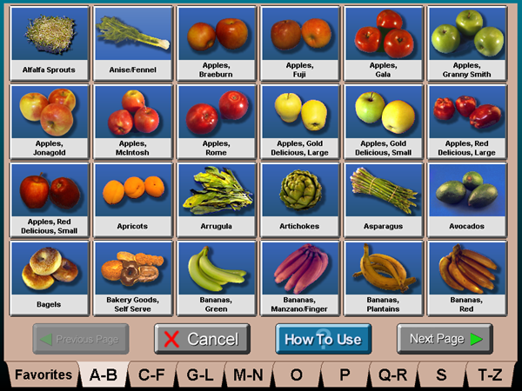 | Screen Captures – pictures representing the screens that appear on the Self Checkout monitor’s touch-sensitive screen as seen by the user.
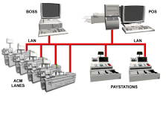 | Figures – graphics or diagrams used to illustrate components of the Self Checkout System.
Captions are located next to or under graphics | Captions – details or explanations about screen captures or figures.

Standard Lane Components
The diagram below shows the name and location of each part of the standard Self Checkout lane. The following table describes each component’s functions. Knowing component names and functions will enable you to better understand the system’s operations discussed later.
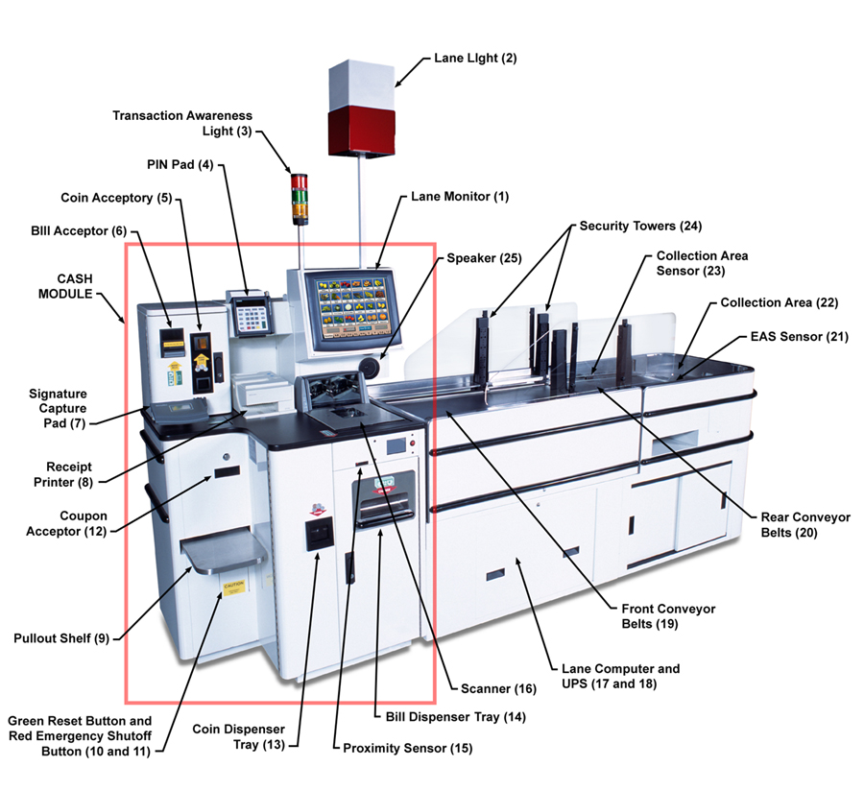
Component | Function
1. Lane Monitor | Displays user-friendly graphics and on-screen instructions for Shoppers. Touching the touch screen monitor activates functions.
2. Lane Light | Indicates the status of the lane. When on, the lane is ready for use. When off, the lane is closed. If flashing, the Shopper Assistant is required at the lane.
- Transaction Awareness Light | Alerts the Shopper Assistant on the status of the transaction: Order has been suspended at the Paystation (yellow), order has been successfully tendered at the lane (green); pass around items contained in the order (green and yellow); hard tags or active soft EAS tags present in bagging area (red).
- PIN Pad | Used by Shoppers for credit and debit card tendering.
- Coin Acceptor | Accepts coins including pennies, nickels, dimes, quarters and $1 coins. The coin acceptor provides all the functionality of standard coin acceptors. This component accepts, counts and deposits coins to a coin collection can inside the cash module.
- Bill Acceptor | Accepts bill denominations of $1, $2, $5, $10, $20, $50 and $100. The bill acceptor cassette holds 600 bills. It detects and rejects counterfeit bills.
- Signature Capture Device | Shoppers whose payment requires a signature sign this device.
- Receipt Printer | Prints an itemized receipt of purchased merchandise.
- Pull-out Basket Shelf | Holds hand-held items and express order baskets for the Shopper.
- Green Reset Button | Forces the ACM lane to recover from a problem during a transaction.
- Red Emergency Shutoff Button | Used to power off the lane in the event of an EMERGENCY.
- Coupon Acceptor | Accepts coupons after the coupons are scanned. This device senses that a coupon is fully inserted and released before the system accepts and credits the shopper. The coupon collection box stores coupons under the coupon acceptor (not shown in diagram) and is locked.
- Coin Dispenser Cup | Dispenses coins as change during a cash tendered transaction at the lane.
- Bill Dispenser Tray | Dispenses bills as change during cash tendered transactions at the lane.
- Proximity Sensor | Detects a Shopper within approximately 18” of the lane. It activates the lane to greet the Shopper and display the Processing Screen.
- Scanner | Scans merchandise by reading barcodes in front of either window.
- Lane Computer | Runs the software and interfaces with the POS system. It is located inside the lane.
- Uninterrupted Power Supply (UPS) Box | During a power surge or failure, this box provides enough power to allow the system to shut down properly and protect ACM® Components.
- Front Conveyor Belt | Transports merchandise through the security area to the rear conveyer belt. This belt reverses if an item fails security. A scale beneath the front belt verifies the item’s weight.
- Rear Conveyer Belt | Transports merchandise to the collection area. This belt reverses if an item fails security. A Sensormatic Pad beneath the rear belt deactivates EAS Soft Tags in stores that use Sensormatic for theft protection.
- EAS Sensor (Optional) | Detects EAS soft tags and hard tags. The red transaction awareness light illuminates when a soft tag item hasn’t deactivated or a hard tag item passes the EAS Sensor.
- Collection Area | Holds items until they are placed in the cart.
- Collection Area Sensor | Detects items in the collection area. When the collection area is full, the lane light flashes and a message calls the Shopper Assistant to remove items from the collection area.
- Security Towers | Works with the front conveyor belt to verify an item and its location on the belt.
- Speaker | Voices a scanned item’s price and instructions to Shoppers.
- Base Unit | Synchronizes the remote scanner with the lane. Used to process large and heavy items and to charge remote scanners. (Not shown in diagram)
- Soft Goods Shelf | Holds fragile items that pass security until someone places them in the carriage. Soft goods include eggs, breads, flowers, potato chips, etc. (Not shown in diagram)
- Coin Dispenser | Holds and dispenses approximately 363 pennies, 282 dimes, 312 quarters and 94 nickels; $115 in coins.
- Bill Dispenser | Dispenses up to 2,500 bills from each cassette tray. The system dispenses $1, $5, and $20 bills.

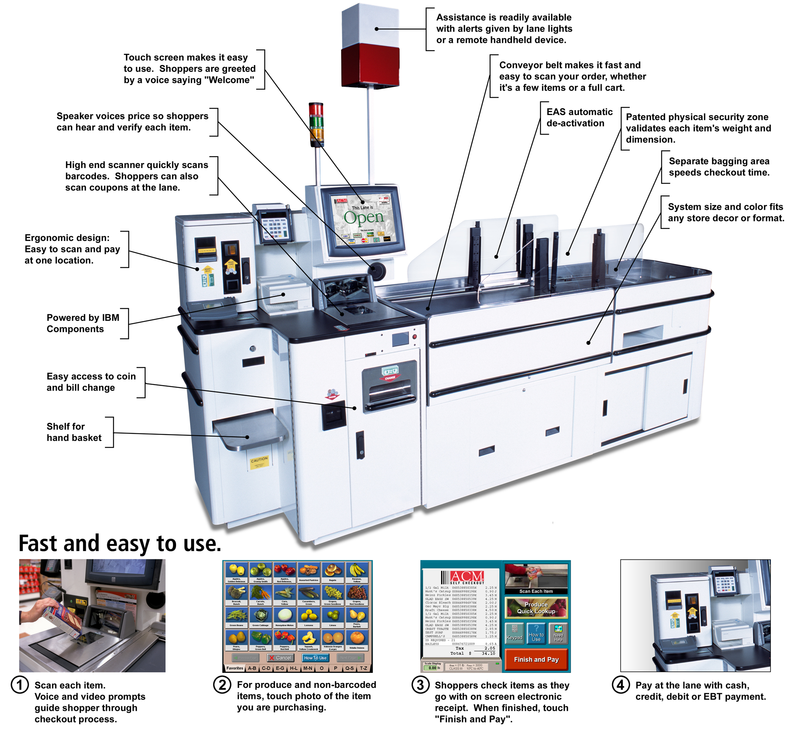

Section One – Processing Orders at the ACM 700 Series Self Checkout Lane
This section discusses how items are processed using the 700 Series Self Checkout lane. Also included are topics on common item handling issues and tips for easier processing.

Transport Methods and Item Security
The ACM® 700 lane enables Shopper Assistants to quickly recognize shoppers who are scanning and paying for items or bagging and leaving the self checkout area. As a Shopper Assistant, take note of shoppers who move back and forth between the ACM Universal Scanning and Payment Module and the bagging area. Shoppers should only move between the ACM Universal Scanning and Payment Module and the bagging area to clear the bagging area sensors and to manually transport pass-around items. Excessive movement between the ACM® Universal Scanning and Payment Module and the bagging area may be an attempt to circumvent the built-in security.

Transport Methods
Shoppers are required to place most items on the belt. Some items are too large or heavy to fit on the bagging area. The ACM® 700 Self Checkout system remembers each item’s transport method in the security database as follows:
Must pass through arches:  - The system voices the price and the belt moves to signal the customer to place the item on the belt. | 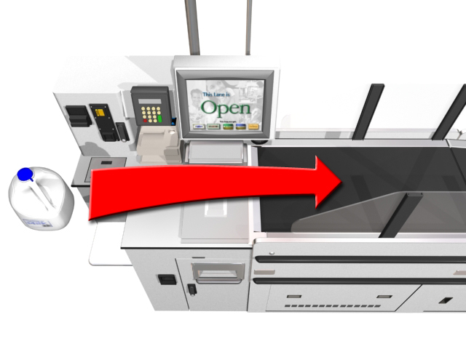  Must Pass Through Items  (Picture)
Optionally pass around:  - These items may be placed on the belt. The belts begin to run and do so for a predetermined amount of time. If the item is placed on the belt, the lane will verify any security information stored on that barcode. If the item is not placed on the belt the lane will not credit back the price of the item nor attempt to return the item. The lane’s transaction awareness light cycles yellow and green to signal the Shopper Assistant that a shopper has processed an optionally pass around item. | 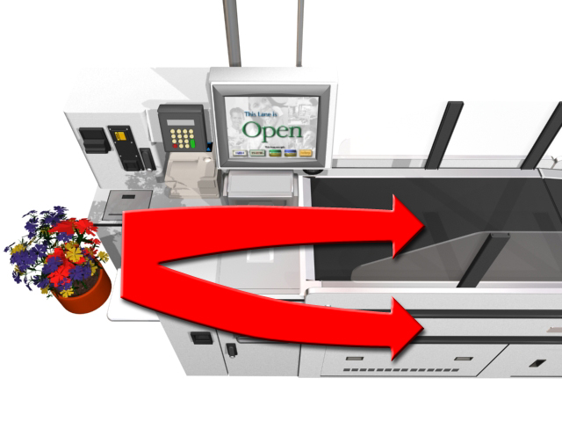  Optionally Pass Through Items  (Picture)
Pass around:  - A voice informs customers that they need not place the item on the belt and should carry it to the bagging area. The belt does not move. The lane’s transaction awareness light cycles yellow and green to signal the cashier that a shopper has processed a pass around item. | 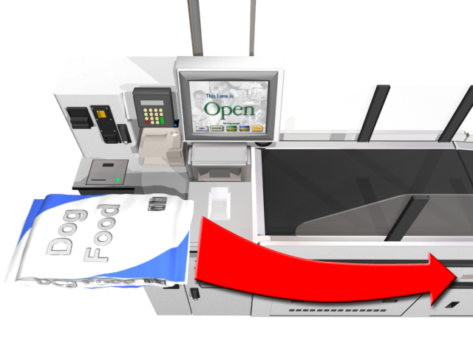  Items That Will Not Fit Through the Lane’s Security  (Picture)

Price Verification
ACM® 700 lanes allow customers and Shopper Assistants to verify the price of an item while scanning it. The price is voiced as well as displayed on the electronic receipt. After the shopper scans the item, the system expects the item to be placed on the belt. If the shopper does not place the item on the belt, the system removes the item from the receipt.

Double Scan Prevention
When a shopper scans an item, the scanner deactivates to prevent the item from scanning twice. The scanner reactivates when the shopper places the item on the belt. If the shopper does not place the item on the belt, the system normally removes the price and description from the order, depending on the transport method.

Scanning Tips for Shoppers
Tip 1  - Place the shopping cart at the front of the lane.  - Stand in front of the monitor screen. | 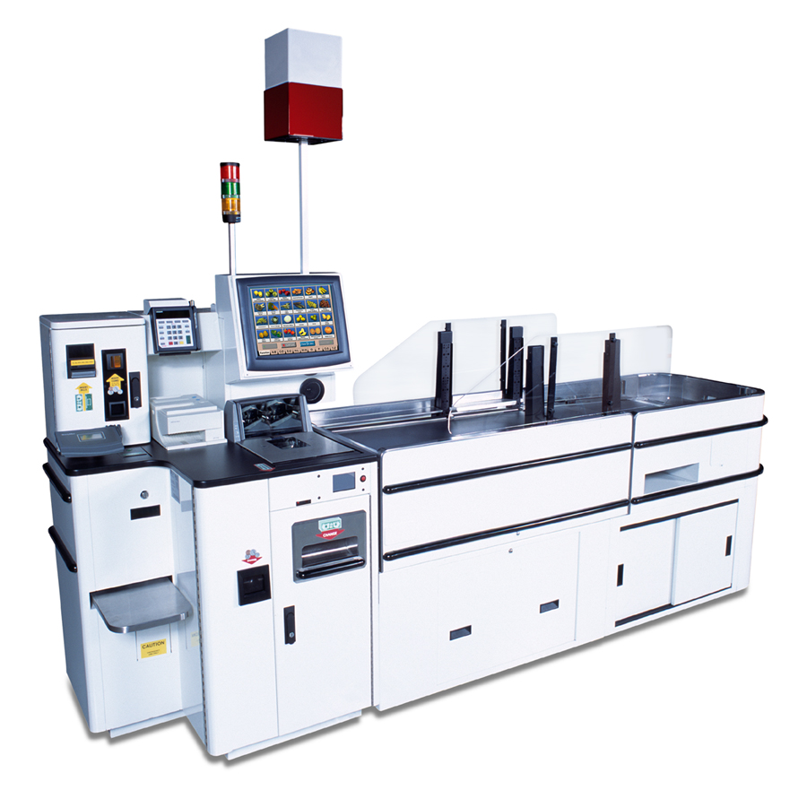  Tip 1: Place Cart at front of lane.  (Picture)
Tip 2  - Pass the item’s barcode two inches from either window of the scanner.  - Find barcodes on the bottoms or backs of items. | 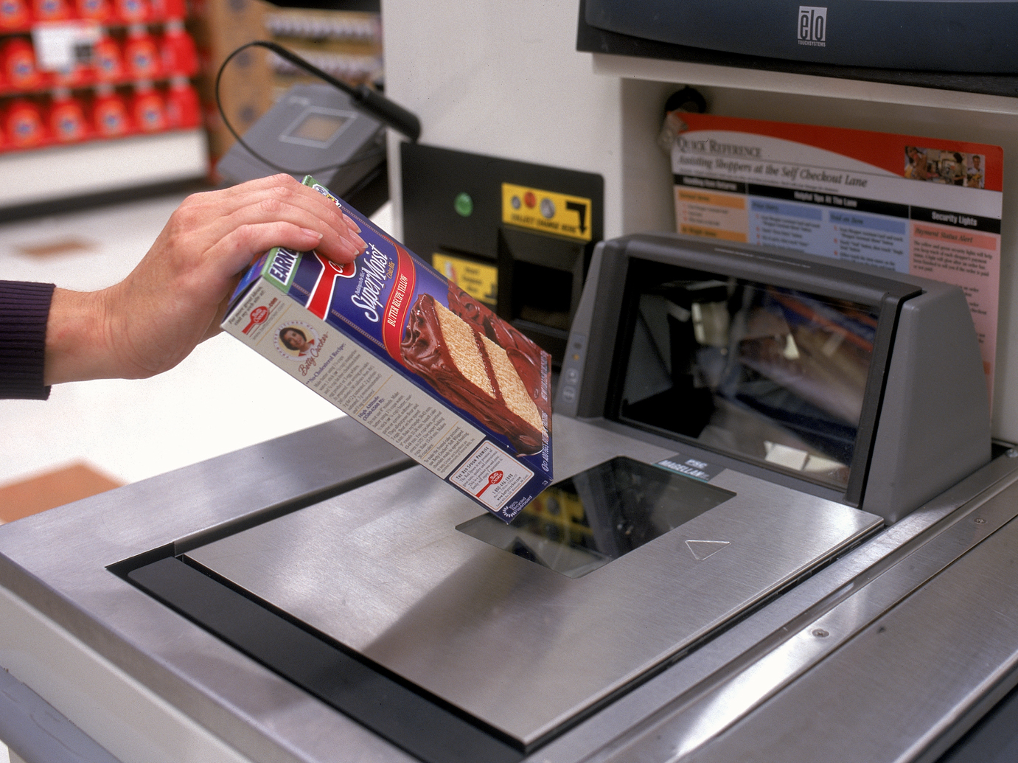  Tip 2: Pass items 2 inches from scanner.  (Picture)
Tip 3  - Make barcodes more readable by stretching bagged items and wiping frost from barcodes on frozen items. | 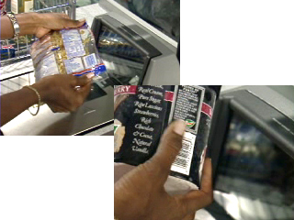  Tip 3: Stretch bags to make barcodes more readable.  (Picture)
Tip 4  - Scan items separately.  - Ensure each item’s price voices before scanning the next item. | 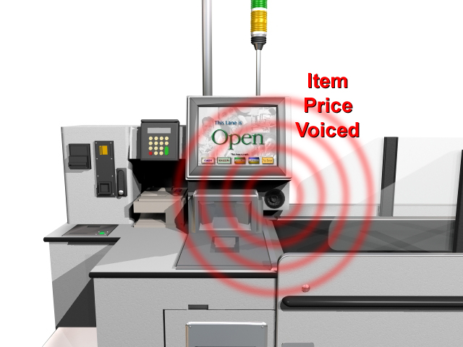  Tip 4:Scan items separately.  (Picture)
Tip 5  - Gently place items on the front conveyor belt and let go.  - Position them so that they don’t touch the sides of the lane.  Note: Keep hands clear of the security arches. This interference causes false item returns. | 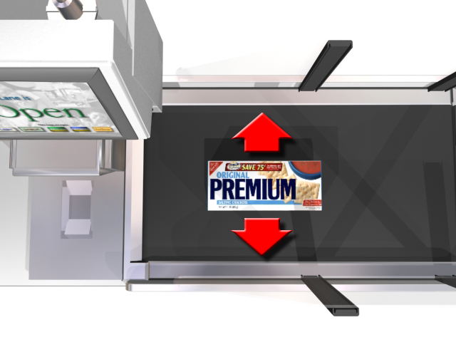  Tip 5: Position items on the center of the belt.  (Picture)
Tip 6  - Scan tall items, and then place them on their sides, especially ones that may break if they fall.  - Prevent bottles from rolling by laying them on their side, pointing toward the bagging area. | 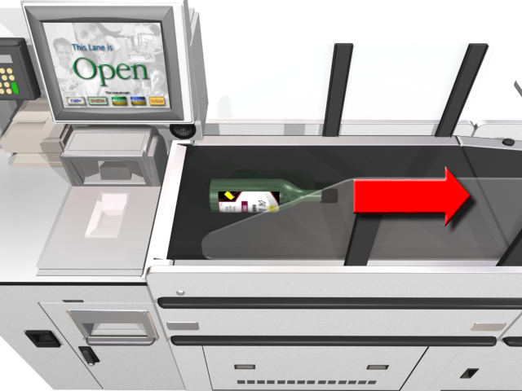  Tip 6: Lay tall items on their sides.  (Picture)
Tip 7  - Process very heavy items or items that are too large to fit through the security arches with the remote scanner. If the store does not have remote scanning enter the item’s barcode or PLU number on the touch screen’s keypad.  Note: These items do not have to be placed on the belt. | 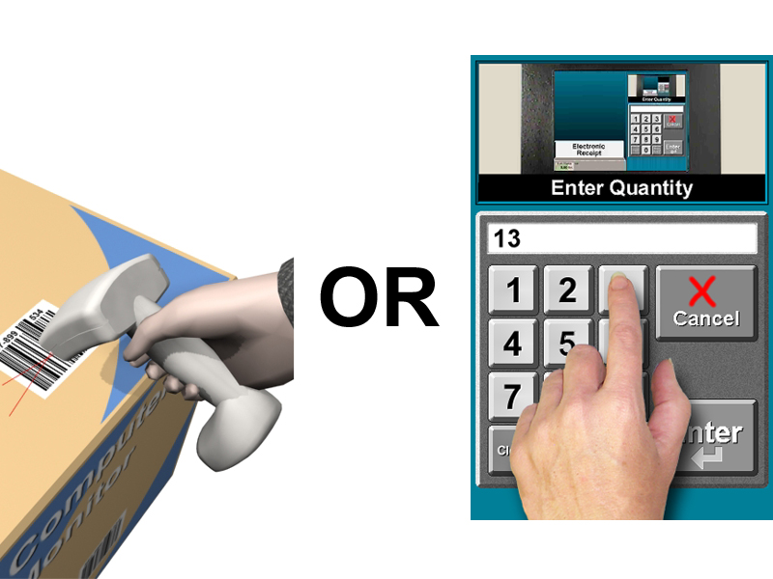  Tip 7: Use remote scanner or the lane keypad for large items.  (Animation)
Tip 8  - Scan fragile and crushable items last. Use the Soft Goods Shelf to hold these items until they are ready to be bagged. | 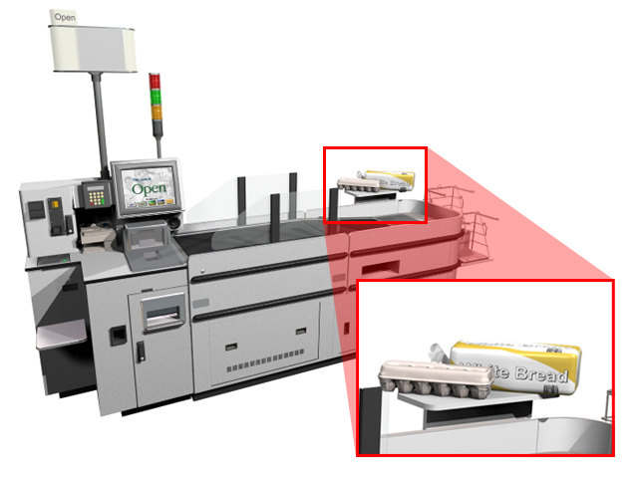  Tip 8: Place fragile items on the lane’s soft-goods shelf.  (Animation)
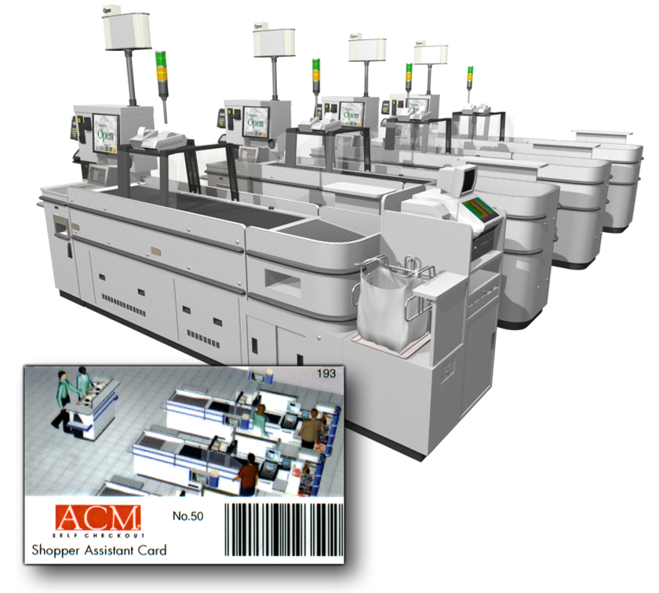

Section Three – ACM® 700 Self-Checkout Shopper Assistant Roles
This section discusses the specific roles and responsibilities of the Self Checkout Shopper Assistant. To fully understand how to fulfill the role, it is important to know why items return to shoppers and how to properly correct the problem.

Items Sometimes Return
Occasionally, processed items return. Each Self Checkout lane has built-in security that checks every item the shopper scans. This system protects both the shopper and the store from pricing errors.
Note: Never reveal to shoppers how the security system works. Shoppers should simply know that there is a security system that checks every item for accuracy and integrity.
Random Weight Item Checks
When a customer processes random weight items, the system checks for packaging problems including label switching, improper weighing, and invalid pricing. When the system catches any of these conditions, the shopper is given the opportunity to try again.
Item Swapping or Doubling – If the shopper scans one item but places another item or two items on the belt, the front conveyor reverses, sending the item or items back to the shopper. | 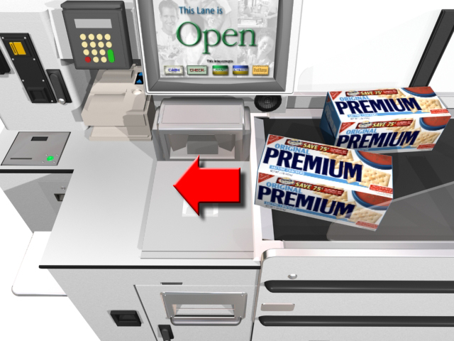  The lane checks for item swapping or doubling.  (Animation)
Item Integrity – If a shopper attempts to process an item as another item (cigarettes as apples, for example), the system detects this and does not allow the item to process. | 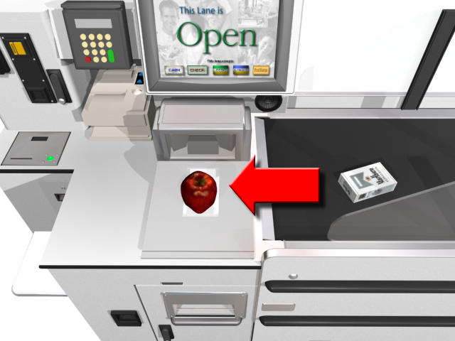  The lane checks for item integrity.  (Animation)
Toss Throughs – If a customer tosses an item through the arches without scanning it, the belts reverse, sending the item back. If the item does not return, a system message displays and the lane light flashes. This requires shopper assistance before the shopper can proceed. | 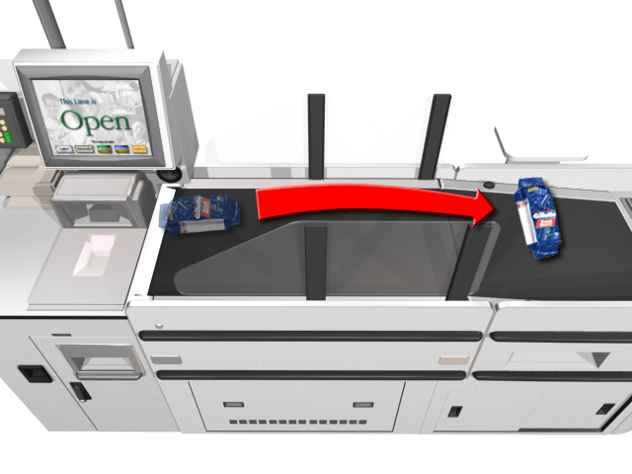  The lane checks for item toss throughs.  (Animation)

Handling False Item Returns
False returns occur because of user error, security database issues (not-on-file, invalid security, item altered), or a lane malfunction. As a shopper assistant, assist the shopper with these false returns by following a few basic procedures. The ACM® 700 Self Checkout lane has built-in security. Once the shopper scans and places the item on the belt, the system ensures the item placed on the belt is the same item that was scanned. The system matches the characteristics of the item on the lane against a security record stored for the scanned item. If the system detects a discrepancy, the belt automatically reverses and sends the item back to the shopper. A voice prompts the shopper to try again.
False Item Return Procedure:  - After two returns, the lane light flashes and the system voice instructs the shopper to put the item aside.  - The system voices that help is on the way.  - The flashing light signals the shopper assistant that help is needed.  - Item returns requiring shopper assistance usually are false returns. | 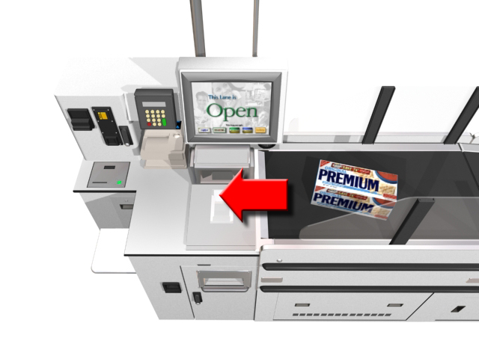  (Animation)
To Process and Learn a Returned Item:  - Scan Shopper Assistant card.  - The system enters security override mode.  - Scan the item and place it on the belt.  - If the item is on file in the POS, it moves through the security zone and the system learns the item.  - Once the item reaches the bagging area, the lane automatically returns to full security mode. | 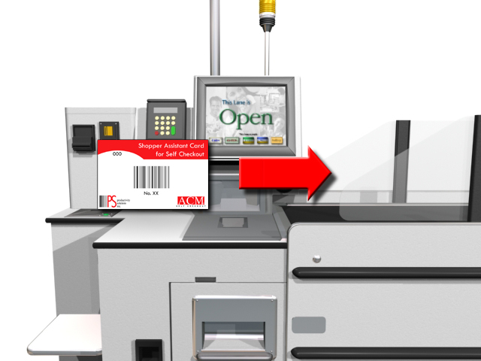  (Animation)  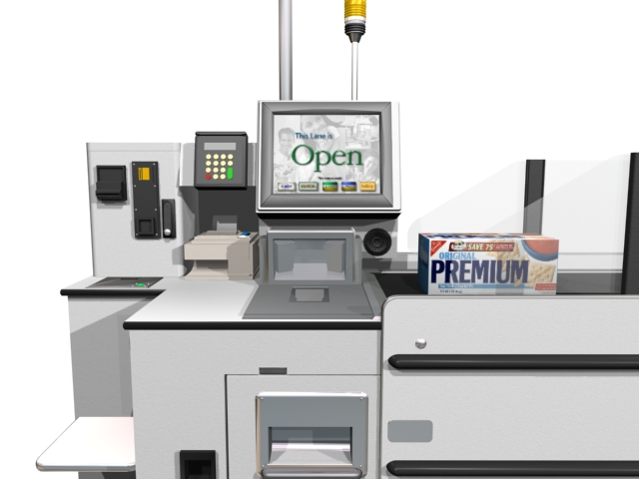  (Animation)

Practice Session
Using the ACM 700 Self Checkout System
 | Multiple choice, select the correct answer.
___________ | A voice prompt informs customers that the item does not need to be placed on the belt and can be carried to the bagging area. The belt does not move. The lane’s transaction awareness light will cycle yellow and green to signify to the Shopper Assistant that a shopper has processed?
- A pass around item.
- A normal item.
- An age restricted item.
- An optional pass around item.
 | List whether the following shopping tips are true or false.
___________ | When items return to the shopper, always allow the shopper to try to process the item a second time.
___________ | After an item is scanned, the system expects the item to be placed on the belt. If the item is not placed on the belt, the item credits off of the order.
___________ | Scan item. Wait for price to voice before scanning the next item.
___________ | Stretch bagged items and wipe frost from barcodes on frozen items.
___________ | Scan fragile items first.
___________ | When scanning tall items, place them on their sides pointing towards the bagging area to prevent breakage or rolling.
 | Hands-On Section  While standing at an ACM® Self Checkout Lane, perform the following shopper action.  ☑ Check off procedures, once performed, in the line provided.
___________ | - Process an optional pass around item.
___________ | - Process a pass around item.
___________ | - Process a normal item.
___________ | - Process a false item return at the lane.
___________ | - Process a toss through item.

Glossary of Self Checkout Terms
age-restricted items — Items, such as alcohol and tobacco, require the purchaser to be a minimum age.
check cart item — Large items, such as a 50 pound bag of dog food are typically placed under the shopping cart. Upon system entry, this type of item will generate a “Check Cart” message on the lane receipt.
extract — File containing diagnostic information gathered while processing each item in an order. The extract file is stored at the BOSS until an ACM® engineer retrieves it for analysis and resolution.
not-for-sale items — Grocery items, such as seasonal items or federally recalled items, that have been pulled from the shelves and are not for sale at the current time.
not-on-file (NOF) items — Grocery items that have not been added to the point-of-sale (POS) system.
plu (price lookup) code — Code used for items that do not have barcodes.
quantity-required items — Grocery items sold by the number of items purchased (i.e., cucumbers, lemons, peaches, etc.).
random weight (type 2) items — Prepackaged items sold by price per kilogram or pound. These items are marked by a type 2 barcode and include most meat products.
retrieving orders — Process of bringing up suspended ACM® orders. The system suspends orders so customers can pay at the Paystation. Retrieving orders allows Shopper Assistants to process the customer’s order like any regular order.
shopper Assistant — Person designated to assist shoppers on the lanes whenever a difficulty is encountered. This assistance may require the use of the Shopper Assistant card.
shopper Assistant card — Programmable scan card that allows the card holder a range of functions in assisting the shopper and/or troubleshooting the lane.
time restricted items — Grocery items that are not sold during certain times or on certain days (for example, alcohol on Sunday).
transport methods — Method for transporting items from the ACM® lanes to the bagging areas. Some items must pass through the security arches, some items may optionally pass through the security arches, and other items must not pass through the security arches.
upc (universal product code) — Barcode printed on grocery items.
value or bonus packaged items — Grocery items that are specially packaged to promote a particular item or to serve as an enticement to shoppers (i.e., 10% more free, buy two for the price of one, etc.).
weight required items — Grocery items that are sold by weight, such as produce (i.e., bananas, beans, etc.) and bulk foods (i.e., trail mix).

Index

Components
Lane, 6
Glossary of Self Checkout Terms, 22
Handling Item Returns, 18
Item Returns, 18
Items
Returns, 17
Lane
Components, 6
Lane Components, 6
Returns
Handling, 18
Why, 17
Role of the Self Checkout Shopper Assistant, 16
Self Checkout
Shopper Assistant, 16
Self Checkout Lane, 10
Using, 10
Shopper Assistant, 16
Role, 16
Shoppers
Tips, 13
System Overview
Lane Components, 6
Tips for Shoppers, 13
Using the ACM Self Checkout Lane, 10
Why Items Sometimes Return, 17

