Main Point: Business Space capabilities help different user roles align around business process goals, objectives and performance. As your business needs change and your business process objectives change, Business Space helps you keep LOB leaders, business users, business analysts, process owners, and many other roles across business and IT continuously aligned.

For example:
- Business leaders can manage and monitor process performance
- Business users can evaluate KPIs, manage human task lists, and staff productivity and make necessary adjustments
- Business analysts can receive direction from business leaders and modify rules, policies and processes quickly and easily
- And Process Owners can analyze process performance to further optimize process models and dashboards

Let’s Look at a quick Scenario Example:

Better Enterprises is a fictitious company in California experiencing a heat wave that threatens manufacturing operations. Better Enterprises is committed to reduce its energy and water consumption to improve profitability and conserve natural resources. Let’s see how business space capabilities can help Better Enterprises leverage insights and put then into actions.

Set up | Script | Visuals
The Demo opens to the Green KPIs Tab. | There is an ongoing drought and heat wave in California that is forecasted to continue. The heat wave is affecting Better Enterprises manufacturing operations in California, driving peak energy costs up and decreasing the water supply for operations. This can affect profitability and disrupt manufacturing operations. | 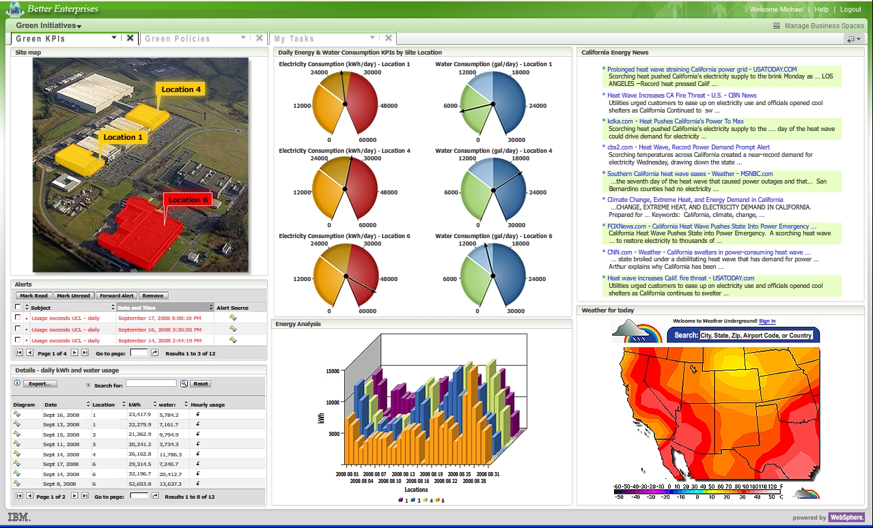
Upper left corner: Site  map shows Location 6 is in red range of the KPI.  Lower left: Notice red energy consumption usage alerts.  Middle column: KPIs on electricity and water consumption  Right column: current weather maps and related news | The manager looks at his Business Space. He reviews status of his manufacturing plants including real-time alerts, KPIs on electricity and water consumption, and other information. He can look at historical data and analysis, along with current weather maps and news content.  Comprehensive insights consolidated into one place allows him to make smarter decisions and take action more rapidly.  Manager receives alerts that power consumption is excessive in Location #6 due to cooling the factory in a heat wave.  He must avoid overheating or risk equipment problems and production delays.  He decide to take action on a contingency plan to avoid putting manufacturing operations and profitability at risk. | Alerts tell the manager that a KPI threshold has been exceeded  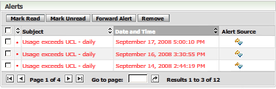
Click on “Green Policies” tab.  The animation will select a policy and make selections automatically on the screen | The manager can use business policies to adapt quickly.  He’s got a few options—including shifting production locations to facilities in cooler climates.  He chooses to shift production from the plants in California to those in Massachusetts, British Columbia and Wyoming while remaining in Business Space. | 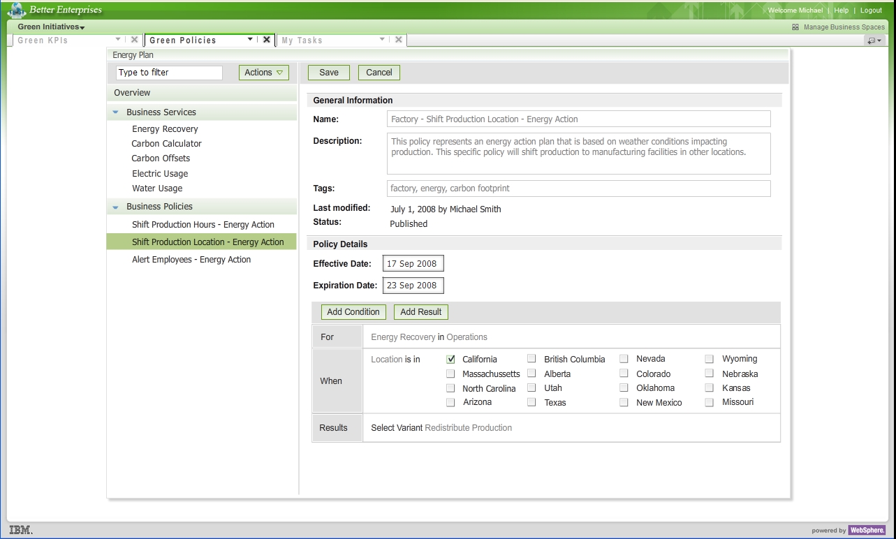
Click on the ‘My Tasks’ Tab  The animation will fill out a form,  Click SUBMIT on the bottom right hand corner of “My Tasks” to progress to the final screen. | The course of action the manager selected modifies existing processes and initiates new ones, including a governance process that requires Senior Mgmt approval starting with an “Energy Plan Change Request’. He selects this task from his Task list and submits this form.  This submission initiates various automated and human-focused processes involved in shifting the manufacturing operations from California to the other locations. | 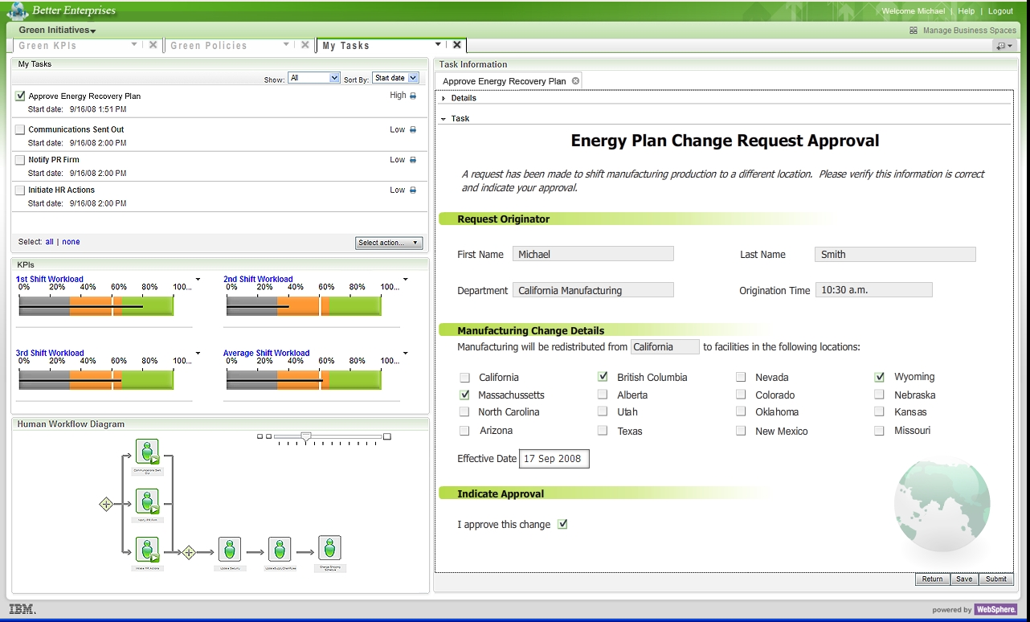
Final Screen – Green KPIs  To RESTART the demo, click again on the Green KPIs tab. | Once the Energy Plan goes into effect, Better Enterprises reduces its consumption of energy and water and allows production to stay on schedule without incurring additional energy costs.  This is reflected in the KPIs for electricity and water usage, which are now all within the desired range.  Better Enterprises averted a crisis and was able to capture insights and convert them into action all within the Business Space environment. | 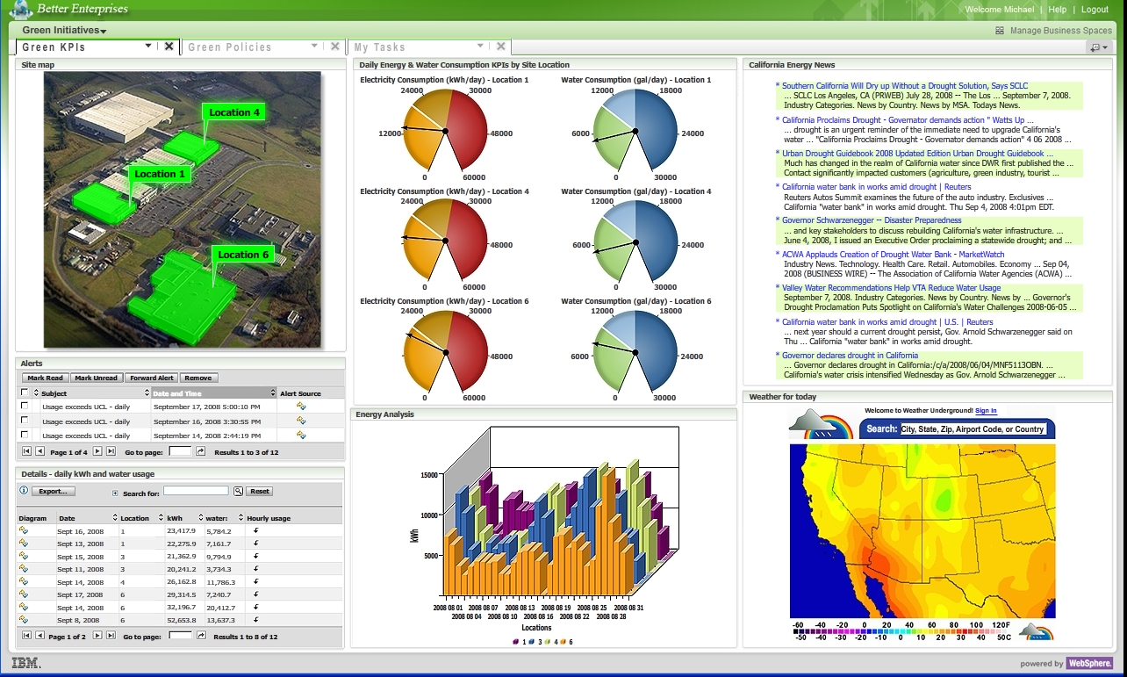

Final Point: Business space enables organizations to manage their processes and their business more effectively, making smarter collaborative decisions, and taking action more quickly.

