IBM France Software Laboratory
Rational Enterprise Tools & Compilers
1, place Jean-Baptiste Clément
93891 Noisy-le-Grand Cedex

IBM Rational Software
Pacbase Convergence Plan
Environment Installation: RTCz Server Setup

1. Introduction 3
2. Install the server 4
3. Create Database 5
4. Edit teamserver.properties to use your DB2 database 9
5. Create the database tables and initial contents 10
6. Initial Launch of the server 12
7. Create another admin user 18
8. Create Project Area 22
9. RTC Client Initial setup 32

Introduction
The objective of this document is to help installing the different parts of the Repository RTCz Server in the context of a Pacbase Convergence Plan evaluation project.

This evaluation will allow you to progressively discover the new integrated development platform and environment that will be used for the maintenance of Pacbase applications, and help facilitate evaluation and organization of the applications transfer.

Install the server

Unzip RTC-Standard-Server-I200906XX-XXXX-Win32.zip in a directory on windows.
Unzip jfs_patch.zip under the jazz/server folder. It should overwrite one file.
Unzip pdp-rtcz-server.zip under the jazz/server folder. It will not overwrite any file.

You should have something like this:

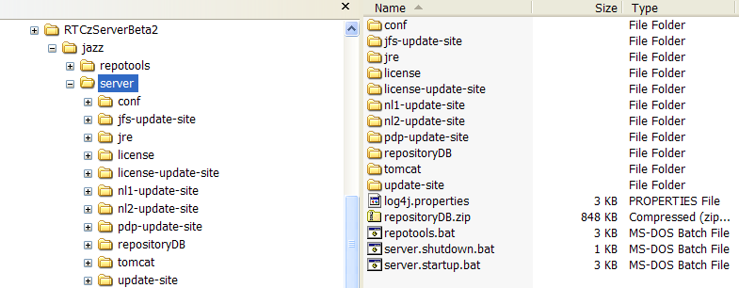

(note the presence of the jfs-update-site folder and the pdp-update-site folder)

Create Database

From the DB2 control center

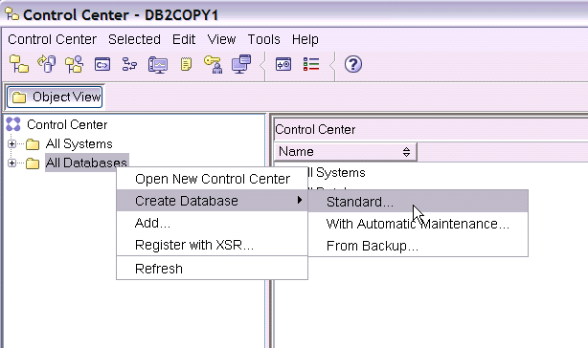

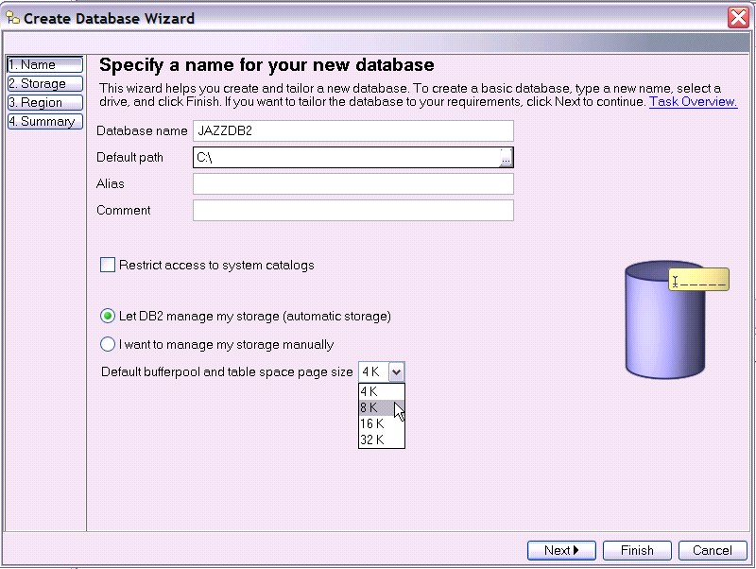

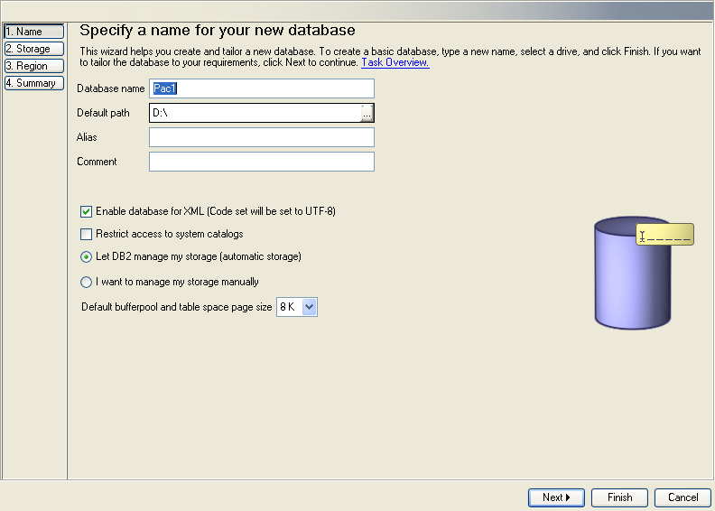
Default Bufferpool name needs to be set to 8K

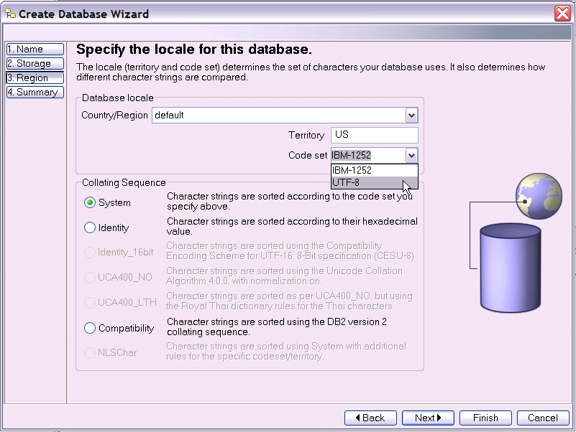

CodeSet needs to be UTF8

You can now do Finish

Edit teamserver.properties to use your DB2 database

Skip this page if you don’t use DB2.

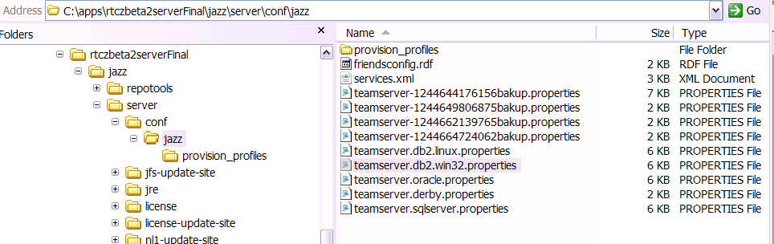

Rename teamserver.db2.win32.properties into teamserver.properties (backup the original)

Open and edit these lines with your database specifics:

It should look like this:

Create the database tables and initial contents

Open a command window in the jazz/server directory

(note: you may have to edit repotools.bat and add
-Dcom.ibm.team.repotools.rcp.allowInvalidBundles=true)

Run repotools –createTables

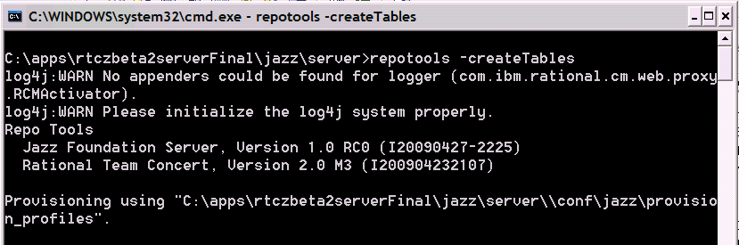

After a while…

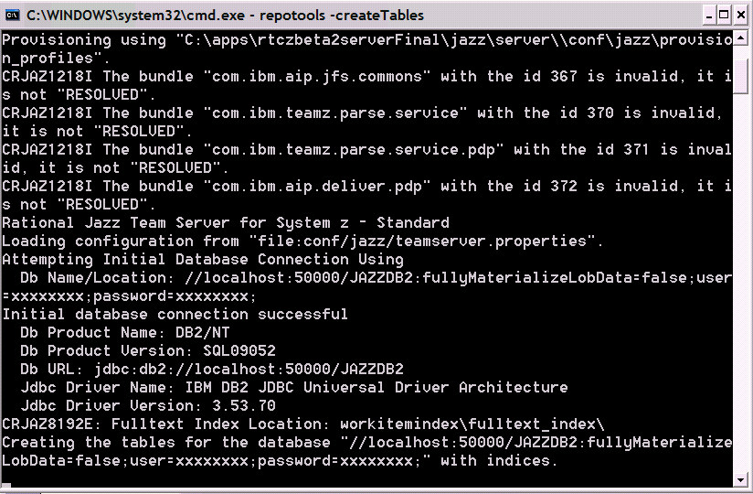

And when it is finished (takes a few minutes):

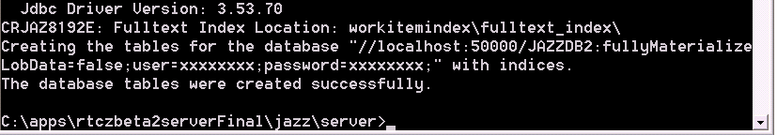

Initial Launch of the server

Launch serverStartup.bat

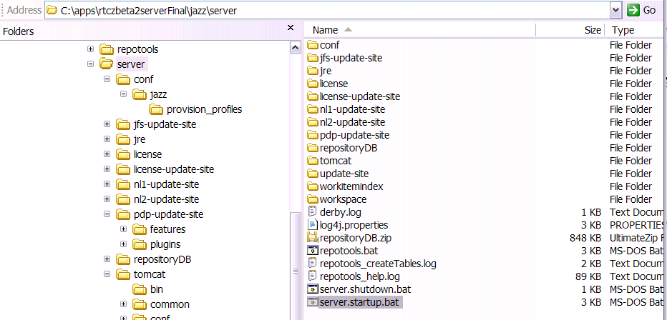

Tomcat starts

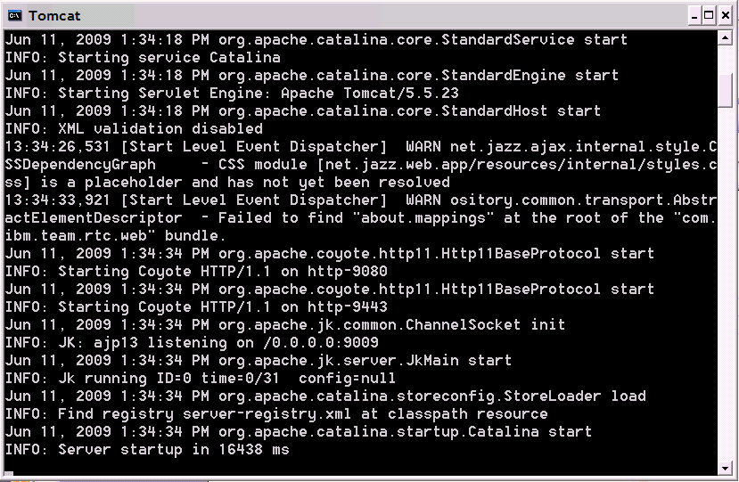

Launch the RTC Admin console. Open a web browser, go to
https://localhost:9443/jazz/

It will redirect you to:
https://localhost:9443/jazz/admin

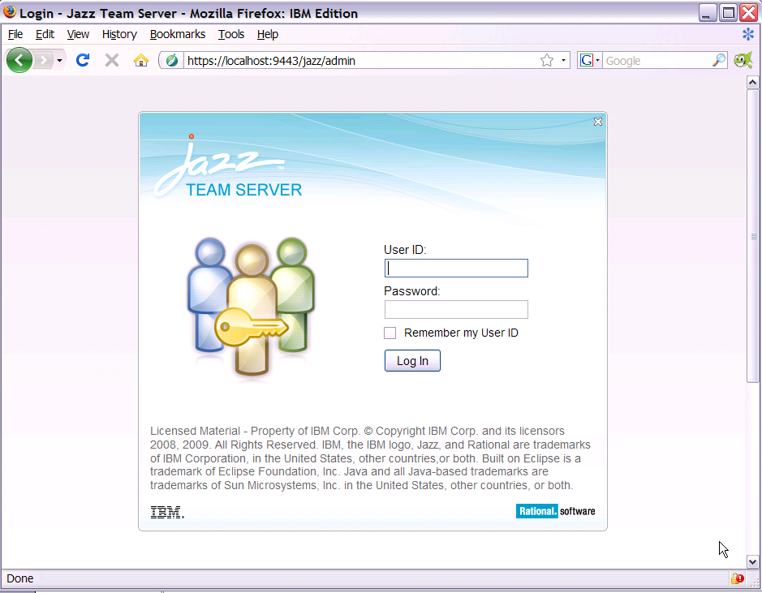

Login with ADMIN ADMIN

(you’ll see that Tomcat connects to the database. It takes a littke while for this initial conection).

You arrive on this page:

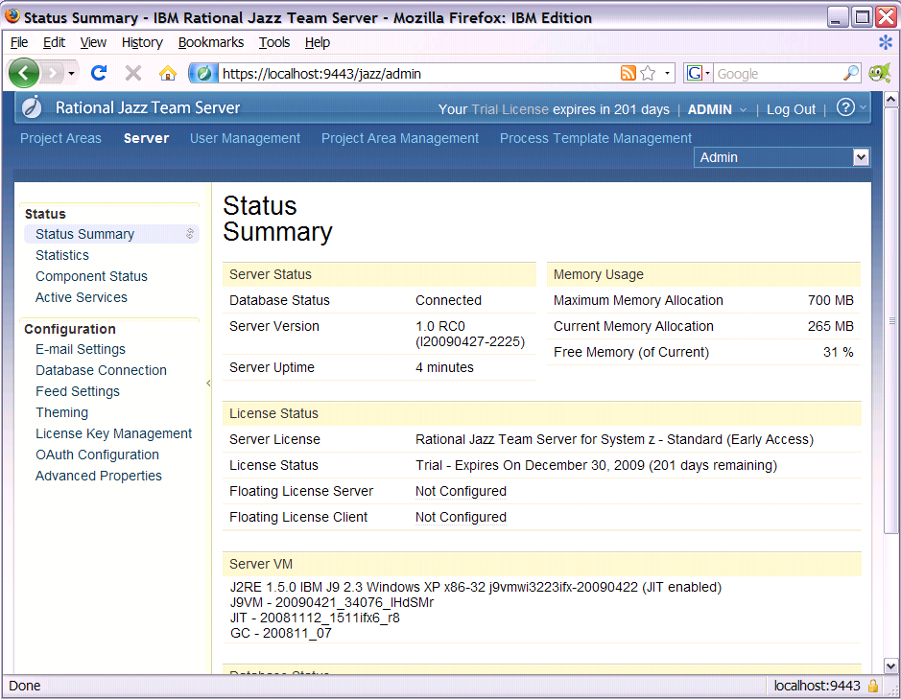

Go to Oauth Configuration

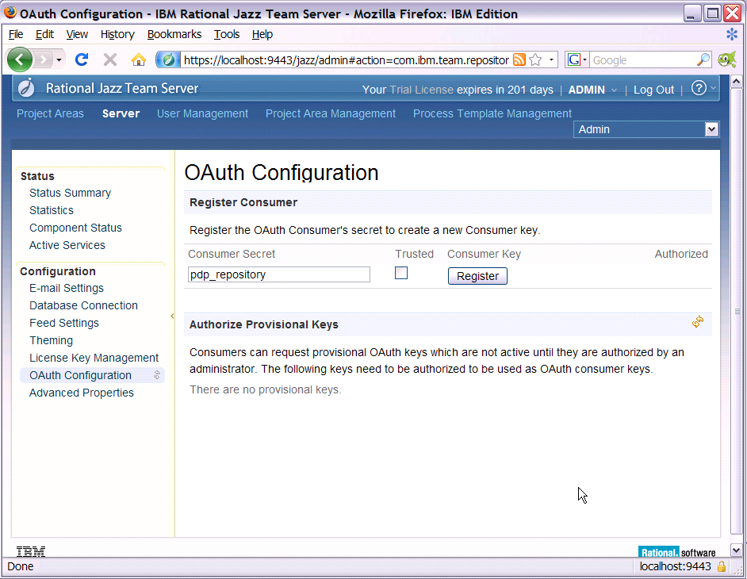

Enter a secret, for example pdp_repository

Click on register.

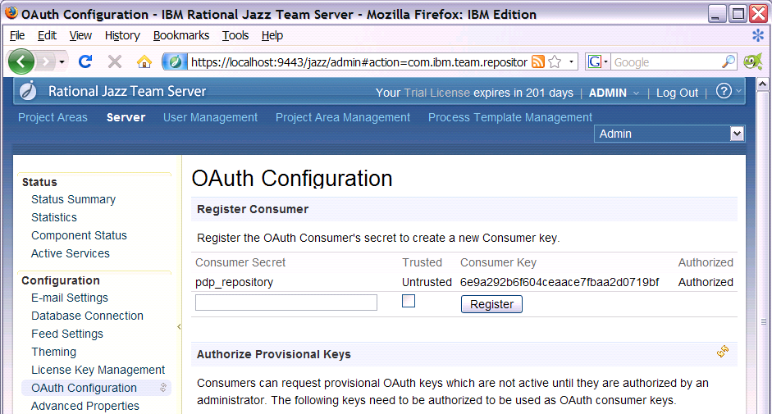

A secret is displayed. Save its value somewhere.
Click on “Advanced properties”

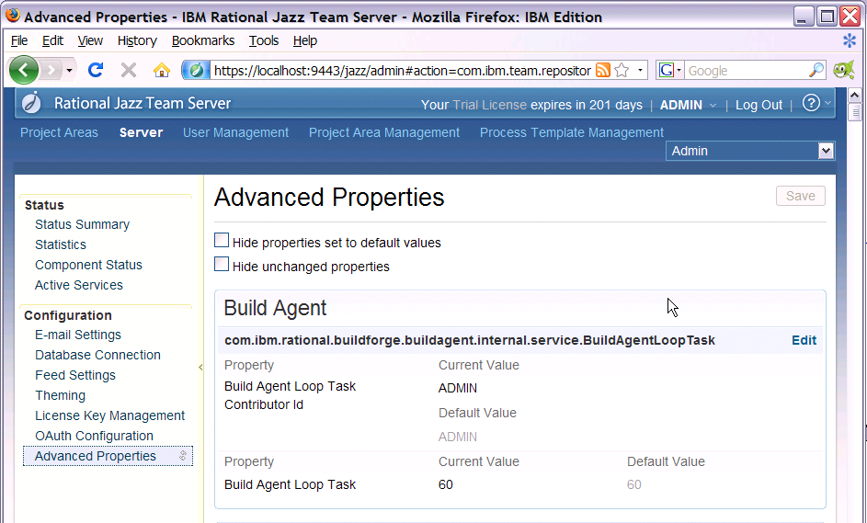

Go to the section PDP repository properties:

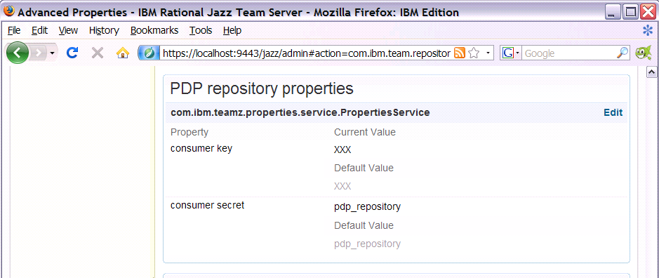

Enter the consumer secret (if you did not use the pdp_repository) and the consumer key:

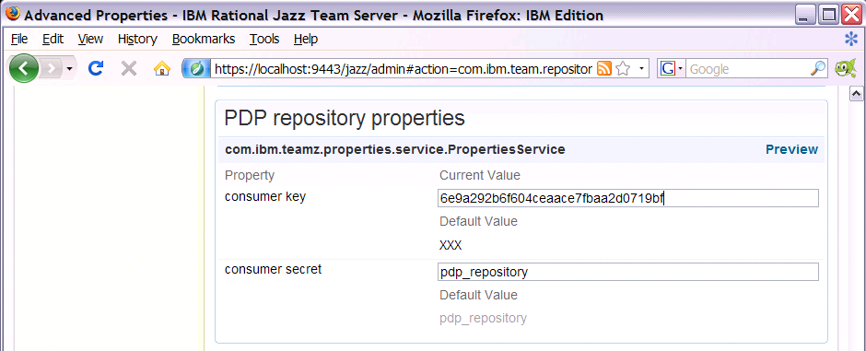

Go to the top of the page and click “Save”

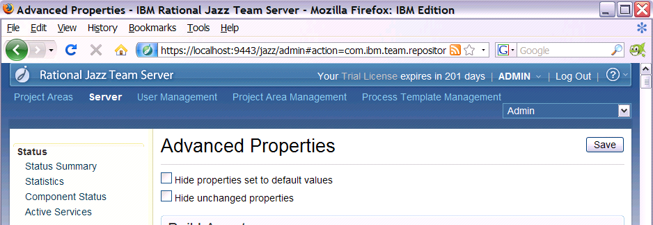

We have now finished configuring the server for the repository access

Create another admin user

Note: for this release, DO NOT disable the ADMIN user.

In the user management section, create a new user:

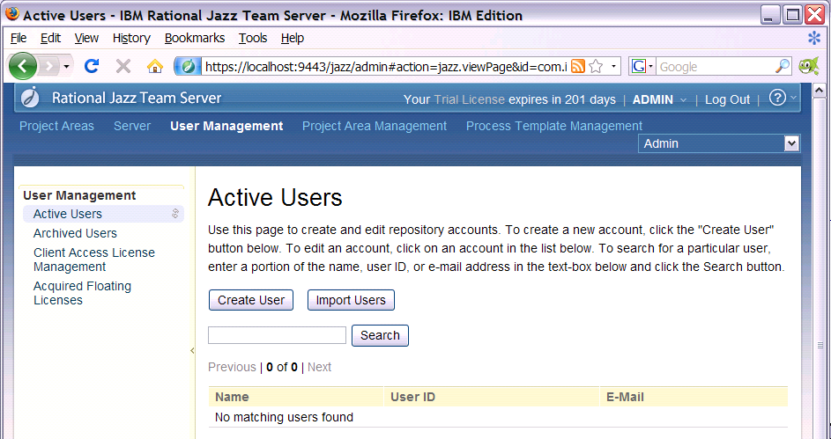

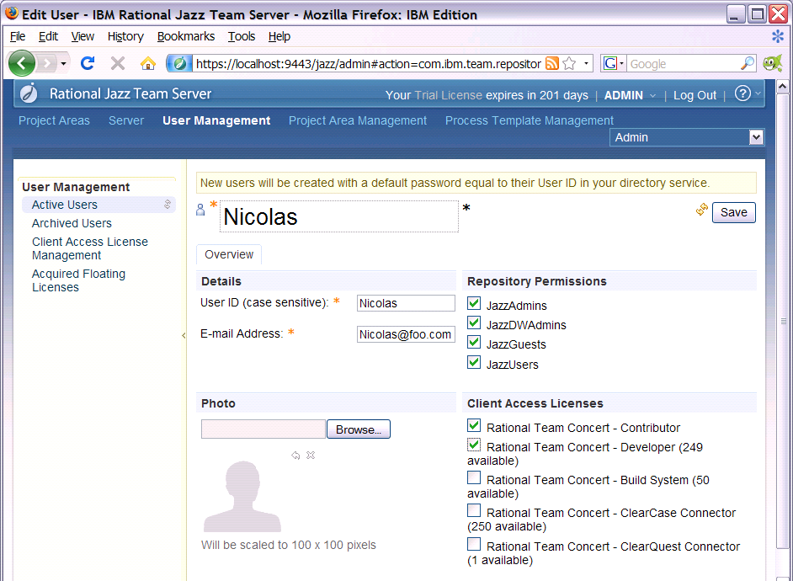

Check all the repository permissions and the CAL Contributor & Developer. Save.

Logout now

Login as the new user:

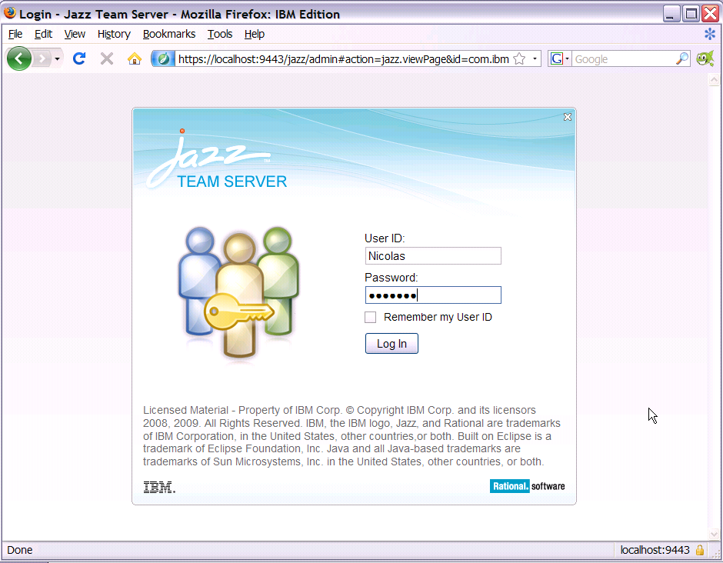

Go to Process Templates management:

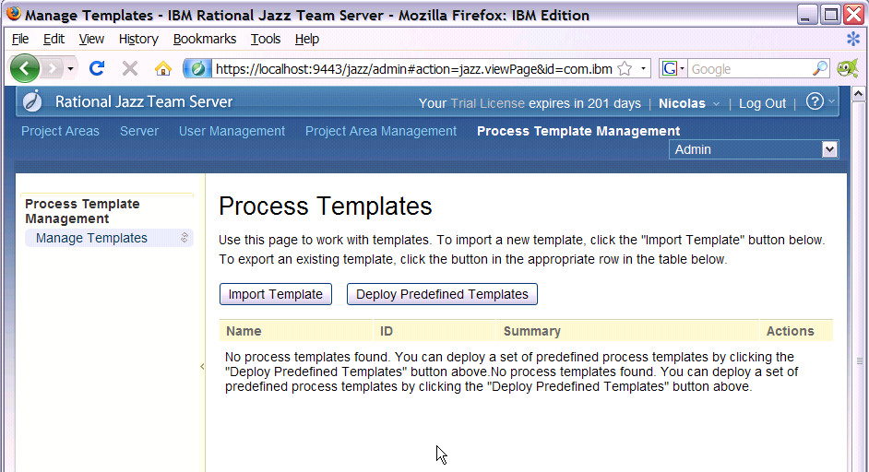

Click on Deploy Predefined Templates

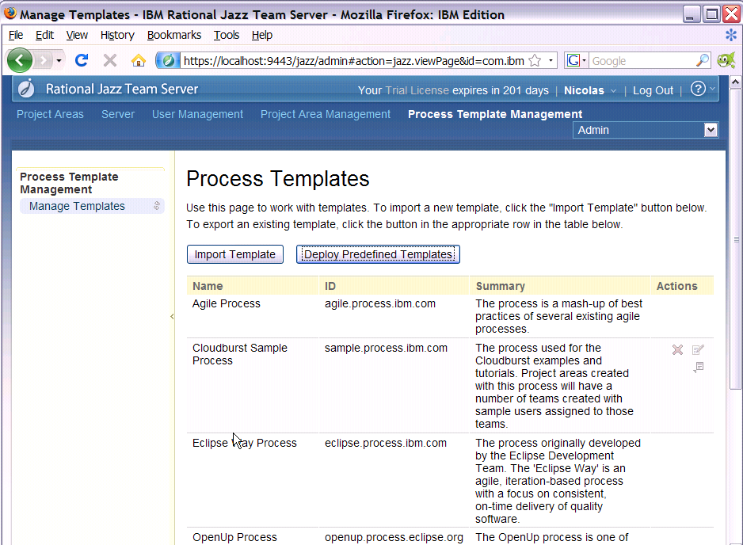

Create Project Area

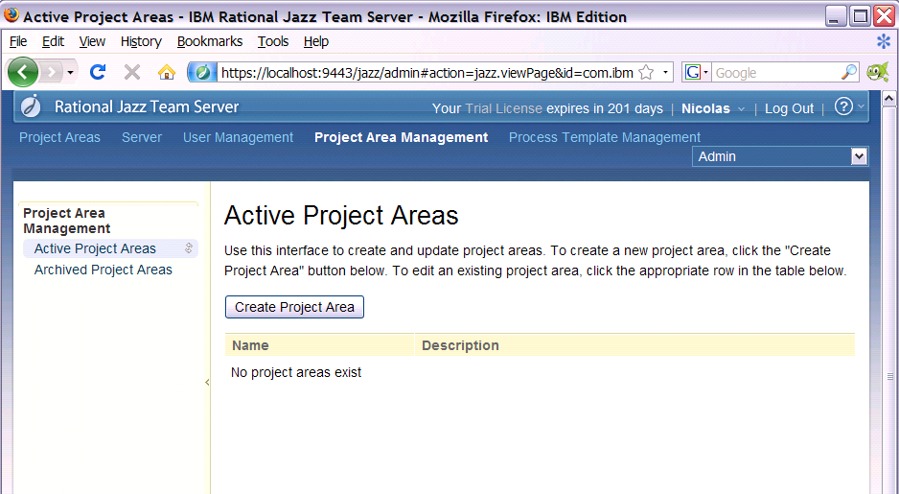

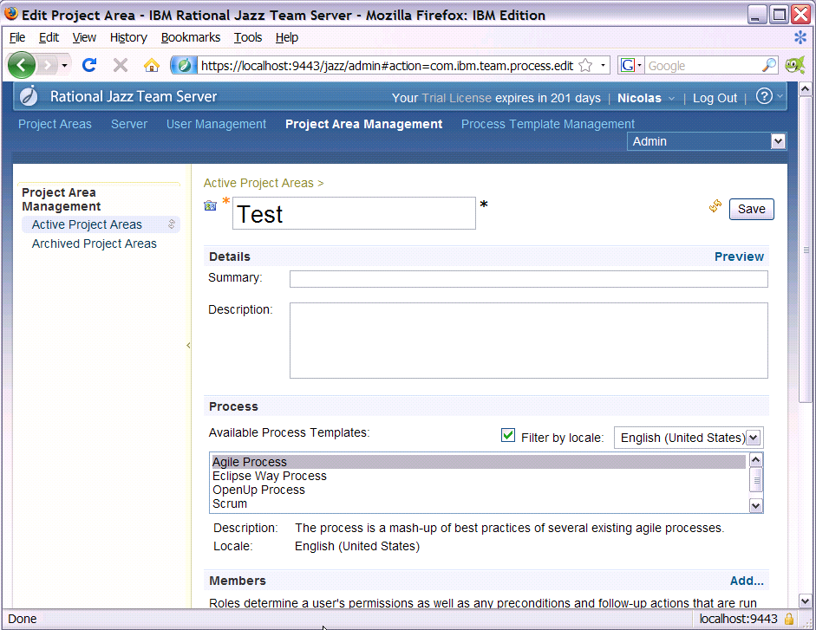

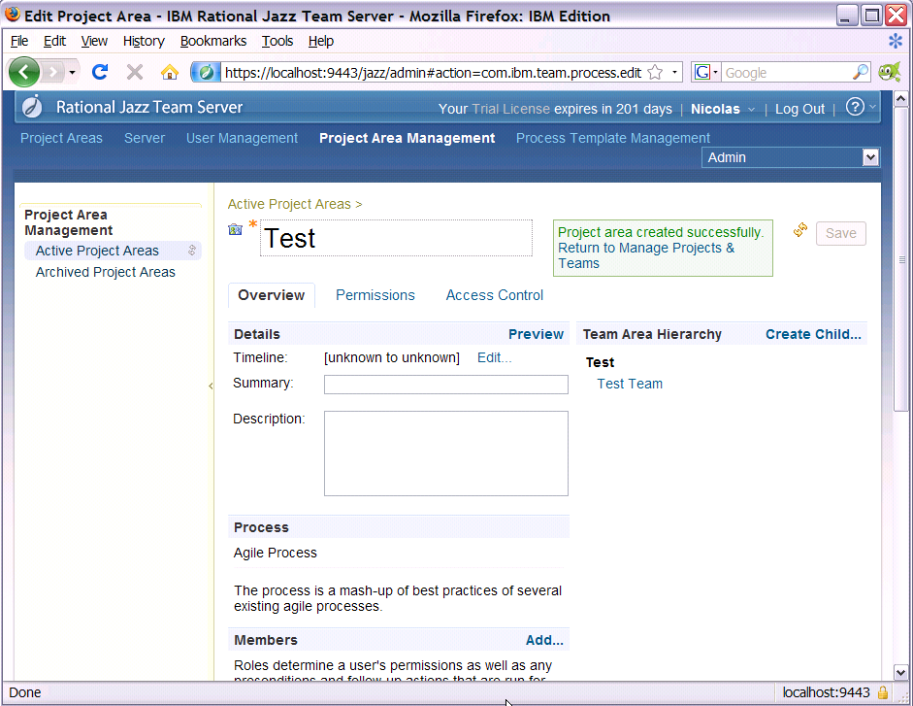

Click on Add… for Members.

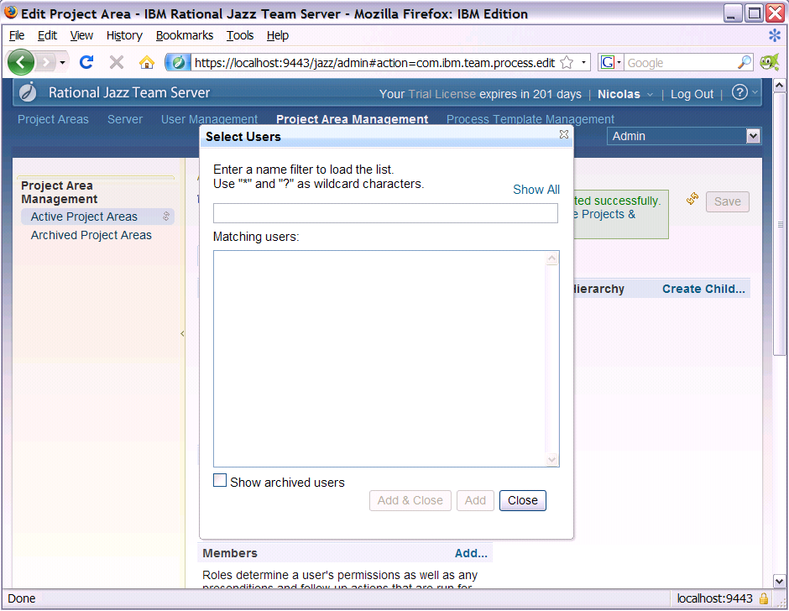

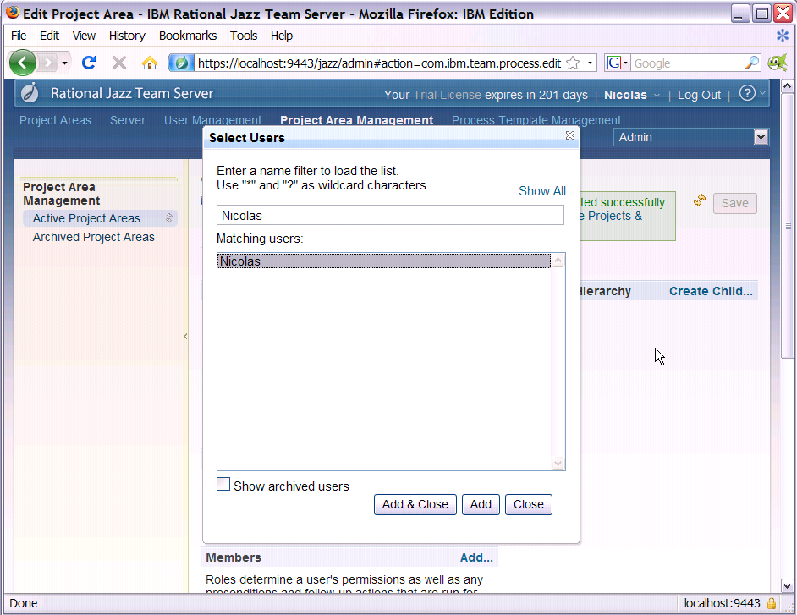

Add roles to the user in the project Area:
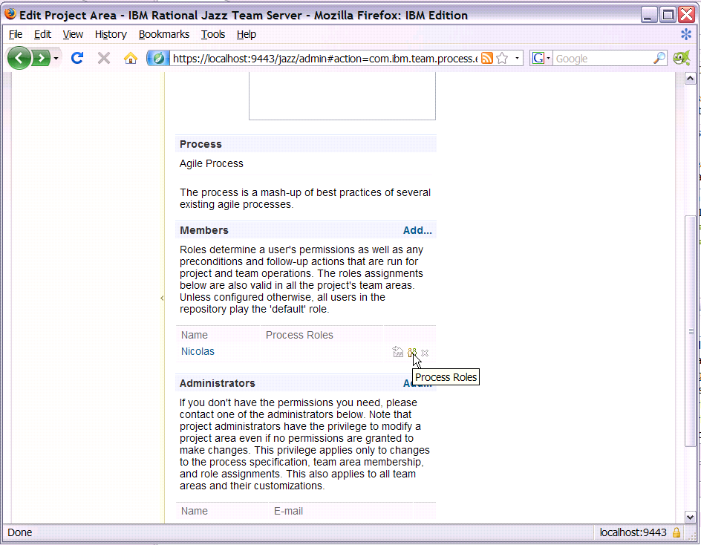

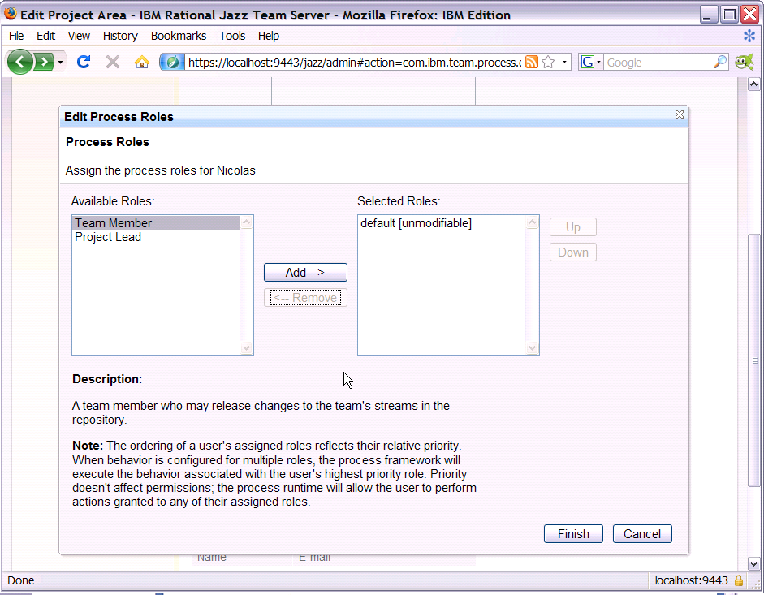

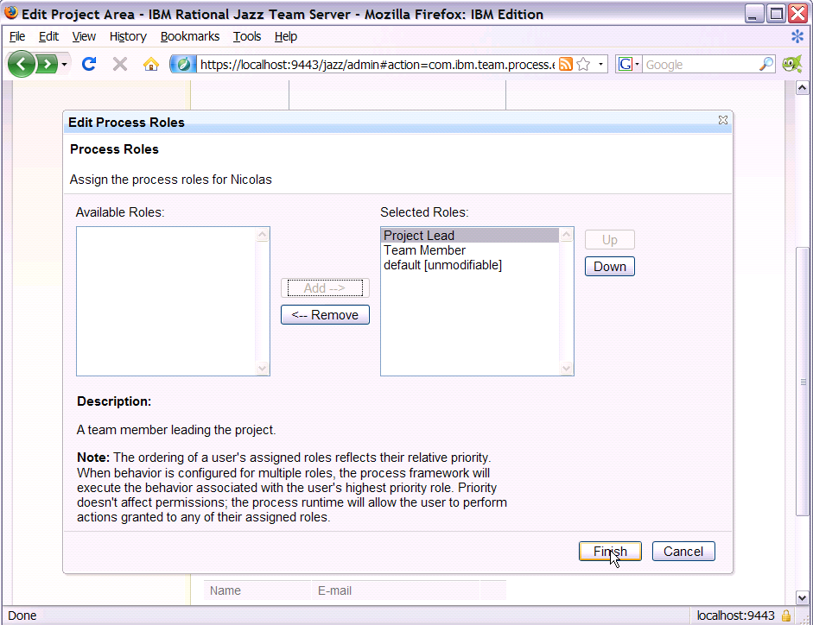

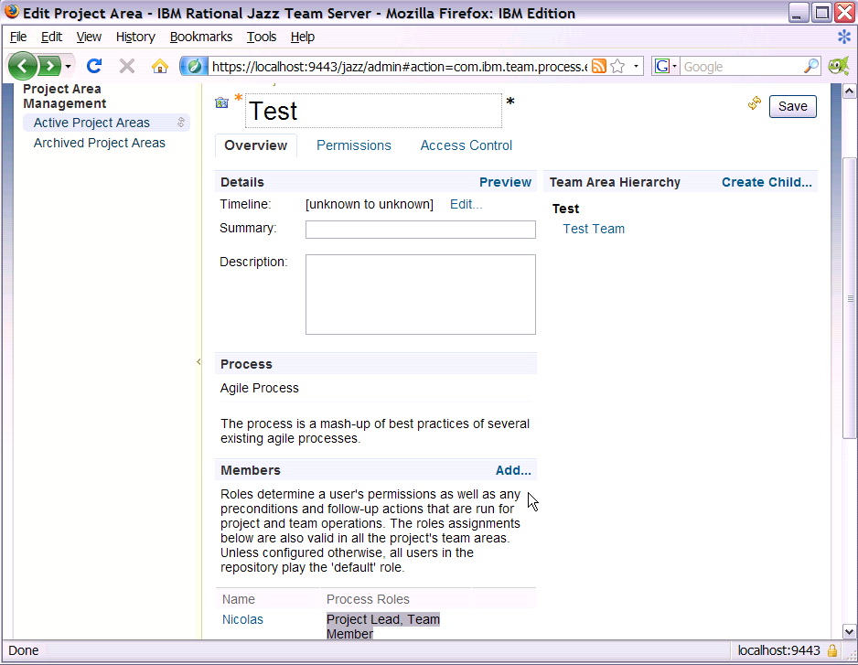

Save now:

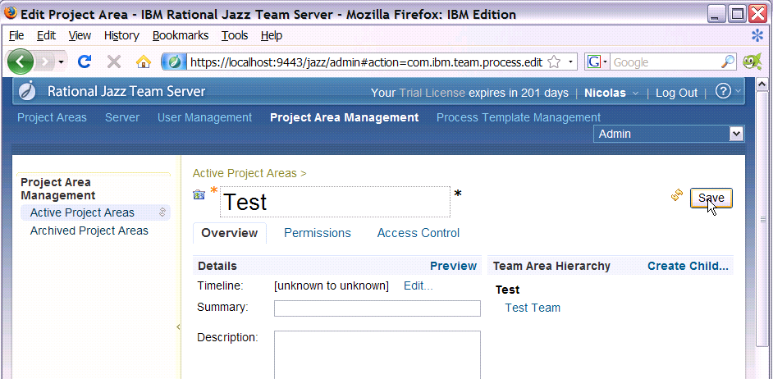

RTC Client Initial setup

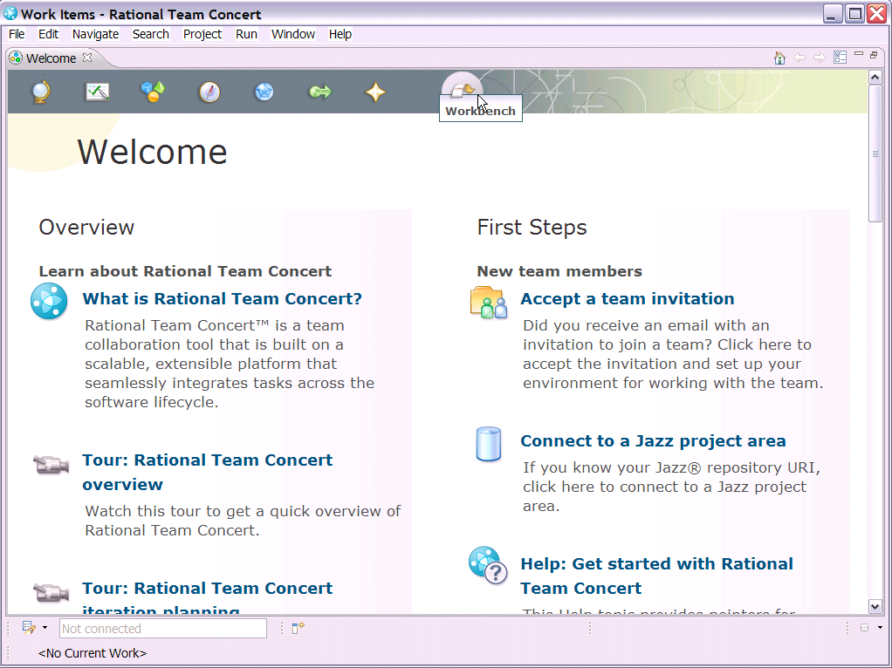

Go to the workbench

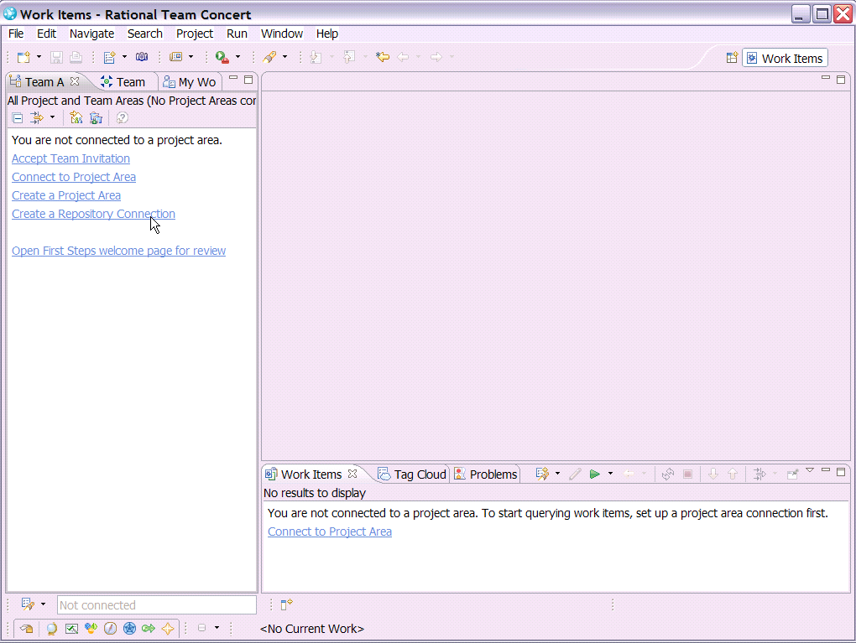

Create a repository connection:

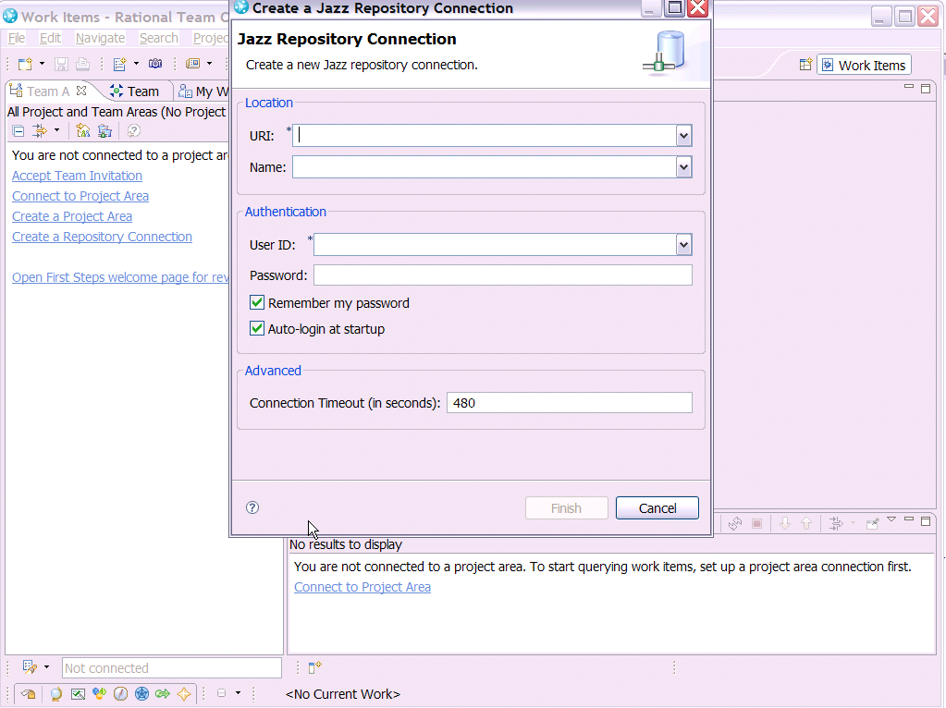

Enter the URI of the server. Note: it is likely that your server will not be on your local machine, so the following values will not apply.
Enter the userid & pwd that has been defined in the web ui.

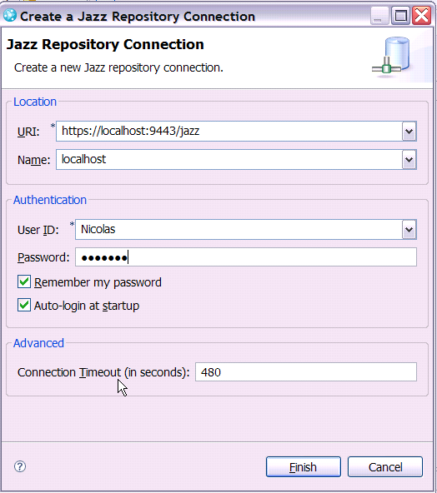

Connect to the project area:

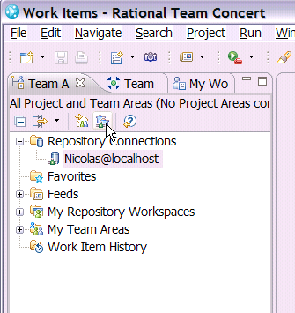

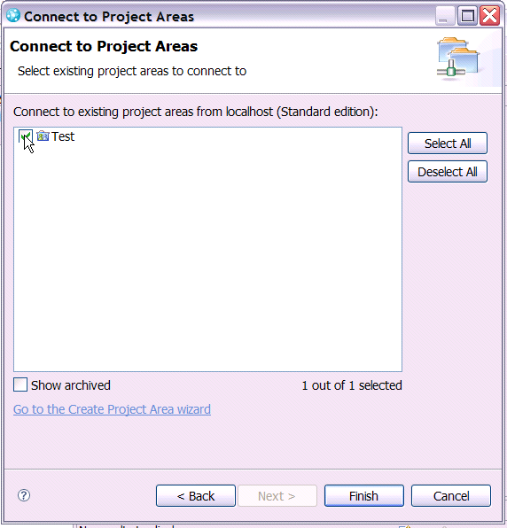

By default a Stream has been created

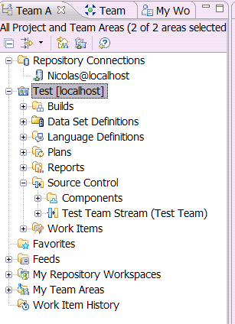

We will customize the project area now (note that you could do the same thing at the team area level if you want to be more granular):

Open the project area:

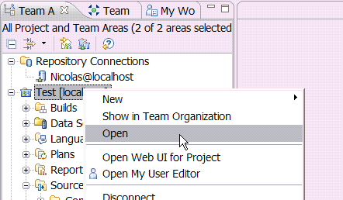

The project area opens? You’ll find the same info & more than in the web ui.
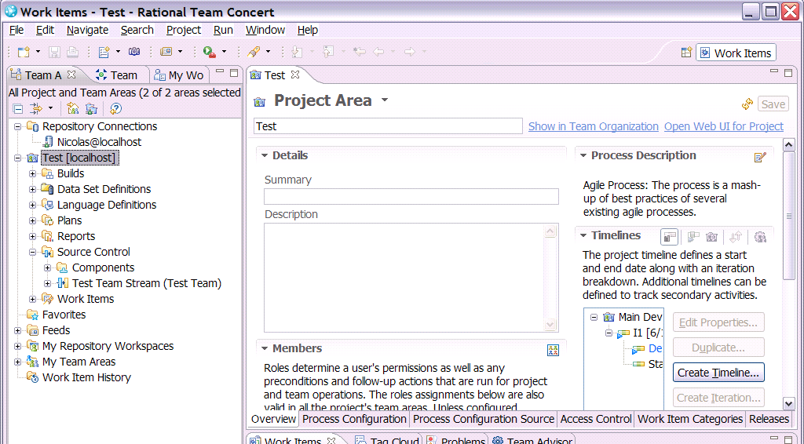

Go to Process Configuration:

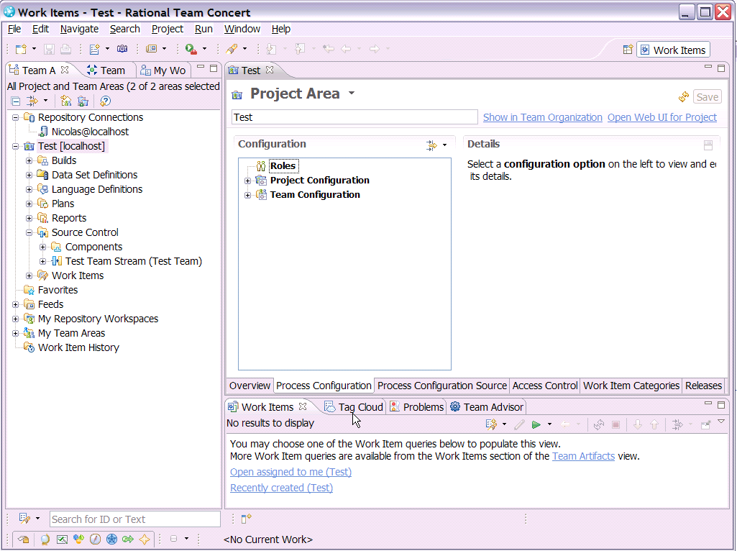

Expand Team Configuration; select operation behavior:

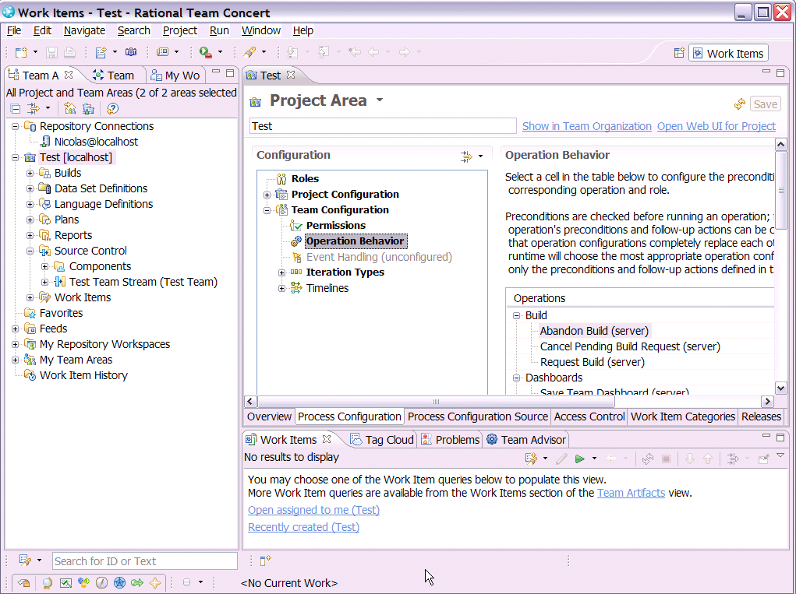

In the table of operations, scroll near the bottom and find the source control section. Select the cell as shown below:

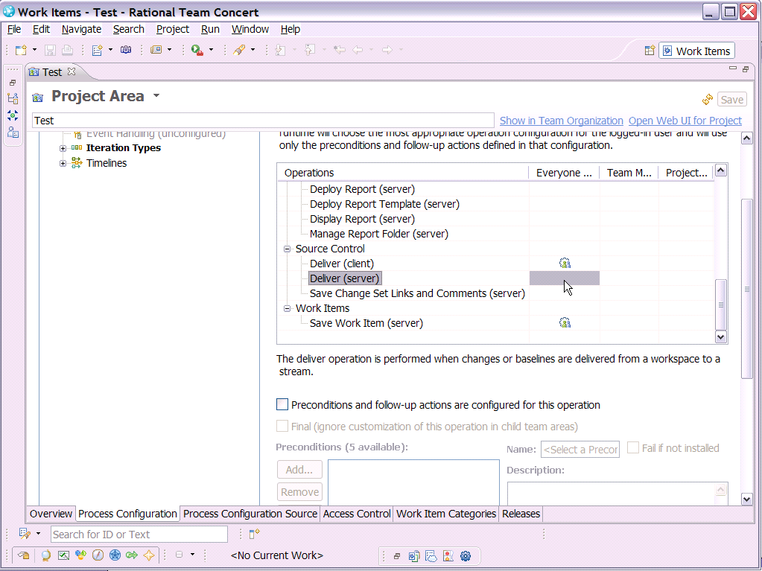

Now, check the checkbox “Preconditions and follow-up actions…”

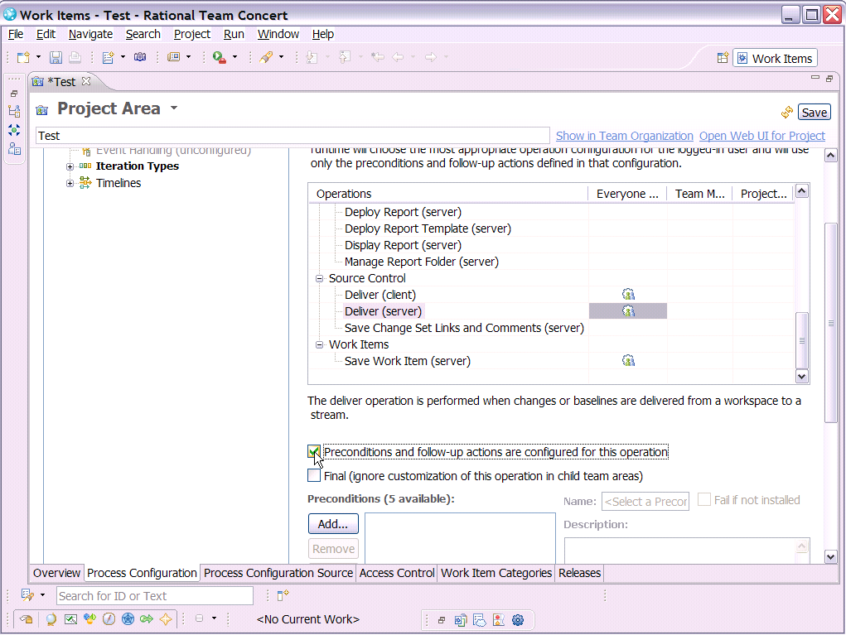

Go to the bottom and add a follow-up action:

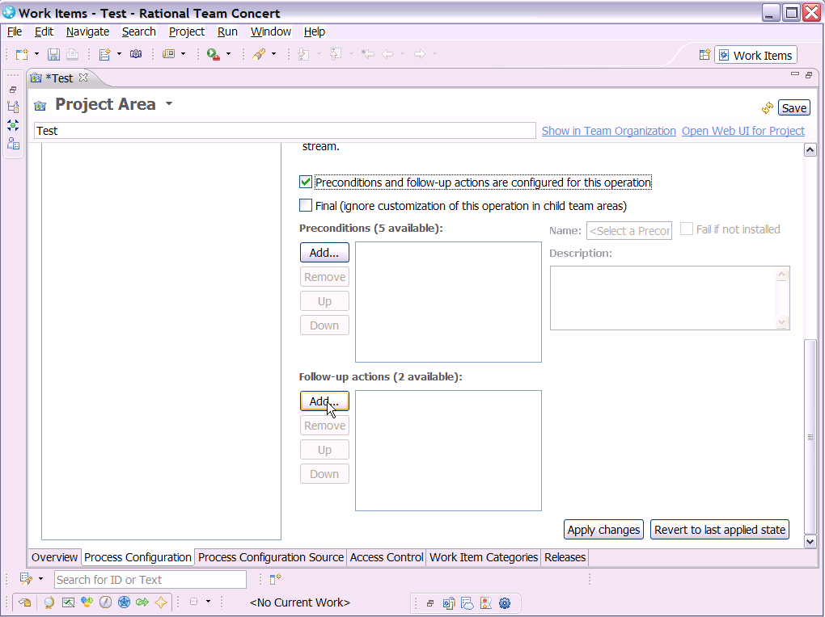

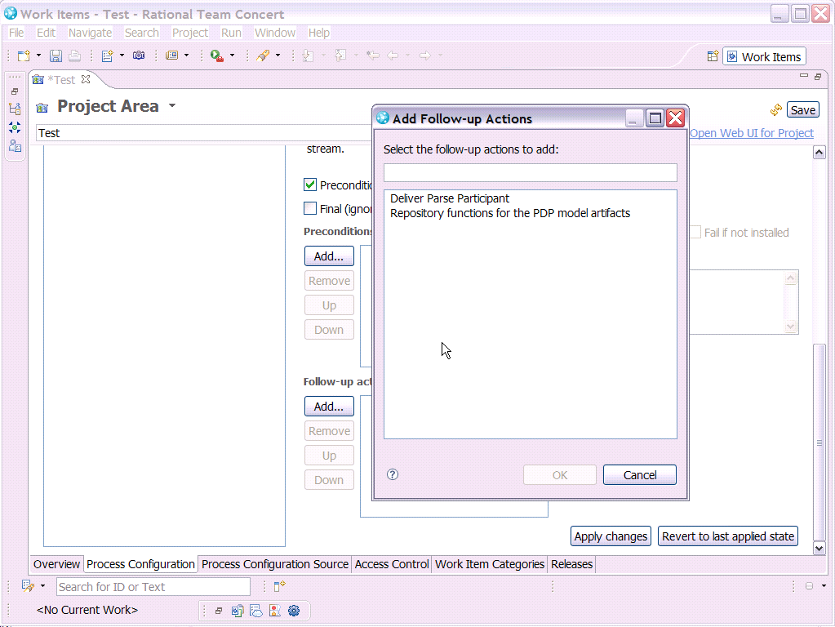

Select “Repository functions for the PDP model artifacts”

Save now:

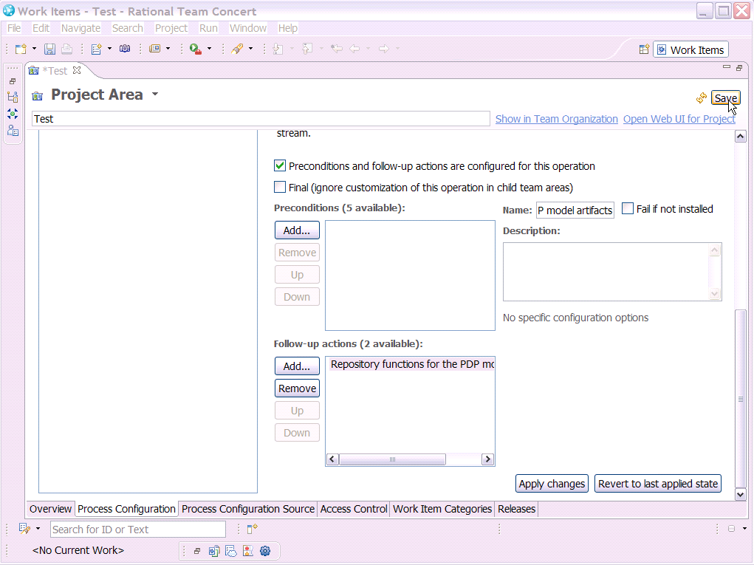

The configuration steps are finished now. When you will deliver a project with PDP model instances, those will be indexed and you will be able to search them through the repository search functions.

